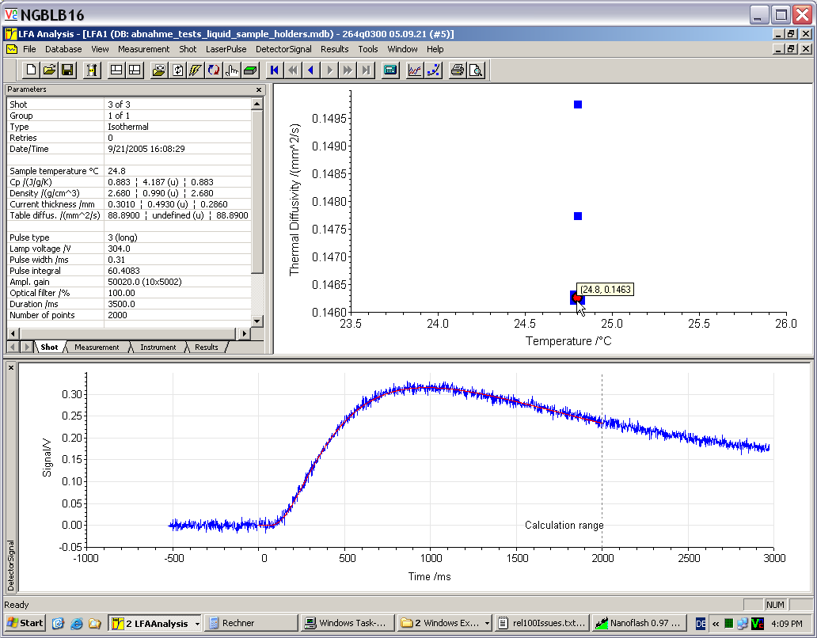
Figure 2 Processing of measurement results

