Structural Equation Modelling For Improving Fire Safety Reliability Through Enhancing Fire Safety Management On High-Rise Building

Abstract. The growth of high-rise building is triggered by expensive land price and the need of building for hotel, office and college. Beside great benefits, high-rise building also has consequence of fire risks. If fire occurs, its extinction is challenging due to flammable furniture and characteristics of high-rise buildings that is difficult to be reached by extinction equipment. To anticipate this, fire safety protection in high-rise buildings must be reliable. The Indonesian government has issued regulations and technical guidelines regarding the reliability of fire safety, but fires still occur and cause loss of life and property. Science and engineering provide an alternative approach, namely performance based. In this study, we offer a reliability of fire safety model which is formed from the integration of Fire Safety Management (FSM) variables, namely fire prevention, people safety, monitoring, audit, review and reactive monitoring. The initial model has been validated by experts in the field of fire safety in high rise building. At the initial stage, identification of FSM implementation for building functions in Jakarta was carried out. Surveys in buildings were conducted using a questionnaire and a checklist for the completeness of the protection system. The data were processed using a spreadsheet to produce the iImplementation of FSM and using the Smart PLS application to test the effect of independent variables on the dependent variables. Sub-variables with low FSM implementation were to improve fire safety conditions in buildings. Reliability can be achieved by implementing all FSM variables. Improvement efforts are prioritized on sub-variables with low implementation and priority on fire prevention and monitoring, audit, and review variables. Integrating the implementation of FSM variables consistently will produce reliability of fire safety and will guarantee life and property safety
Keywords: Fire safety management; Fire Safety Reliability; High-rise building; Life and Property Safety
1. Introduction
Fire is a serious threat in developing countries which significantly threaten life, infrastructures, property and environment (Kodur et al., 2018). The provincial government of Jakarta recorded more than five hundred fire accidents annually in the past five years. The fires caused fatality and injuries. In 2017, for example, the fires caused forty six deaths and injured 118 people. While in 2018, the fires led to 25 fatalities and injured more than 150 people. (Rahardjo, 2020). Moreover, fire also causes direct economic losses as many as fivefold of losses due to earthquake and only one level below drought and flood. Economic losses due to fire in Jakarta in the middle of 2019 areis estimated to be 137,8 billion rupiah. (Zhi-Xiang, 2011).
Due to multipurpose usages, intensive access of non-specific persons and low environmental sensitivity, high-rise building needs to implement fire safety management (FSM) system to effectively guide individuals to follow appropriate fire evacuation procedures to guarantee personal safety (Ying-Yueh Chen et al., 2012). FSM is one of the efforts to help manage fire risk from design, construction, monitoring to operation stages (Ramli, 2010). The Regulation of Minister of Public Works No: 26/PRT/M/2008 about Technical Requirement for Fire Protection System in Buildings and Environment states that a building must function securely by having fire protection system from planning, operation, development and utilization. (Suprapto, 2008; Murtiadi, 2013; Ajizah, 2018). Fire safety generally aims to prevent the collapse of the building under fire conditions, giving occupants enough time to escape safely. (Suwondo, et.al, 2021)
This study aims to identify dominant factors of Fire Safety Management that influence fire safety reliability. According to Indonesia regulations, fire safety reliability is achieved through the execution of active and passive protection, rescue facilities and exit route. (Xiang et al., 2011; Ying-Yueh Chen et al., 2012; Tofilo, et al., 2013). The potential for fire in high-rise buildings must be minimized. High-rise building facilities must be adequate to achieve fire safety for occupants and property. Occupancy management must be regulated so that the behavior and activities of building occupants are in accordance with safe criteria. All equipment must be regularly maintained, maintained and tested. The principles above are known as fire safety management. The implementation of good fire safety management will ensure fire safety reliability. In the study of FSM implementation in high-rise building, various functions are identified and recommendation is delivered for continuous improvement
Structural Equation Modeling is useful for describing the concept of a model with latent variables which are variables that cannot be measured directly but can be measured through indicators. These variables are essentially processed in path analysis with SEM (Chin, 1998). The use of SEM as a research method is intended to enable constructing unobservable variables, which are measured by indicators (also called items, manifest variables, or observed measures) as well as using direct measurement models to measure the observed variables (Chin, 1998).

2. Methods
This section explains the research methods that were carried out which include the selection of research strategies, the research process, identification of research variables, research instruments, data collection and analysis methods. This study used a questionnaire survey method and SEM-PLS. Survey through questionnaires was used to collect research data. The survey through this questionnaire is a qualitative method to collect indicator data on variables that are useful for increasing the reliability of fire safety. SEM-PLS was used to assess the research indicators. The SEM PLS method was developed to test weak theory and data, small sample sizes or data normality problems (Wold H., 1982). This method does not require data to be normally distributed and parameter estimation can be carried out directly without the goodness of fit criteria requirements. The analysis method negates the assumptions of Ordinary Least Squares (OLS) regression, it does not have to be free from the problem of multicollinearity between exogenous variables (Wold H., 1985).
2.1. Identification Research Variables

The variables were obtained from the results of a literature study that had been synthesized on the research framework which was then validated by fire safety experts in order to obtain the variables to be measured in this research. The research variables are fire prevention; safety of people; monitoring, audit, review; reactive monitoring, and reliability of fire safety. Fire Prevention is efforts to minimize the occurrence of ignition, reduce spread of fire and smoke, avoiding sudden damage (Ferguson & Janicak, 2005; Abolghasemzadeh, 2013; Chen, et al., 2015). Safety of people is methods taken from the pre-construction stage to building operations so that building occupants can save themselves in the event of a fire (Muckett & Furness, 2007; Jutras & Meacham, 2016; Maluk et al., 2017). Monitoring, audit, and review is process of reducing the risk of fire at the operational stage of the building in various ways, especially with the availability of procedures and guidelines for what to do in emergency, periodic checks on installed facilities/infrastructure, evaluation of the adequacy of procedures for regulations and the latest technological developments. (Ferguson & Janicak, 2005; Chen, et al., 2015). Reactive monitoring is all efforts made by the building manager at the building maintenance stage to respond quickly after a fire/bad incident occurs by conducting an investigation to find out the cause of the incident so that it can be anticipated that it will not happen again (Ferguson & Janicak, 2005; Chen et al., 2012). Reliability of fire safety is the reliability of high-rise buildings on fire safety that ensures the safety of life and property (Ferguson & Janicak, 2005; Abolghasemzadeh, 2013). Each variable has a different number of indicators, X1 (60 indicators), X2 (22 indicators), X3 (33 indicators), and X4 (19 indicators)
Variables identification in this study is used to assist in determining the data collection and also the technical tools of content and construct validation processing in order to achieve validated variables so that it can be used in the structural equation model analysis process. The implementation of Fire Safety Management is carried out by fulfilling the criteria contained in fire prevention, safety of people, monitoring, audit, review, and reactive monitoring. Reliability of fire safety in High-Rise Building is achieved if the implementation of all variables in the FSM is adequate. In this condition the purpose of saving life and property will be fulfilled.

2.2. Research Methodology
Figure 1 explains the implementation mechanism of each stage that is discussed based on the input-process-output diagram. The discussion of input includes an explanation of the types of data used as well as the data collection instruments at each stage. Discussion of the process is a discussion related to data processing methods or data analysis used in each stage. The discussion of the output is an explanation related to the description of the results or findings obtained from each stage.
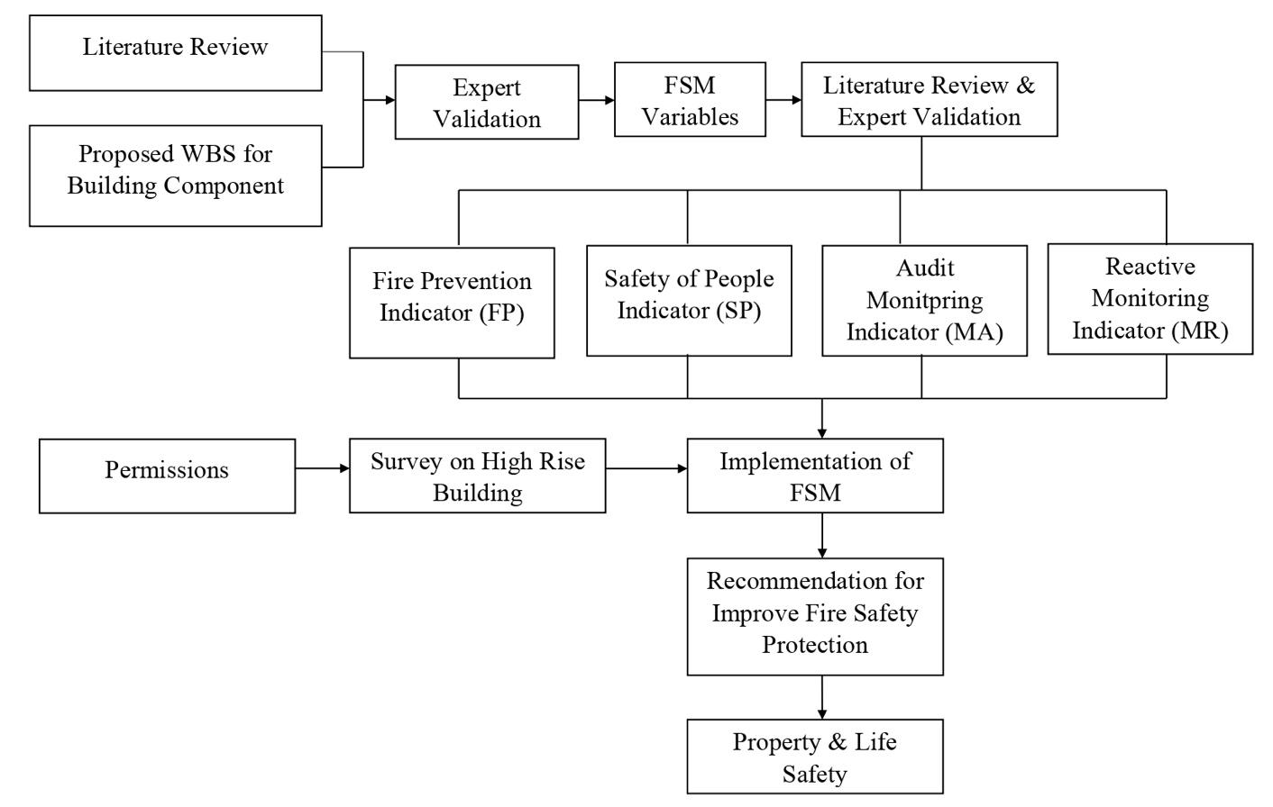
Figure 1 Research methodology
The first thing to do in this research is a literature study to determine the research variables as shown in Figure 1 thate were obtained from various references from previous studies and regulations on fire safety management systems. After the variables were formed from the literature study, then validation was carried out by experts to validate the variables that have been formed from the results of the literature study. There were 8 experts selected in this study with a minimum criterion of master’s education in fire safety and a minimum of 15 years experience in the construction field. The next step was conducting a pilot survey with 30 respondents which aims to validate the research questionnaire that has been prepared in this study to prove whether the questionnaire acceptable to the respondents. The target respondents are building owners and management of high-rise buildings in Jakarta. The function of building are hotel, office and college. Variables are measured through the implementation of each indicator. The list of questions is submitted in softcopy and hardcopy. The number of questionnaires distributed was 225, while the responses received were 105. Respondent criteria area minimum bachelor’s degree and at least 5 years of experience. After the questionnaires were collected, a Structural Equation Model Analysis was carried out with Smart PLS software to determine the relationship among the variables of fire prevention; safety of people; monitoring, audit and review and monitoring reactive which had implications for fire safety reliability. The last step of this research was to carry out final validation of the results of the study which aims to integrate all variables to achieve fire safety reliability.

3. Results and Discussion
3.1. Research Data Analysis

Validation was carried out by experts to check the variables and indicators that have been formed from the results of the literature study. Data collection through questionnaires is carried out after the validation process. There were 8 experts selected with a minimum criterion of master’s education in fire safety and a minimum of 15 years experience in the construction field. The experts are presented in Table 1.

Table 1. List of Construction and Safety Expert for Content and Construct Validation
Expert | Position | Education | Experience
Expert 1 | Instructor and Lecturer | Doctoral Degree | 22 Years
Expert 2 | CEO in insurance company | Master Degree | 20 Years
Expert 3 | Director of Risk Manag. in insurance company | Master Degree | 29 Years
Expert 4 | Senior Fire Safety Expert in Const. Company | Doctoral Degree | 40 Years
Expert 5 | Senior Fire Safety Expert | Bachelor Degree | 35 Years
Expert 6 | Senior Fire Safety Expert in Const. Company | Bachelor Degree | 30 Years
Expert 7 | Senior Fire Safety Expert in Const. Company | Bachelor Degree | 15 Years
Expert 8 | Practitioner in Construction Field | Bachelor Degree | 20 Years

The initial construct in this study is the result of a literature review. Initially, the variables causing fires in high-rise buildings were grouped. This variable is a latent variable, so it cannot be measured directly. Each variable is searched for indicators so that the value of the variable can be measured. The initial construct was validated by the expert. Initially, a pilot survey was conducted to 10 respondents to get feedback on the questionnaire in this study. The questionnaire was corrected and then a main survey was conducted to collect complete data. The data is processed, analyzed and produces the output of the fire safety reliability model. This final result was validated by the same expert who did the initial construct checking.
In this process, the Delphi method with structured interviews by experts to determine research variables and indicators. This method is used for the decision-making process on the results of data collection involving several independent experts. The decision-making process using the Delphi method is carried out in one round to arrive at the consensus stage. The validation carried out by these experts was carried out one by one for all eight experts.. Five variables were obtained, namely fire prevention, safety of people, monitoring, audit, review; monitoring reactive, and fire safety reliability shown in the Figure 1. According to experts, these indicators are in accordance with the variables formed from the results of the literature study
3.2. Implementation of FSM in Jakarta
Table 2 FSM Implementation in high-rise Building
Occupancy | FSM Implementation in High-Rise Buildings
 | Fire Prevention | People Safety | Monitoring, audit and Review | Reactive Monitoring
Hotel | 96.24% | 92.41% | 96.55% | 96.47%
Office | 92.93% | 89.50% | 89.18% | 91.32%
College | 84.62% | 77.86% | 79.79% | 81.58%

The values ​​in table 2 are obtained from a field survey of high rise buildings in Jakarta. The type of question is how to implement indicators in high-rise bulding carried out by building owners and bulding management. The survey results are used to measure the value of 4 variables, namely X1 is Fire Prevention, X2 is People Safety, X3 is monitoring, audit, review, and X4 is Reactive Monitoring. The percentages in table 2 show the value of implementing indicators of Fire Safety Management variables in high-rise buildings.
FSM implementation on high-rise building in Jakarta is more than 80 percent on average. The best implementation ordered from the largest to smallest is hotel, office and college buildings. The greater the percentage of the implementation of Fire Safety Management in high-rise buildings, the better the fire safety reliability. The weight of variable implementation by building management for all functions tends to be the same. The best implementation is achieved on the variables of fire prevention and the worst on the variable of people safety. This finding corroborates previous studies.
Hotel building as service industry should provide the best service to customers. Early fire protection system equipment should be mandatory for hotel owner. This is in accordance with the study by (Zulfiar & Gunawan, 2018) which assessed reliability of building fire system. The result shows that hotel buildings in Yogyakarta have reliability of 91,60% which is in good category. (Wulandari & Trikomara, 2018) states that hotel buildings in Pekanbaru have reliability of 91,46% which is also in good category.
The study on building reliability is also conducted on office building. The result shows that the reliability of office building is 68,05%, which is lower than hotel buildings (Mareta & Hidayat, 2020).
The study on the building reliability of college building was performed with reliability value of 37,26%, which is lower than hotel and office buildings. The components that cannot be satisfied are landscape comprehensiveness (water source and hydrant in yard), rescue tools, exit route construction, passive protection system, fire-resistant of building structure, compartmented room and protection of openings), as well as all active protection system components (Selena et al., 2019).
3.3. Relationship analysis with SEM-PLS Using Smart PLS 3.0 Software
SEM-PLS aims to test the predictive relationship between the constructs by seeing whether there is a relationship or influence between the constructs. The benefit of using SEM-PLS is that the test can be carried out without a strong theoretical basis, ignoring some assumptions (non-parametric) and the accuracy parameters of the prediction model can be seen from the coefficient of determination (R²). Therefore, SEM-PLS is very appropriate to be used in research that aims to develop theory.
The purpose of using Smart PLS 3.0 is to estimate the causal-predictive relationship between FSM variables and the level of fire safety reliability in high-rise building.

Table 3 Loading factors Average Variance Extracted (AVE)
Research Variables | AVE
Fire Prevention | 0.723
Safety of people | 0.571
Monitoring, audit, and review | 0.670
Reactive monitoring | 0.621
Reliability of fire safety | 0.681

Modelling research results using smart PLS as shown in Figure 2.

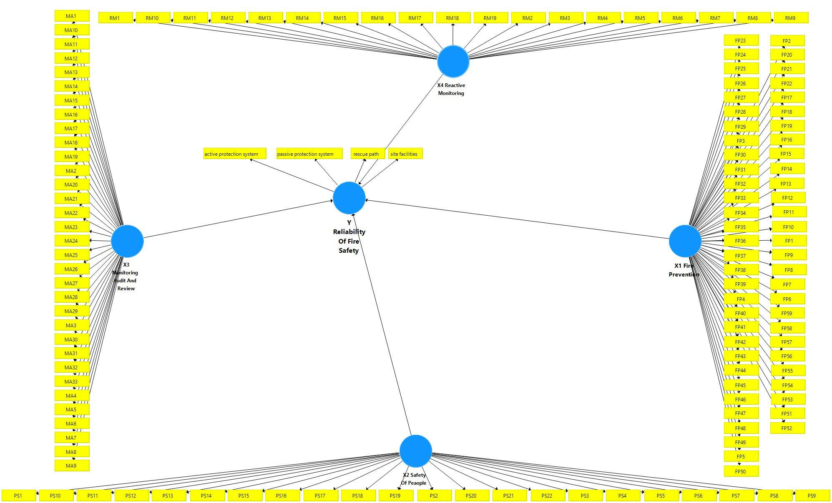
Figure 2 Calculation of PLS Algorithm (Outer Loadings)

Figure 2 shows the dependency relationship between the independent variable, X and the independent variable, Y where in the circular part are the variables X and Y, where X1 is Fire Prevention, X2 is People Safety, X3 is Audit Monitoring, X4 is Reactive Monitoring and the variable Y is fire safety reliability. These variables were tested with SmartPLS 3.0 software. This test passes the outer model test, namely the test of validity and reliability values. In the validity test, there are loading factor parameters, Average Variance Extracted (AVE), Cross loading, and Sqrt AVE. In the reliability test, there are Cronbach's alpha and composite reliability parameters. From the two tests, it was found that the research data had a valid value. Next is the inner model. By using the SmartPLS 3.0 software, the R square result is 0.807 or 80.7%. This means that the fire safety reliability variable can be explained by fire prevention; safety of people; monitoring monitoring, auditing, reviewing; and reactive monitoring of 80.7%. Based on the results of T-statistics which is worth more than 1.96, it is found that all variables have a significant effect on the reliability of fire safety.
Standardized loading factors as shown in Table 3 are useful for assessing whether a construct has sufficient discriminant validity, which is obtained by comparing the correlation of indicator of a construct with the correlation of these indicators with other constructs. If the correlation of indicator of the construct has a higher value than the correlation of these indicators with other constructs, then the construct is said to have high discriminant validity. Standardized loading factor describes the magnitude of the correlation of each measurement item (indicator), meaning that the indicator with the loading factor at a level > 0.7 is valid as an indicator that measures the construct. Item reliability is assessed from the loading factor according to kind of literatures which mention the loading factor above 0.7 is ideal. However, a standardized loading factor value above 0.5 is acceptable, while a standardized loading factor below 0.5 can be excluded.
By running the calculate main menu in the Smart PLS 3.0 program, there is a PLS Algorithm option by which the step is often referred to as the first-order confirmatory factor analysis with the results can be seen Table 4.

Table 4 Interrelation variable for Reliability improvement (R²)
Research Variable |  | R Square (R²)
Fire Prevention | 0.811
Safety of people | 0.521
Monitoring, audit, and review | 0.683
Reactive monitoring | 0.531
Reliability of fire safety | 0.807

Based on the R² table above, the R-Square value of Reliability of Fire Safety is 0.807, meaning that the variability of the Fire Safety Reliability construct can be explained by Fire Prevention; Safety of people; Monitoring, audit, review; and Reactive monitoring of 80.7%. Fire prevention intervention in this case will contribute about 81 percent to the achievement of reliability. Monitoring, audit, and review will contribute 68 percent to reliability of fire safety.
Fire prevention is done through planning and inshigh riseation of detector system, alarm and sprinkler that is useful for preventing ignition and hindering the spreading of fire and fog. Provision of signage, evacuation route, emergency lighting, fire lift is part of indicators of people safety. Monitoring, audit and review that comprises procedures, fire training and maintenance of equipment are performed by building management in the operational stage. If fire and harmful condition occur, investigation and checking procedures are implemented by investigator. This is done to prevent the same incident. The Strategy 4 is called reactive monitoring. Implementation of all abovementioned efforts is associated with the achievement of fire safety reliability on high-rise building.
3.4. FSM Improvement on High-Rise Building
The results of the validation process to experts contained in table 1, explained that the intervention of fire prevention; monitoring audit review; reactive monitoring; and people safety will improve reliability of fire safety. Enhancement of reliability is conducted by prioritizing the most influencing FSM variables with the order mentioned above. Improvement efforts on each variable will be more effective by treating sub-variable that has lowest level of implementation.

Table 5 FSM Improvement in College Building
No. | Variable | Indicator | Implementation | Improvement
1 | Fire Prevention | Fire Lift | 16% | It is necessary to have fire and smoke barriers installed on the fire lift in order to withstand diffusion on the lift shaft (Haitao et al., 2012)
2 | Fire Prevention | Evacuation procedures | 68% | In the evacuation procedure, it is necessary to have an evacuation pattern related to the number of people on each floor, the number of emergency stairs available and the number of floors directly affected by the fire. (Sharma et al., 2014)
3 | Safety of people | Stairwell Intercom Systems/communication system on emergency stairs | 58% | Equipment and installation systems must be secured against interference such as electromagnetic wave interference (Chen et al., 2012)
4 | Safety of people | Help disabled residents to save themselves | 61% | There needs to be evacuation arrangements and procedures for disabled occupants who need special assistance in the event of a fire evacuation (Egodage et al., 2020)
5 | Safety of people | Fire detection method | 65% | The use of the Internet of Things is capable of detecting the presence of smoke and fire for evacuation, alerting firefighters and ensuring that damage can be minimized. IoT can display the required data and correct reports that automatically send the data (Eltom et al.,2018)
6 | Monitoring, Audit, and Review | Annual review and report | 52% | Create a management team that is responsible for independently verifying the status of implementation of recommendations and performing tracking and reporting functions. Also make sure that this team has the necessary technical knowledge to lead the review effort on the annual report (Landa, 2014)
7 | Monitoring, Audit, and Review | Level and detailing to be audited, due to the size of the building and organization | 65% | Empowers internal inspection software that can assess up to 184 inspection points for 24 different categories of building work (Government of Western Australia, 2021)

The above table shows FSM sub-variables and the efforts for performance improvement for college building. The variable indicators and proposed improvements in table 5 are identified based on the results of field surveys on high-rise buildings with lecture functions. In the 4 FSM variables, the indicators with the lowest implementation values ​​were identified
Implementation of FSM on college building has the lowest value, so that the implementation of FSM in college building is more emphasized. Some of sub-variables have been identified to have implementation level less than 70%. If the implementation value is small, the sub-variables need to get more attention. Recommended improvement efforts are placed in the right column to reach fire safety reliability of college building.
The contribution in this research is the development of the Theory of Fire Safety Management Improvement, that Implementation of FSM contributes to the reliability of fire safety. The contribution will be more effective if the treatment on 4 FSM variables is done consistently.
Implementation of FSM on hotel building is the best among office and college buildings. However, performance enhancement needs to be improved particularly on the variables that have smaller implementation compared to other sub-variables. These results explain that reliability will increase significantly with treatment in the FSM implementation.

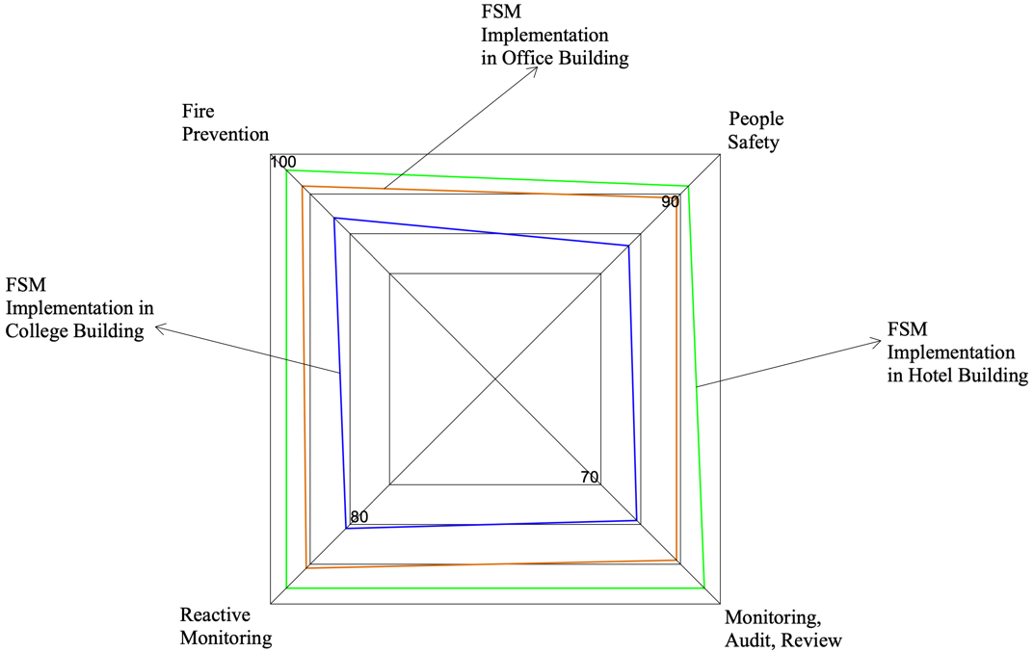
Figure 3 Fire Safety Reliability Level in High-Rise Building

Figure 3 is a spider web that was developed based on the results of a survey on the application of the indicator variable fire safety management in table 2. Based on Figure 3, it can be seen that the application of indicators on the variable fire safety management shows that hotel buildings are the best in fire prevention; safety of people; monitoring review, audit, review; and reactive monitoring as mentioned in table 2. The worst application is the lecture building. Applications in office buildings are between hotel buildings and college buildings.
From the explanation above, when compared with other studies conducted previously, the results are almost the same as those mentioned in the explanation in table 2. The application of Fire safety Management in high-rise buildings with hotel, office and college functions is in the good category with a successive percentage of 95 %, 90.5% and 80.75 percent with good rating category (Nugroho, 2021).
The hypothesis of this research according to the validation results is that the implementation of FSM affects the reliability of fire safety. This result is proven by testing all variables using the Smart PLS application. This theory explains that the reliability of fire safety can increase with improve implementation of fire prevention; people safety; monitoring, audit, review; and reactive monitoring.
FSM consists of 4 variables, namely fire prevention; people safety; monitoring, auditing, reviewing; and reactive monitoring. Each contributes to the performance of the FSM. Adequate implementation for each variable will result in a good value integration of FSM variables. These dimensions need to be understood and implemented by building managers so that reliability performance can be achieved. FSM implementation will affect the reliability of fire safety. This is in accordance with previous research which states that building safety can be realized if the building design considers, among others, regulations, simulations of many fires and people (Cowlard et al., 2013).
Fire safety in high rise buildings is necessary on a regular basis. Safety goals can be achieved by relying on active, passive prevention systems and fire safety equipment maintenance systems. Stakeholder and occupant management is an important part of achieving a safety strategy. (Nimlyat et al., 2017) fire safety is carried out by carrying out fire prevention, fire and control, fire control and element resistance strategies. Safety and emergency facilities must be ensured to function. (Chen et al., 2012) An integrated safety program will effectively manage all hazards if process safety and fire protection techniques are integrated. Both areas require extensive testing, inspection, maintenance, auditing, training, planning, and drilling (Chen, et al., 2015) Fire safety can be achieved by design based on regulations and arrangements with the needs/characteristics of the building and occupants resulting in better buildings (Maluk et al., 2017) The fire safety system must be improved. Safety and fire are the initial principles to reduce accidents and losses. The way to do this is by integrating man-machine-environment resources by optimizing hardware and software (Xiuyu et al., 2012).

4. Conclusions
Some recommendations for the fire safety reliability improvement from the dominant significant variables are as follows:
Fire lift variable indicators, annual reports and communication on emergency exits need attention because the lowest implementation is 16%, 52% and 58% in lecture function buildings. The variables of fire prevention, people safety, audit monitoring, and reactive monitoring have a significant effect on fire safety reliability. This variable has an effect of 80.7% on fire safety reliability.
Implementation of FSM on high-rise building in Jakarta for hotel, office and college buildings is good. The implementation of fire safety management in hotel function buildings has the highest value. The implementation of FSM in high-rise buildings with lecture functions has the lowest value. The implementation of FSM in office buildings has a value between the hotel function building and the college function building. Several recommendations for improvement on each FSM variable have been provided on variables with low implementation. To achieve optimum reliability of fire safety, treatment should be conducted on variables having dominant influence which are fire prevention and monitoring, audit, review. Model of fire safety reliabiliy resulted in the study is affected by fire protection, people safety, monitoring, audit, review and reactive monitoring. The higher the implementation on the 4 variables, the better the reliability. The integration of all FSM variables will support the assurance of life and property safety in high-rise buildings.

Acknowledgements
The Authors would like to thank the financial support provided by Ministry of Research and Technology/National Research and Innovation Agency through PDUPT Grant 2021 with contract number: NKB-220/UN2. RST/HKP.05.00/2021 managed by the Directorate for Research and Community Engagement (DRPM) Ministry of Research and Technology/National Research and Innovation Agency (BRIN).

References

Ajizah, N. (2018). Perencanaan Sumber Daya Pada Pekerjaan Mekanikal dan Elektrikal Bangunan Gedung Apartemen Berbasis WBS (work breakdown Structure).
Alianto, B., Astari, N., Nareshwara, D., Nugroho, Y.S., 2017. Modeling of Smoke Control in Underground Parking-garage Fires. International Journal of Technology, Volume 8(7), pp. 1296-1305
Chen, H., Pittman, W., Hatanaka, L., Harding, B., Boussouf, A., Moore, D., & Mannan, M. (2015). In Integration of process safety engineering and fire protection engineering for better safety performance (pp. 74-81). Journal of Loss Prevention in the Process Industries. doi:https://doi.org/10.1016/j.jlp.2015.06.013
Chen, Y.-Y. C.-J.-H.-Y.-W. (2012). The adoption of fire safety management for upgrading the fire safety level of existing hotel buildings. Building and Environment, 51, 311-319. doi:https://doi.org/10.1016/j.buildenv.2011.12.001
Chen H. et al. (2015). In Integration of process safety engineering and fire protection engineering for better safety performance, Journal of Loss Prevention in the Process Industries 37 (pp. 74-81).
Cowlard, A., Bittern, A., Empis, C. A., & Torero, J. (2013). In Fire safety design for high rise buildings (pp. 169-181). Procedia Engineering. doi:https://doi.org/10.1016/j.proeng.2013.08.053
Eltom, R. H., Hamood, E. A., Mohammed, A. A., & Osman, A. A. (2018). Early warning firefighting system using internet of things. In 2018 International Conference on Computer, Control, Electrical, and Electronics Engineering (pp. 1-7).
Ferguson, L., & Janicak, C. (2005). Fundamentals of Fire Protection for Safety Professional. Lanhamn Maryland: Government Institutes, an imprint of The Scarecrow Press, Inc.
Furness, A., & Muckett, M. (2007). Introduction to Fire Safety Management (1 ed.). Burlington: Linacre House, Jordan Hill, Oxford.
Government of Western Australia. (2021). Building and Energy.
Gruen, B., & Hornik, K. (2011). topicmodels: An R Package for Fitting Topic Models. Journal of Statistical Software, 40(13), 1-30.
Haitao C., Lei L., Jiuzi Q. (n.d.). In Accident Cause Analysis and Evacuation Countermeaures on the High-Rise Building Fires, International Symposium on Safety Science and Engineering in China ISSSE 2012, Procedia Engineering 43 (2012) (pp. 23-27).
Jutras, Ian & Meacham, Brian. (2016). Development of Objective-Criteria-Scenario Triplets and Design Fires
for Performance-Based Fire Safety Design. Journal of Building Engineering. 8. 10.1016/j.jobe.2016.09.002.
Kodur, V., Kumar, P., & Rafi, M.M. (2018). Fire hazard in buildings: review, assessment and strategies for improving fire safety. doi:https://doi.org/10.1108/PRR-12-2018-0033
Maluk, C., Woodrow, M., & Torero, J. (2017). In The potential of integrating fire safety in modern building design (pp. 104-112). Fire Safety Journal. doi:https://doi.org/10.1016/j.firesaf.2016.12.006
Mareta, Y., & Hidayat, B. (2020). In Evaluasi Penerapan Sistem Keselamatan Kebakaran Pada Gedung-gedung umum di Kota Payakumbuh (pp. 65-76). Jurnal Rekayasa Sipil (JRS-Unand). doi:https://doi.org/10.25077/jrs.16.1.65-76.2020
Murtiadi, S. (2013). In Review of Indonesian standard for concrete building subjected to fire (pp. 668-674). Procedia Engineering. doi:https://doi.org/10.1016/j.proeng.2013.03.061
Nimlyat, P. S., Audu, A. U., Ola-Adisa, E. O., & Gwatau, D. (2017). An evaluation of ﬁre safety measures in high-rise buildings in Nigeria. doi:https://doi.org/10.1016/j.scs.2017.08.035
Pangaribuan, A., Fadhil, Santoso, M.A., Dhiputra, I.M.K., Nugroho, Y.S., 2016. Controlling Fire Growth in Electrical Cable Compartment by Reducing Oxygen Concentration at Horizontal Orientation. International Journal of Technology. Volume 7(2), pp.332-342
Rahardjo, H. A. (2020). The most critical issues and challenges of fire safety for building sustainability in Jakarta. Journal of Building Engineering, 29. doi:https://doi.org/10.1016/j.jobe.2019.101133
Selena, I., Safriani, M., & Novrizal. (2019). In Identifikasi Sistem Proteksi Kebakaran Serta Tingkat Keandalan Keselamatan Bangunan Fakultas Kesehatan Masyarakat di Univeristas Teuku Umar (pp. 50-58). Education Building. doi: https://doi.org/10.24114/ebjptbs.v5i2%20DES.16141
Sharma, P., Dhanwantri, K., & Mehta, S. (2014). In Evacuation Patterns in High-Rise Buildings (pp. 2278-3652). International Journal of Civil Engineering Research.
Suprapto. (2008). Tinjauan Eksistensi Standar-Standar (SNI) Proteksi Kebakaran dan Penerapannya dalam Mendukung Implementasi Peraturan Keselamatan Bangunan. . Prosiding PPIS Bandung.
Suwondo, R., Cunningham, L., Gillie, M., Suangga, M., Hidayat, I., 2021. Model Parameter Sensitivity for Structural Analysis of Composite Slab Structures in Fire. International Journal of Technology. Volume 12(2), pp. 339-348
Tofilo, P., Konecki, M., Galaj, J., Jaskolowski, W., Tusnio , N., & Cisek, M. (2013). In Expert system for building fire safety analysis and risk assessment (pp. 1156-1165). Procedia Engineering. doi:https://doi.org/10.1016/j.proeng.2013.04.146
Wulandari, B., & Trikomara, R. (2018). In Analisa Keandalan Sistem Proteksi Kebakaran Pada Bangunan Ayola First Point Hotel Pekanbaru (pp. 1-9). Jom FTEKNIK.
Xiang, X. Z., Fang, Z. X., & Li, G. W. (2011). In Applied research of performance-based fire protection design in a large building (pp. 566-574). Procedia Engineering. doi:https://doi.org/10.1016/j.proeng.2011.04.697
Xiuyu, L., Hao, Z., & Qingming, Z. (2012). In Factor analysis of high-rise building fires reasons and fire protection measures (pp. 643-648). Procedia Engineering. doi:https://doi.org/10.1016/j.proeng.2012.08.216
Ying-Yueh Chen et al. (2012). In The adoption of fire safety management for upgrading the fire safety level of existing hotel buildings, Building and Environment 51 (2012) (pp. 311–319). doi:https://doi.org/10.1016/j.buildenv.2011.12.001
Zadeh, Puyan. (2013). A Comprehensive Method for Environmentally Sensitive and Behavioral Microscopic Egress Analysis in Case of Fire in Buildings. Safety Science. 59. 1-9. 10.1016/j.ssci.2013.04.008.
Zhi-Xiang, X. X.-F.-L. (2011). Applied Research of Performance-based Fire Protection Design in a Large Building. Procedia Engineerin, 11. doi:https://doi.org/10.1016/j.proeng.2011.04.697
Zulfiar, M., & Gunawan, A. (2018). In Evaluasi sistem proteksi kebakaran pada bangunan hotel UNY 5 lantai di Yogyakarta (pp. 65-71). Semesta Teknika. doi:https://doi.org/10.18196/st.211212

