**Calculation model and theoretical solution of the problem**

*1 Calculation model*

The cross-section of the chisel fertilizer working tool is a dihedral wedge with a front edge at a cutting angle  to the direction of travel and the other along the direction of travel (Figure 1).

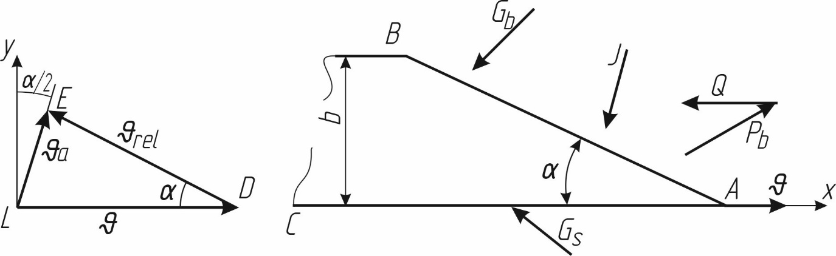

Figure 1 - Interaction of the ripper-distributor’s working tool with the soil

The implement moves in the soil at speed (m/s) and acts on it with force *Pb (N),* which is the result of normal and friction forces on the blade face. The soil resists the movement of the ripper-distributor through the following forces:

 – soil layer resistance in front of the ripper-distributor;

*J* – dynamic impact of soil on the working body;

– soil layer resistance on the front edge of the blade; and

 – lateral impact of soil layer on the second edge.

Lateral impact can also occur on the second edge after point *B*. Obviously, this force is much smaller compared to the others and so it can be disregarded.

*2 Theoretical solution*

Determine the pulling force of the tool as it moves in the soil.

Consider the speed triangle (Fig. 1). Based on this we have:

|  |  |
| --- | --- |
|  | (1) |
| where . |  |

Substitute into (1) the values of the angles

|  |  |
| --- | --- |
|  | (2a) |
|  | (2b) |

From the last expression and Figure 4, the absolute speed of the particles υa will be directed at an angle to the direction of the *y-axis*. The equations of equilibrium of the acting forces in the x,y axis directions are as follows:

|  |  |
| --- | --- |
|  | (3a)  (3b) |

The dynamic disturbance of deformed soil particles can be expressed by Newton's formula:

|  |  |
| --- | --- |
|  | (4) |

where is the acceleration of the soil particles that are displaced upon the action of the wedge surface, *m/s2*;

 – the mass of the soil layer, *kg*.

The acceleration of soil particles is calculated using the following formula:

|  |  |
| --- | --- |
|  | (5) |

The speed of the soil particles at  is also zero so .

The travel time of the soil particles on the surface of the wedge can also be calculated as

|  |  |
| --- | --- |
|  | (6) |

where *ll* is the blade length, *m*;

 – is the relative speed of the soil particles and equal to the progressive speed of the working tool, *m/s*.

Given the latter expression, the acceleration (5) is . By substituting it into expression (2), we obtain

|  |  |
| --- | --- |
|  | (7) |

The mass of the soil medium that receives the dynamic disturbance is equal to:

|  |  |
| --- | --- |
|  | (8) |

Where  is the width of the fertilizer-working tool, *m*;

 – the depth of cultivating, *m*;

 – is the soil density, .

Substituting (7) and (8) into (4), we can obtain

|  |  |
| --- | --- |
|  | (9) |

The resistance of the reservoir to the leading edge of the wedge is determined by the cross-sectional area of the still undisturbed reservoir:

|  |  |
| --- | --- |
|  | (10) |

where is the compressive strength of the soil,  .

Figure 4 shows

|  |  |
| --- | --- |
|  | (11) |

From the second equation of system (3), we have:

|  |  |
| --- | --- |
|  | (12) |

Given (11):

.

|  |  |
| --- | --- |
|  | (13) |

The normal side edge pressure is determined by the formula

|  |  |
| --- | --- |
|  | (14) |

where is the length of the lateral edge of the wedge, *m*.

From (12), you can obtain:

|  |  |
| --- | --- |
|  | (15) |

From Fig. 4 we can determine:

|  |  |
| --- | --- |
|  | (16) |

The working tool blade exerts normal pressure on the soil layer at the front:

|  |  |
| --- | --- |
|  | (17) |

Given the last formula, we can obtain from (15)

|  |  |
| --- | --- |
|  | (18) |

In (12), we can substitute (13) and (16) and obtain:

|  |  |
| --- | --- |
|  | (19) |

From the system of equation (3), we can determine the tractive force of the ripper-distributor:

|  |  |
| --- | --- |
|  | (20) |

By substituting values of its components into equation (20), we can obtain

|  |  |
| --- | --- |
|  | (21) |

By converting we get:

|  |  |
| --- | --- |
|  | (22) |

Using the following designations:

|  |  |
| --- | --- |
|  | (23) |
|  | (24) |

In this case, the tractive force is equal to:

.

|  |  |
| --- | --- |
|  | (25) |