Put the Title of Paper Here, in Capitalize Each Word without Line Seperation

Put authors name here¹, Put author name here¹, Put author name here¹, Put author name here², Put authors name here²

¹Put author’s affiliation here, complete with address, postal code, and country
²Put author’s affiliation here, complete with address, postal code, and country

Abstract. Abstract with no more than 300 words should be supplied to reflect the content of the paper. A concise and factual abstract is required. The abstract should state briefly the context of the problem (background), purpose/aim of the research, the principal methods, the results and major conclusion (contribution). An abstract is often presented separately from the article, so it must be able to stand-alone. For this reason, References/citation should be avoided. Also, non-standard or uncommon abbreviations should be avoided, but if essential they must be defined at their first mention in the abstract itself.
Keywords: Alphabetically sorted; Capitalized first word; From a to z; Maximum 5 keywords; Sentence case; Separate by semicolon (;) between keyword

1. Introduction
Provide an adequate background, context of the problems based on the literature review. State the objectives of the work and emphasize the originality (state of the art). Introduction text - Introduction text - Introduction text - Introduction text - Introduction text - Introduction text - Introduction text - Introduction text - Introduction text - Introduction text - Introduction text - Introduction text - Introduction text - Introduction text - Introduction text - Introduction text - Introduction text - Introduction text - Introduction text - Introduction text - Introduction text - Introduction text - Introduction text - Introduction text - Introduction text - Introduction text - Introduction text - Introduction text - Introduction text - Introduction text - Introduction text - Introduction text - Introduction text - Introduction text - Introduction text -
Citation more than one cited article/reference should be written in order by year - Citation more than one cited article/reference should be written in order by year - Citation more than one cited article/reference should be written in order by year - (Mettam et al., 1994; Berawi, 2004; Mamat et al., 2009) Introduction text - Introduction text (Gang-Ji, 2008) Introduction text - Introduction text - Introduction text - (Bruker, 2005) Introduction text - Introduction text (Kusrini and Saleh, 2009) - Introduction text - Introduction text - Introduction text - Introduction text (Mamat et al., 2009). Introduction text - Introduction text - Introduction text - Introduction text - Introduction text - Introduction text - Introduction text - Introduction text - Introduction text - Introduction text - Introduction text - Introduction text - Introduction text - Introduction text.
Introduction Text - Introduction Text - Introduction Text - Introduction Text - Introduction Text - Introduction Text - Introduction Text - Introduction Text - Introduction Text - Introduction Text - Introduction Text - Introduction Text - Introduction Text - Introduction Text - Introduction Text - Introduction Text - Introduction Text - Introduction Text - Introduction Text - Introduction Text - (Foundation, 2016).

2. Methods
Provide sufficient detail methods to allow the work to be reproduced. Methods already published should be indicated by a reference: only relevant modifications should be described.
Methodology text -methodology text -methodology text -methodology text -methodology text -methoology text -methodology text -methodology text -methodology text -Methodology text -methodology text -methodology text - methodology text - methodology text (Aparna et al., 2016).
2.1. Size of Dataset
Methodology text – sise of dataset - sise of dataset - sise of dataset - sise of dataset - sise of dataset - sise of dataset – Methodology text – sise of dataset - sise of dataset - sise of dataset - sise of dataset - sise of dataset - sise of dataset – Methodology text – sise of dataset - sise of dataset - sise of dataset - sise of dataset - sise of dataset - sise of dataset – (Gromacs, 2016).
Formulae should be numbered consecutively throughout the manuscript as Equation 1, and Equation 2. In cases where the derivation of formulae has been abbreviated, it is of great help to the reviewers if the full derivation can be presented on a separate sheet (not to be published).
Formulae should be centered and numbered.
(1)
where L is the length of river, C is the coefficient of runoff – Result text – Result text – Result text – Result text:
(2)
where P_{gen} is the generated precipitation - Discussion text - Discussion text - Discussion text - Discussion text - Discussion text - Discussion text - Discussion text - Discussion text - Discussion text - Discussion text - Discussion text - Discussion text – (Rester, 2008).
2.2. LPG Applications in Vehicles
Methodology text – sise of dataset - sise of dataset - sise of dataset - sise of dataset - sise of dataset - sise of dataset – Methodology text – sise of dataset - sise of dataset - sise of dataset - sise of dataset - sise of dataset - sise of dataset – Methodology text – sise of dataset - sise of dataset - sise of dataset - sise of dataset - sise of dataset - sise of dataset – Methodology text – sise of dataset - sise of dataset - sise of dataset - sise of dataset - sise of dataset - sise of dataset – Methodology text – sise of dataset - sise of dataset - sise of dataset - sise of dataset - sise of dataset - sise of dataset –.
2.2.1. ORF primary frames
Methodology text – sise of dataset - sise of dataset - sise of dataset - sise of dataset - sise of dataset - sise of dataset – Methodology text – sise of dataset - sise of dataset - sise of dataset - sise of dataset - sise of dataset - sise of dataset – Methodology text – sise of dataset - sise of dataset - sise of dataset - sise of dataset - sise of dataset - sise of dataset –. Methodology text – sise of dataset - sise of dataset - sise of dataset - sise of dataset - sise of dataset - sise of dataset –. Methodology text – sise of dataset - sise of dataset - sise of dataset - sise of dataset - sise of dataset - sise of dataset –. Methodology text – sise of dataset - sise of dataset - sise of dataset - sise of dataset - sise of dataset - sise of dataset –. Methodology text – sise of dataset - sise of dataset - sise of dataset - sise of dataset - sise of dataset.
Table should be original (not as embedded figure), no vertical border (only horizontal border and bold), use single line spacing, font size 11 as shown in Table 1. Tables should be centered and numbered accordingly.
Table 1 Number of receptors in each container
Experiment | Container | Receptor
1 | 50 | 28
2 | 100 | 14
3 | 150 | 9
4 | 200 | 7
5 | 250 | 5

Short explanation regarding the Table’s meaning and significant – Experimental methods can be supported with a diacgram, clearly shown the process and completed with legend, scale/dimension if required (Figure 1).
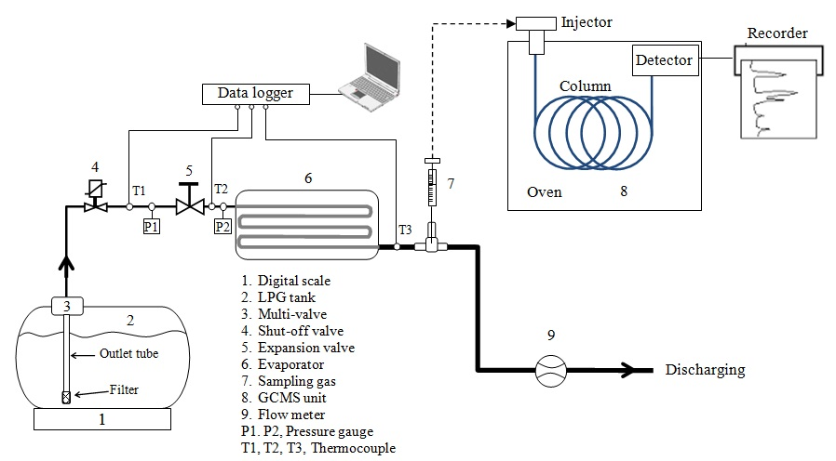
Figure 1 Experiment set-up and apparatus

3. Results and Discussion
3.1. System Performance Benchmark
Results should be clear and concise. Show only the most significant or main findings of the research. Discussion must explore the significance of the results of the work. Adequate discussion or comparison of the current results to the previous similar published articles should be provided to shows the positioning of the present research (if available).
Result text -Result text - Result text - Result text - Result text - in Figure 1. Result text -Result text - Result text - Result text - Result text - Result text -Result text - Result text - Result text - Result text - Result text -Result text - Result text - Result text - Result text - Result text -Result text - Result text - Result text - Result text -.
3.1.1. Memory performance result
Result text -Result text - Result text - Result text. Result text -Result text - Result text - Result text - Result text - Result text -Result text - Result text - Result text - Result text – Experimental results are presented in Figure 2.
Figures 2a and 2b shows the RAM speed SMP both for integer and floating point, respectively (Stillinger and Rahman, 1974).
Please send your figures both embedded in your word file and in the original format (not embedded, as supporting file during online submission). For printing a vector format is preferred. In case of photos etc. a resolution of 300 dpi should be provided. Please make sure that all text in the Figures is readable - font size ≥ 8pt. Figures and caption should be numbered and centered.
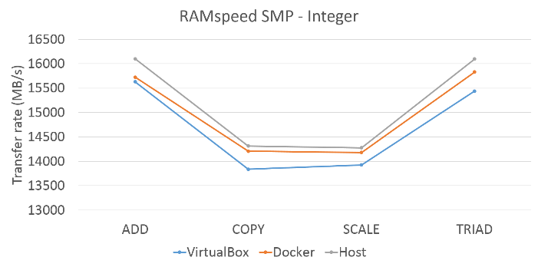 | 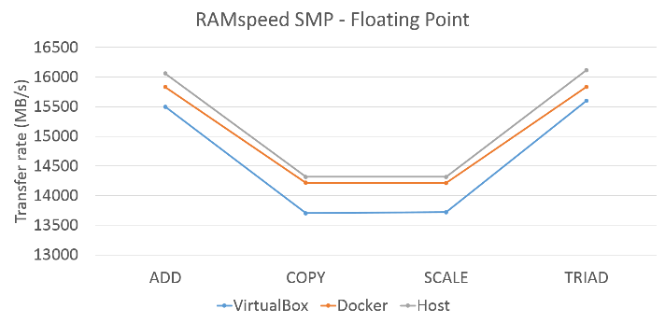
(a) | (b)
Figure 2 Memory performance result: (a) Integer; and (b) Floating point
Discussion text - Discussion text - Discussion text - Discussion text - Discussion text - Discussion text - Discussion text - Discussion text - Discussion text - Discussion text - Discussion text - Discussion text - Discussion text - Discussion text – (Chung et al., 2016).
3.1.2. Storage performance result
Result text -Result text - Result text - Result text - Result text – (Figure 3). Result text -Result text - Result text - Result text - Result text - Result text -Result text - Result text - Result text - Result text - Result text -Result text - Result text - Result text - Result text - Result text -Result text - Result text - Result text - Result text - Result text -Result text - Result text - Result text - Result text - in Figure 1. Result text -Result text - Result text - Result text - Result text - Result text -Result text - Result text - Result text - Result text - Result text -Result text - Result text - Result text - Result text - Result text -Result text - Result text - Result text - Result text -.
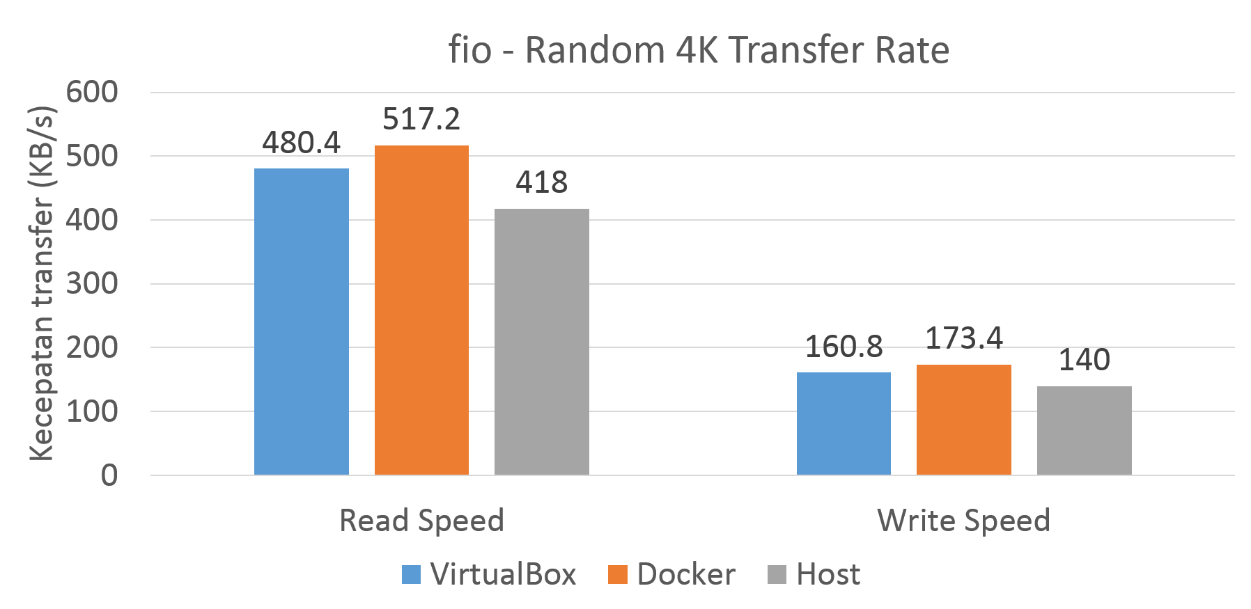 | 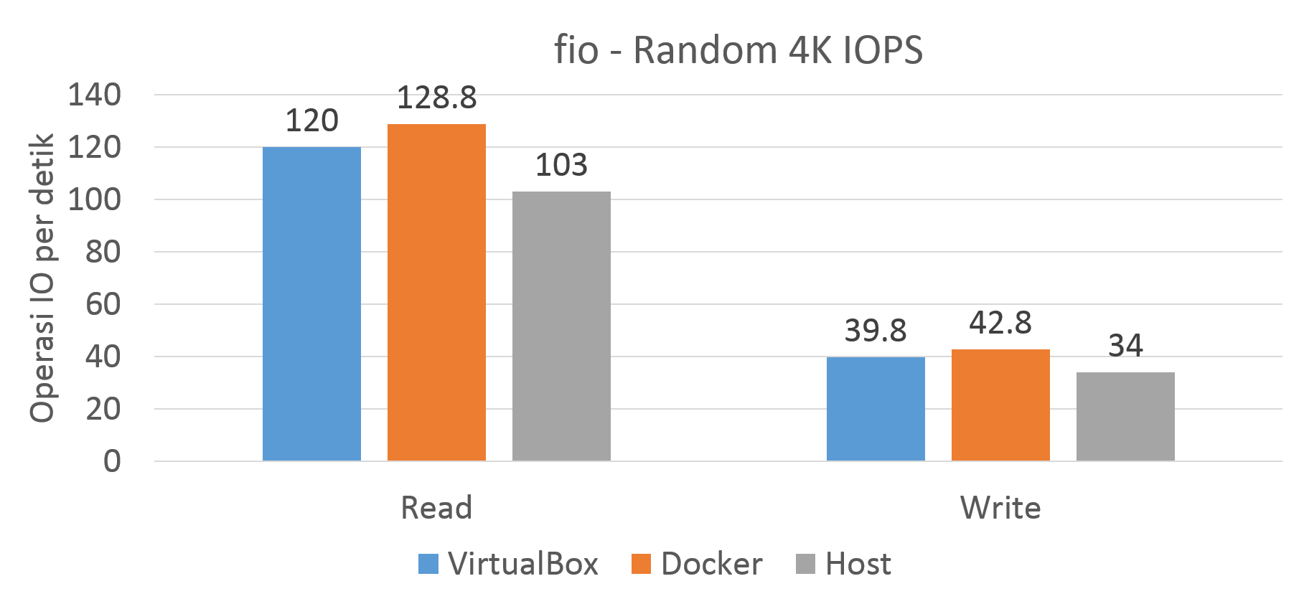
(a) | (b)
Figure 3 Storage performance result
Discussion text - Discussion text - Discussion text - Discussion text - Discussion text - Discussion text - Discussion text - Discussion text - Discussion text - Discussion text - Discussion text - Discussion text - Discussion text - Discussion text – (Chung et al., 2016).
3.2. Molecular Dynamics Results
Discussion text - Discussion text - Discussion text - Discussion text - Discussion text - Discussion text - Discussion text - Discussion text - Discussion text - Discussion text - Discussion text - Discussion text - Discussion text - Discussion text.

4. Conclusions
The main conclusion of the study may be presented in a short Conclusions section, which may stand-alone. It should not repeat the Results, instead provide significant findings and contribution of the study.
Conclusion text - Conclusion text - Conclusion text - Conclusion text - Conclusion text - Conclusion text - Conclusion text - Conclusion text - Conclusion text - Conclusion text - Conclusion text - Conclusion text - Conclusion text - Conclusion text.

Acknowledgements
Provide acknowledgements accordingly. List here those individuals or institutions who gaves help, assistance during the research (e.g., providing grants, laboratory facility, writing assistance or proof reading the article, etc.). In case of the grants, please provide the number and year of the grant received.

References
Listed in alphabetical order (A-Z) of author’s last name, year. Title of the Article. Journal’s Title, Volume(issue), pp. page-page
Aparna, K., Nair, M.K., 2016. Incorporating Stability and Error-based Constraints for A novel Partitional Clustering Algorithm. International Journal of Technology, Volume 4, pp. 691–700
Berawi, M.A., 2004. Quality Revolution: Leading the Innovation and Competitive Advantages. International Journal of Quality & Reliability Management, Volume 21(4), pp. 425–438
Bruker, 2005. APEX2, SAINT and SADABS. Bruker AXS Inc., Madison, Wisconsin, USA
Chung, M.T., Quang-Hung, N., Nguyen, M.T., Thoai, N., 2016. Using Docker in High Performance Computing Applications. In: IEEE Sixth International Conference on Communications and Electronics (ICCE), pp. 52–57
Gang-Ji, Z., 2008. Hydrodinamics and Water Quality, Modeling Rivers, Lakes, and Estuaries. Wiley-Interscience, John Wiley & Sons, Inc., Hoboken, New Jersey, USA
Gromacs Manual 4.5.4., 2011. What and Why Gromacs? Available Online at: ftp://ftp.gromacs.org/pub/manual/manual-4.5.4.pdf, Accessed on December 22, 2016
Kusrini, E., Saleh, M.I., 2009. Luminescence and Structural Studies of Yttrium and Heavier Lanthanide-picrate Complexes with Pentaethylene Glycol. Inorganic Chimica Acta, Volume 362, pp. 4025–4030
Mamat, M., Kusrini, E., Yahaya, A., Hussein, M.Z., Zainal, Z., 2009. Synthesis and Characterization of Zn-Al-Anthranilate Nanocomposites. In: Proceedings of the 25th Regional Conference on Solid State Science and Technology 2009, Perlis, 2 December, Malaysia
Mettam, G.R., Adams, L.B., 1994. Introduction to the Electronic Age. In: Jones, B.S., Smith, R.Z. (Eds.), E-Publishing, Inc. New York, pp. 281–304
Rester, U., 2008. From Virtuality to Reality—Virtual Screening in Lead Discovery and Lead Optimization: A Medicinal Chemistry Perspective. Current Opinion in Drug Discovery & Development, Volume 11(4), pp. 559–568
Stillinger, F.H., Rahman, A., 1974. Improved Simulation of Liquid Water by Molecular Dynamics. The Journal of Chemical Physics, Volume 60(4), pp. 1545–1557

• Maximum of the paper length: 10 pages (or about 4,000 to 6,000 words)

Corresponding author’s email: name@ai.ue.oa, Tel.: +00-00-000000; Fax: +00-00-000000 doi: 10.14716/ijtech.v0i0.0000

