Cost-Effective 28 GHz Class-AB Power Amplifier Implementation in 180-nm CMOS Technology for Next-Generation 5G Industrial Internet of Things Applications
This document contains supplementary figures and tables supporting the main manuscript, adhering to the 8-item limit in the primary text.

Table S1: Detailed Comparison with prior 180-nm Work
Parameters | Hasan et al. (2019) | Hasan et al. (2020) | This Work | Status
Topology | Cascade | Cascade | Two-stage Class-AB | Different
Matching network | L-section | L-section | T-type | First T-type at 28 GHz / 180-nm
RBB voltage (V) | −0.05 | −0.6 | −0.8 (optimized) | Systematic sweep
Psat (dBm) | 14.2 | 15.1 | 13.43 | −1.7 dB
PAE (%) | 15.3 | 16.8 | 19.35 | +15–26%
Gain (dB) | 16.5 | 17.2 | 10.26 | −6.24 to −6.94 dB
BW (GHz) | N/R | N/R | 4 (26–30 GHz) | New data
ACLR (dBc) | N/R | N/R | −27 | 5G NR compliant
EVM (%) | N/R | N/R | 6.5 | 5G NR compliant

Table S2: Cost-Benefit Analysis for 100,000-Node Deployment
Parameters | 180-nm (This Work) | 65-nm | 40-nm
Die cost per PA ($) | 0.07 | 0.18 | 0.29
PCB area (mm²) | 25 | 20 | 18
Total PA cost per node ($) | 1.87 | 2.91 | 3.99
Total PA cost — 100k nodes | $187,000 | $291,000 | $399,000
Cost savings vs. 65-nm | $104,000 | — | —
Average DC power (mW) | 142 | 95 | 82
10-year energy cost — 100k nodes | $620,000 | $410,000 | $360,000
Total 10-year TCO | $807,000 | $701,000 | $759,000

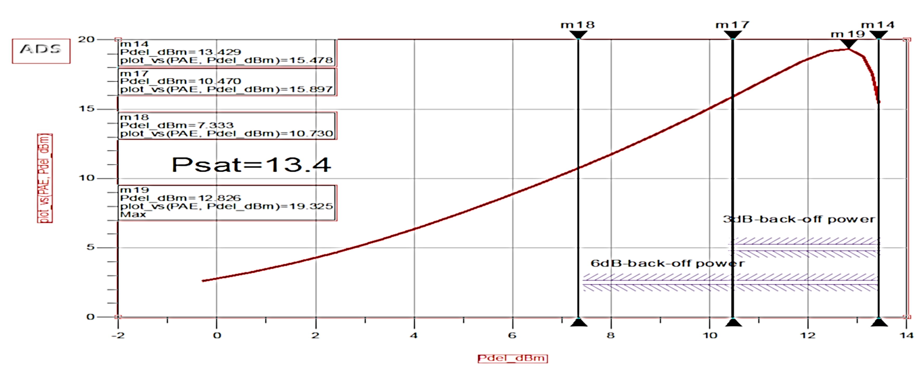
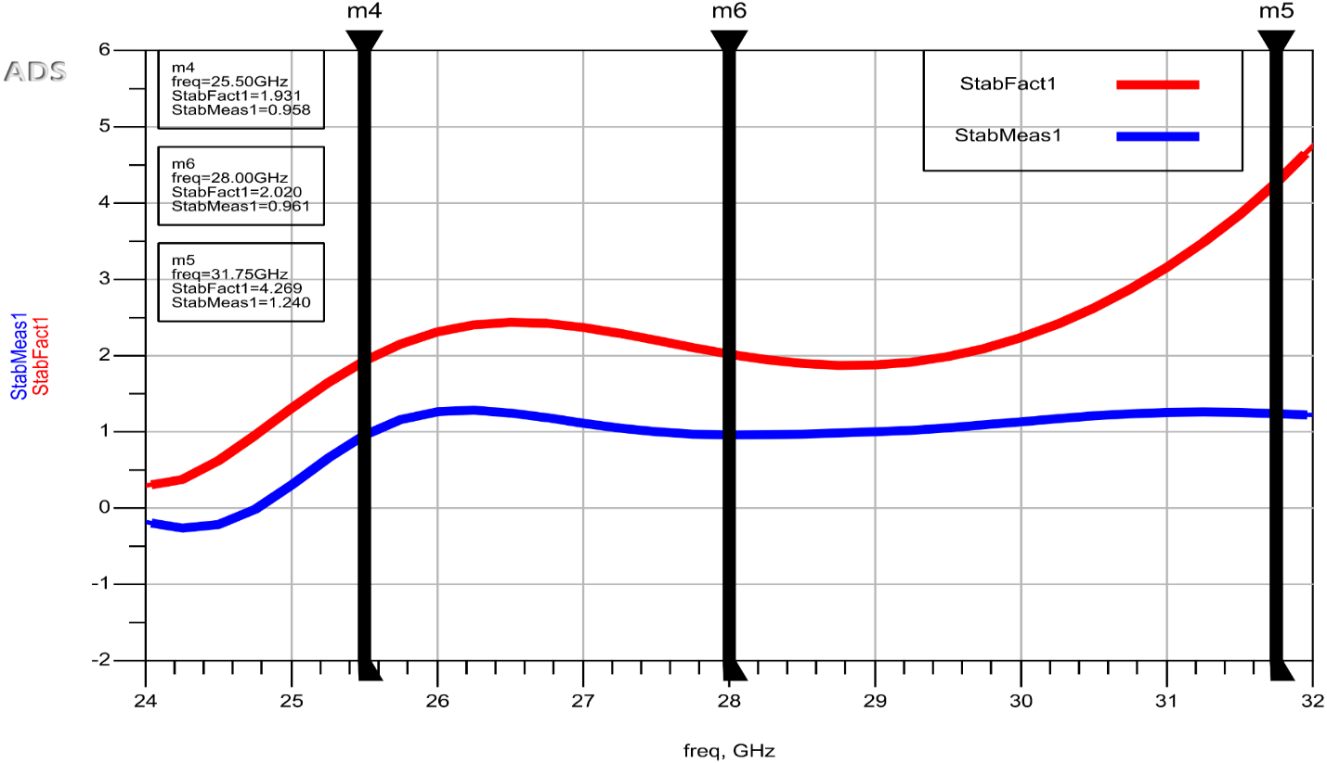
Figure S1: Stability analysis of the Class-AB power amplifier (K > 1.3, µ > 1.2).
Figure S2: Back-off efficiency characteristics showing graceful efficiency roll-off.

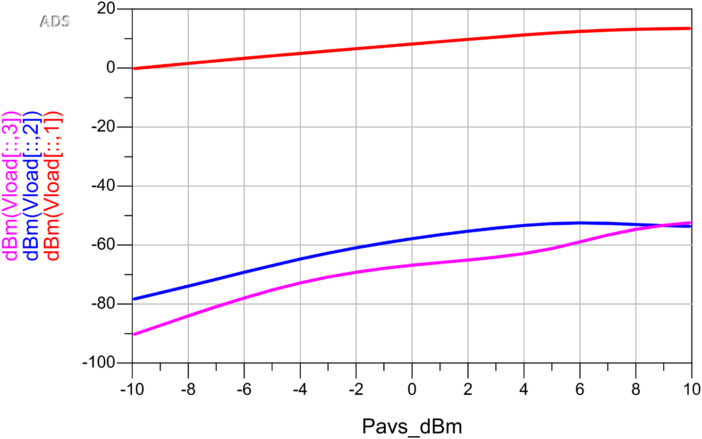
Figure S3: Harmonics balance analysis showing second and third harmonic suppression.
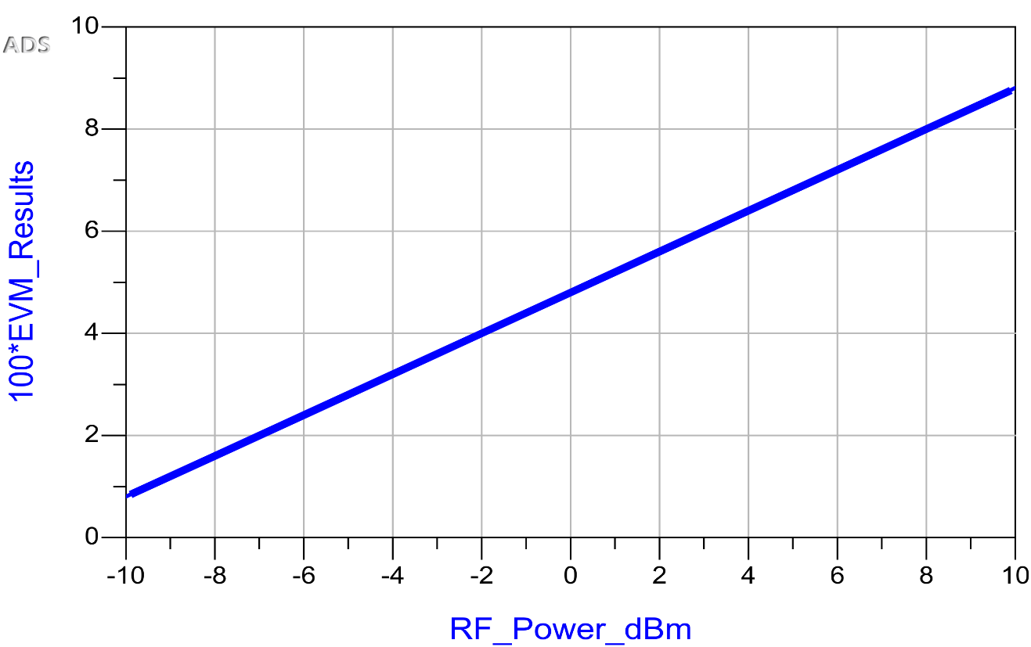
Figure S4: Error Vector Magnitude (EVM) analysis for 64-QAM modulation.
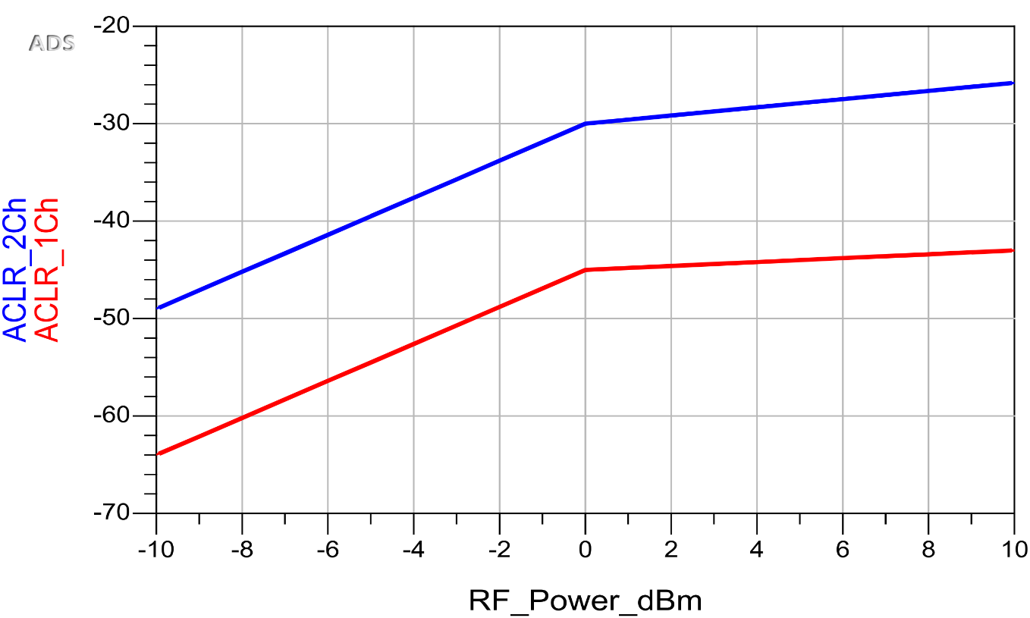
Figure S5: Adjacent Channel Leakage Ratio (ACLR) analysis demonstrating compliance with 5G NR standards.

