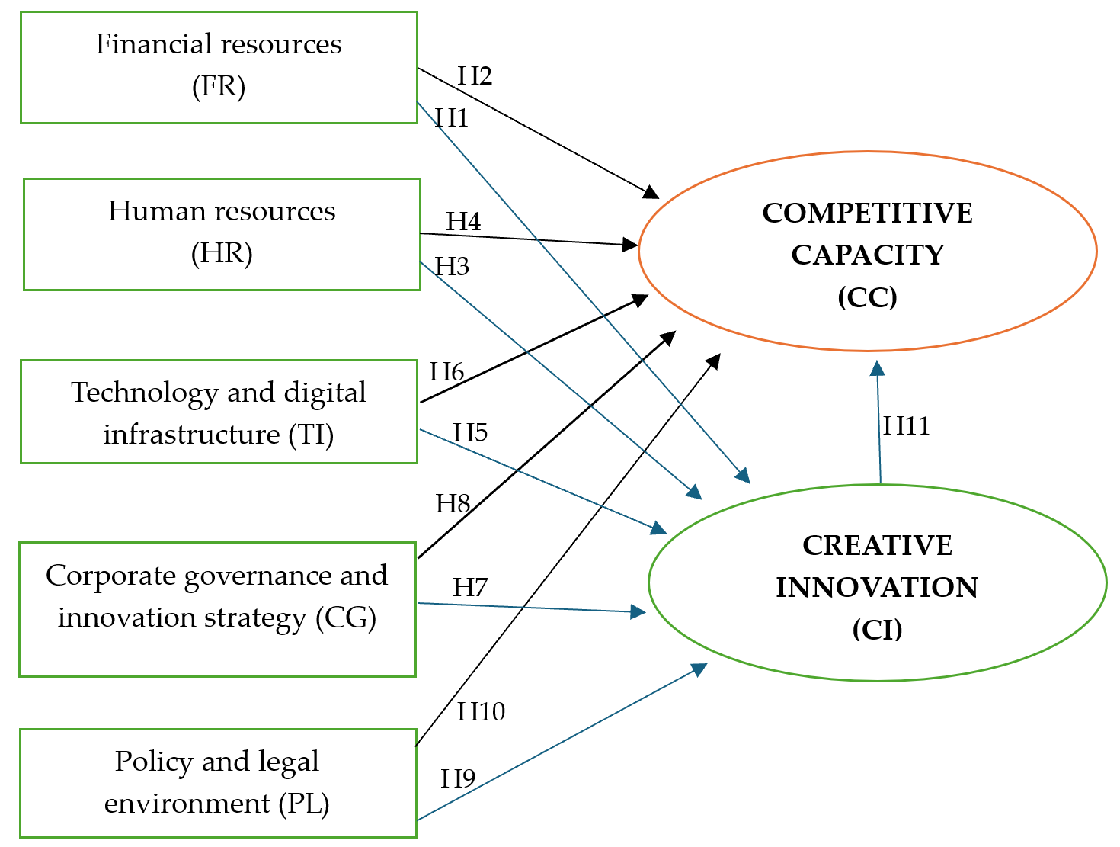

**Figure 1** The model for critical factors affecting creative innovation and competitive capacity