Supplementary File

Table S1 Cost-Emission Coefficients and Operational Constraints.
Gen-$i$ | $$a_{i}$$  (Rp) | $$b_{i}$$  (Rp/MW) | $$c_{i}$$  (Rp/MW2) | $$d_{i}$$  (Ton) | $$e_{i}$$  (Ton/MW) | $$f_{i}$$  (Ton/MW2) | $$P_{i,min}$$  (MW) | $$P_{i,max}$$  (MW) | Ramp Rate  (MW/h)
$$P_{1}$$ | 57,543,208.00 | 3,332,794.00 | -400 | 34,251,909.80 | 1,983,806.20 | -236.7 | 1,610.00 | 4,200.00 | 300
$$P_{2}$$ | 519,353,767.10 | 3,047,098.00 | 691 | 72,202,664.70 | 423.6 | 96.2 | 934 | 2,308.00 | 510
$$P_{3}$$ | 0 | 400 | 0 | 0 | 0 | 0 | 404 | 1008 | 930
$$P_{4}$$ | 0 | 660 | 0 | 0 | 0 | 0 | 208 | 700 | 660
$$P_{5}$$ | 133,177,025.60 | 2,828,349.00 | -80 | 93,654,729.70 | 1,988,993.90 | -56.90 | 848.00 | 2,400.00 | 337.00
$$P_{6}$$ | 180,205,527.90 | 2,104,640.00 | 218 | 123,428,443.80 | 1,441,534.90 | 149.5 | 1,080.00 | 4,714.00 | 420
$$P_{7}$$ | 140,621,312.50 | 2,545,832.00 | 203 | 140,621,312.50 | 2,545,832.50 | 62.1 | 360 | 900 | 240
$$P_{8}$$ | 112,522,922.10 | 5,877,235.00 | -73 | 24,146,549.80 | 1,261,209.30 | -15.8 | 305 | 1,610.00 | 420

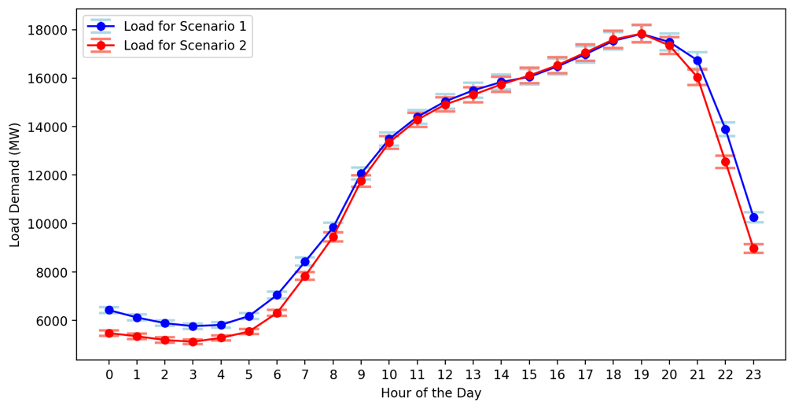
Figure S1 Daily load demand patterns for system testing.

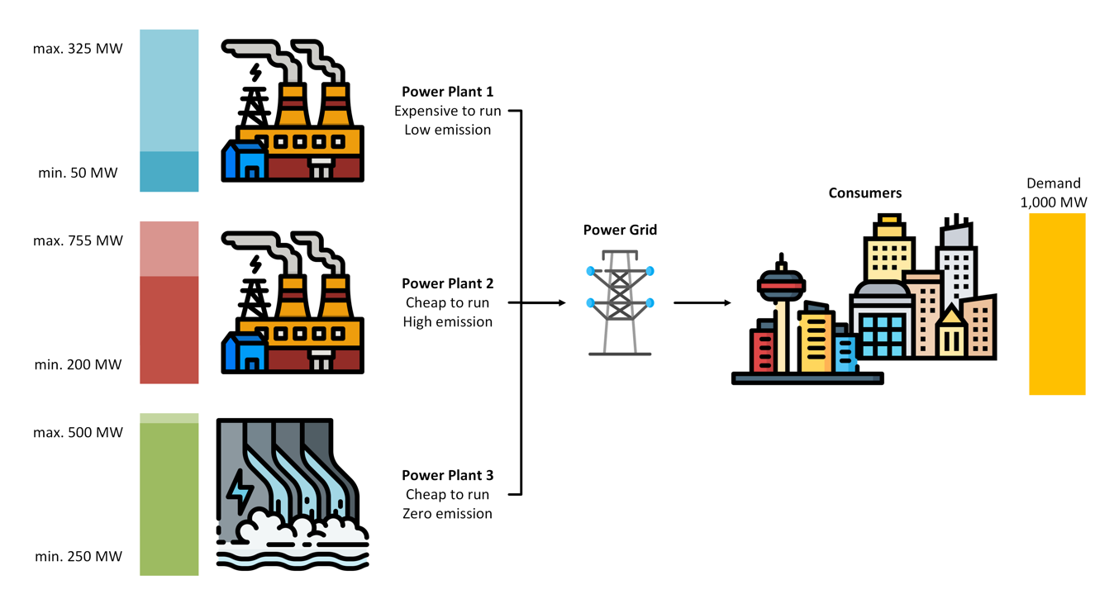
Figure S2 Economic and Emission Dispatch Illustration

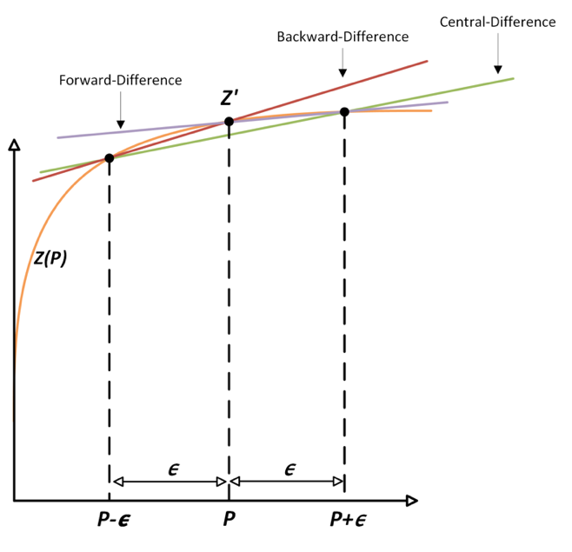
Figure 3 Central Finite Difference Method for gradient approximation during the local search phase.

Algorithm S1 GRASP-BLS
1: procedure GRASP_BLS (data, demand, parameters)
2: define GRASP(func, bounds, parameters):
3: Initialize best_solution ← ∅, best_value ← ∞
4: for iteration in 1 to parameters.max_iterations do
5: // Constructive Phase
6: P ← ∅
7: for i in 1 to |bounds| do
8: candidates ← generate_candidates(bounds[i])
9: P[i] ← select_candidate(candidates, func)
10: end for
11:
12: // Local Search Phase
13: repeat:
14: grad ← compute_gradient(func, P)
15: P_new ← Backtracking_Line_Search(P, grad, func, parameters.α, parameters.β)
16: if |P_new - P| < parameters.tolerance then
17: break
18: end if
19: P ← P_new
20: until convergence
21:
22: if func(P) < best_value then
23: best_solution ← P, best_value ← func(P)
24: end if
25: end for
26: return best_solution
27:
28: define Backtracking_Line_Search(P, grad, func, α, β):
29: step ← 1.0
30: repeat until step ≤ parameters.tolerance:
31: P_new ← P - step × grad
32: if func(P_new) < func(P) - α × step × grad ⋅ grad then
33: return P_new
34: end if
35: step ← step × β
36: end repeat
37: return P
38: end procedure

Table S2 Parameter tuning configurations for all optimization methods.
Method | Parameter | Value
GRASP-BLS | Construction ($α_{1}$) | 0.3
GRASP-BLS | Step size reduction factor ($β$) | 0.8
GRASP-BLS | Sufficient decrease ($η$) | 1.0
GRASP-BLS | Tolerance (${tol}_{1}$) | $${10}^{-6}$$
GRASP-BLS | Iterations ($t_{1}$) | 100
GSA | Number of agents ($n_{1}$) | 30
GSA | Iterations ($t_{2}$) | 100
GSA | Gravitational decay ($α_{2}$) | 20
GSA | Gravitational constant ($G_{0}$) | 100
GSA | Tolerance (${tol}_{2}$) | $${10}^{-3}$$
GWO | Number of wolves ($n_{2}$) | 30
GWO | Iterations ($t_{3}$) | 100
GWO | Tolerance (${tol}_{3}$) | $${10}^{-6}$$
PSO | Number of particles ($n_{3}$) | 30
PSO | Tolerance (${tol}_{4}$) | $${10}^{-6}$$
PSO | Inertia weight ($w$) | 0.5
PSO | Acceleration coefficients ($c_{1}$, $c_{2}$) | 2

Table S3 Comparison of GRASP-BLS and Simulated Annealing results for 4-hour load demand.
a. GRASP-BLS
Time | $$P_{D}$$  (MW) | $P_{i}$ (MW) |  |  |  |  |  |  |  | $$\sum{P_{i}}$$  (MW) | C  (US$) | E  (tCO₂e)
Time | $$P_{D}$$  (MW) | $$P_{1}$$ | $$P_{2}$$ | $$P_{3}$$ | $$P_{4}$$ | $$P_{5}$$ | $$P_{6}$$ | $$P_{7}$$ | $$P_{8}$$ | $$\sum{P_{i}}$$  (MW) | C  (US$) | E  (tCO₂e)
18:00 | 13,096 | 4,090.556 | 2,184.611 | 861.9499 | 590.556 | 2,227.82 | 2,475.508 | 360 | 305 | 13,096 | 2,309,153 | 15,043
19:00 | 13,108 | 4,084.331 | 2,192.236 | 880.1277 | 569.4206 | 2,284.31 | 2432.578 | 360 | 305 | 13,108 | 2,312,559 | 15,051
20:00 | 12,863 | 4,046.034 | 2,206.29 | 906.3587 | 598.3587 | 2,251.30 | 2,189.658 | 360 | 305 | 12,863 | 2,260,078 | 14,479
21:00 | 12,228 | 3,984.536 | 2,143.15 | 871.0137 | 503.3773 | 2,200.28 | 1,860.648 | 360 | 305 | 12,228 | 2,155,890 | 13,686
Average |  |  |  |  |  |  |  |  |  |  | 2,259,420 | 14,565
Computation Time (s) |  |  |  |  |  |  |  |  |  |  | 3.69
 |  | b. SA
18:00 | 13,096 | 3,109 | 934 | 1,008 | 700 | 2,030 | 3,823 | 900 | 592 | 13,096 | 2,338,676 | 19,034
19:00 | 13,108 | 3,099 | 934 | 1,008 | 700 | 2,031 | 3,843 | 900 | 593 | 13,108 | 2,343,912 | 19,084
20:00 | 12,863 | 3,099 | 801 | 998 | 700 | 2,013 | 3,812 | 898 | 542 | 12,863 | 2,272,440 | 18,881
21:00 | 12,228 | 3,025 | 589 | 998 | 700 | 2,013 | 3,465 | 898 | 540 | 12,228 | 2,118,992 | 17,933
Average |  |  |  |  |  |  |  |  |  |  | 2,268,505 | 18,733
Computation Time (s) |  |  |  |  |  |  |  |  |  |  | <60

 | Table S4 Ramp rate changes from 18:00 to 21:00.
Gen-$i$ |  | 18:00 to 19:00 | 19:00 to 20:00 | 20:00 to 21:00 | Ramp Rate (MW/h)
$$P_{1}$$ |  | -6.22492 | -38.2964 | -61.498 | 300
$$P_{2}$$ |  | 7.625041 | 14.0539 | -63.1393 | 510
$$P_{3}$$ |  | 18.17777 | 26.23095 | -35.345 | 930
$$P_{4}$$ |  | -21.1354 | 28.93802 | -94.9814 | 660
$$P_{5}$$ |  | 56.48785 | -33.0065 | -51.0265 | 337
$$P_{6}$$ |  | -42.9304 | -242.92 | -329.01 | 420
$$P_{7}$$ |  | 0 | 0 | 0 | 240
$$P_{8}$$ |  | 0 | 0 | 0 | 420

Table S5 GRASP-BLS Scheduling in Scenario 1.
Time | $$P_{D}$$  (MW) | $P_{i}$ (MW) |  |  |  |  |  |  |  | $$\sum{P_{i}}$$  (MW) | C  (US$) | E  (tCO₂e)
Time | $$P_{D}$$  (MW) | $$P_{1}$$ | $$P_{2}$$ | $$P_{3}$$ | $$P_{4}$$ | $$P_{5}$$ | $$P_{6}$$ | $$P_{7}$$ | $$P_{8}$$ | $$\sum{P_{i}}$$  (MW) | C  (US$) | E  (tCO₂e)
00:00 | 6,433 | 2,294 | 934 | 404 | 208 | 848 | 1,080 | 360 | 305 | 6,433 | 1,232,464 | 8,562
01:00 | 6,128 | 1,989 | 934 | 404 | 208 | 848 | 1,080 | 360 | 305 | 6,128 | 1,198,152 | 8,267
02:00 | 5,893 | 1,754 | 934 | 404 | 208 | 848 | 1,080 | 360 | 305 | 5,893 | 1,168,243 | 8,009
03:00 | 5,770 | 1,631 | 934 | 404 | 208 | 848 | 1,080 | 360 | 305 | 5,770 | 1,151,213 | 7,863
04:00 | 5,824 | 1,685 | 934 | 404 | 208 | 848 | 1,080 | 360 | 305 | 5,824 | 1,158,787 | 7,928
05:00 | 6,187 | 2,048 | 934 | 404 | 208 | 848 | 1,080 | 360 | 305 | 6,187 | 1,205,258 | 8,328
06:00 | 7,054 | 2,865 | 984 | 404 | 208 | 848 | 1,080 | 360 | 305 | 7,054 | 1,298,053 | 9,008
07:00 | 8,430 | 3,532 | 1,692 | 404 | 208 | 848 | 1,080 | 360 | 305 | 8,430 | 1,575,118 | 9,503
08:00 | 9,838 | 3,817 | 1,840 | 645 | 343 | 1,400 | 1,127 | 360 | 305 | 9,838 | 1,749,328 | 10,734
09:00 | 12,064 | 4,082 | 2,216 | 904 | 608 | 2,198 | 1,392 | 360 | 305 | 12,064 | 2,095,062 | 12,816
10:00 | 13,487 | 4,091 | 2,143 | 880 | 591 | 2,275 | 2,843 | 360 | 305 | 13,487 | 2,383,022 | 15,929
11:00 | 14,398 | 4,094 | 2,161 | 878 | 594 | 2,279 | 3,727 | 360 | 305 | 14,398 | 2,608,628 | 18,087
12:00 | 15,038 | 4,087 | 2,181 | 877 | 587 | 2,224 | 4,417 | 360 | 305 | 15,038 | 2,793,924 | 19,836
13:00 | 15,494 | 4,120 | 2,171 | 942 | 641 | 2,346 | 4,109 | 808 | 357 | 15,494 | 2,833,342 | 20,445
14:00 | 15,837 | 4,147 | 2,227 | 948 | 642 | 2,299 | 4,660 | 557 | 357 | 15,837 | 2,953,922 | 21,247
15:00 | 16,049 | 4,174 | 2,280 | 1,002 | 685 | 2,353 | 4,237 | 867 | 450 | 16,049 | 2,965,680 | 21,122
16:00 | 16,480 | 4,148 | 2,294 | 1,008 | 690 | 2,369 | 4,677 | 884 | 410 | 16,480 | 3,085,477 | 22,370
17:00 | 16,981 | 4,174 | 2,308 | 990 | 685 | 2,353 | 4,567 | 900 | 1,004 | 16,981 | 3,298,854 | 22,818
18:00 | 17,537 | 4,200 | 2,308 | 971 | 700 | 2,400 | 4,641 | 878 | 1,439 | 17,537 | 3,495,649 | 23,579
19:00 | 17,822 | 4,200 | 2,308 | 1,008 | 700 | 2,400 | 4,696 | 900 | 1,610 | 17,822 | 3,583,462 | 24,003
20:00 | 17,489 | 4,200 | 2,266 | 971 | 690 | 2,353 | 4,604 | 900 | 1,505 | 17,489 | 3,489,512 | 23,514
21:00 | 16,733 | 4,200 | 2,308 | 1,008 | 690 | 2,400 | 4,714 | 884 | 529 | 16,733 | 3,155,351 | 22,683
22:00 | 13,892 | 4,066 | 2,172 | 876 | 537 | 2,292 | 3,285 | 360 | 305 | 13,892 | 2,503,774 | 17,011
23:00 | 10,264 | 3,717 | 1,956 | 656 | 313 | 1,876 | 1,080 | 360 | 305 | 10,264 | 1,869,199 | 11,530
Average |  |  |  |  |  |  |  |  |  |  | 2,285,478 | 15,633
Computation Time (s) |  |  |  |  |  |  |  |  |  |  | 21.94673

Table S6 Comparison results for Scenario 1.
Time | $$P_{D}$$  (MW) | GRASP-BLS* |  | GSA |  | GWO |  | PSO
Time | $$P_{D}$$  (MW) | C  (US$) | E  (tCO₂e) | C  (US$) | E  (tCO₂e) | C  (US$) | E  (tCO₂e) | C  (US$) | E  (tCO₂e)
00:00 | 6,433 | 1,232,464 | 8,562 | 1,232,729 | 8,565 | 1,277,751 | 9,114 | 1,372,206 | 8,722
01:00 | 6,128 | 1,198,152 | 8,267 | 1,204,489 | 8,346 | 1,205,891 | 8,229 | 1,271,466 | 8,322
02:00 | 5,893 | 1,168,243 | 8,009 | 1,174,466 | 8,096 | 1,168,765 | 8,016 | 1,168,766 | 8,082
03:00 | 5,770 | 1,151,213 | 7,863 | 1,151,213 | 7,863 | 1,151,213 | 7,863 | 1,151,991 | 7,874
04:00 | 5,824 | 1,158,787 | 7,928 | 1,161,792 | 7,971 | 1,162,285 | 7,979 | 1,171,153 | 7,852
05:00 | 6,187 | 1,205,258 | 8,328 | 1,240,955 | 8,547 | 1,203,036 | 8,377 | 1,325,040 | 8,383
06:00 | 7,054 | 1,298,053 | 9,008 | 1,419,624 | 9,650 | 1,286,457 | 9,029 | 1,565,672 | 9,991
07:00 | 8,430 | 1,575,118 | 9,503 | 1,748,450 | 11,185 | 1,590,560 | 10,638 | 1,573,805 | 10,729
08:00 | 9,838 | 1,749,328 | 10,734 | 1,883,873 | 13,144 | 1,885,643 | 12,913 | 1,993,181 | 14,581
09:00 | 12,064 | 2,095,062 | 12,816 | 2,470,060 | 15,931 | 2,373,824 | 18,450 | 2,543,426 | 16,526
10:00 | 13,487 | 2,383,022 | 15,929 | 2,650,891 | 18,026 | 2,630,736 | 17,703 | 2,437,169 | 17,978
11:00 | 14,398 | 2,608,628 | 18,087 | 2,875,154 | 18,535 | 2,797,852 | 19,603 | 2,720,411 | 21,669
12:00 | 15,038 | 2,793,924 | 19,836 | 3,133,133 | 20,282 | 2,962,644 | 19,190 | 2,872,555 | 20,998
13:00 | 15,494 | 2,833,342 | 20,445 | 3,137,844 | 20,527 | 3,055,462 | 18,801 | 2,956,444 | 22,025
14:00 | 15,837 | 2,953,922 | 21,247 | 3,133,806 | 21,644 | 3,106,171 | 19,632 | 3,202,696 | 22,768
15:00 | 16,049 | 2,965,680 | 21,122 | 3,196,645 | 21,665 | 3,032,204 | 20,630 | 3,326,008 | 22,012
16:00 | 16,480 | 3,085,477 | 22,370 | 3,360,776 | 22,411 | 3,352,165 | 21,726 | 3,320,917 | 23,071
17:00 | 16,981 | 3,298,854 | 22,818 | 3,353,828 | 22,201 | 3,351,371 | 21,715 | 3,300,508 | 22,478
18:00 | 17,537 | 3,495,649 | 23,579 | 3,536,522 | 23,567 | 3,502,287 | 23,202 | 3,553,357 | 23,944
19:00 | 17,822 | 3,583,462 | 24,003 | 3,588,572 | 24,053 | 3,583,462 | 24,003 | 3,585,555 | 24,023
20:00 | 17,489 | 3,489,512 | 23,514 | 3,536,788 | 23,720 | 3,450,369 | 23,626 | 3,528,271 | 23,444
21:00 | 16,733 | 3,155,351 | 22,683 | 3,300,050 | 22,334 | 3,357,255 | 21,854 | 3,364,313 | 22,675
22:00 | 13,892 | 2,503,774 | 17,011 | 2,638,733 | 18,806 | 2,388,233 | 17,026 | 2,608,306 | 19,596
23:00 | 10,264 | 1,869,199 | 11,530 | 1,999,631 | 13,436 | 2,127,073 | 14,330 | 1,694,563 | 12,914
Average |  | 2,285,478 | 15,633 | 2,422,084 | 16,271 | 2,375,113 | 15,985 | 2,400,324 | 16,694
Comp. Time (s) |  | 21.95 |  | 8.15 |  | 2.89 |  | 0.02
Δ* |  |  |  | -136,606 | -638 | -89,635 | -352 | -114,846 | -1,061
Δ%* |  |  |  | -5.64 | -3.92 | -3.77 | -2.20 | -4.78 | -6.36

Table S7 GRASP-BLS Scheduling in Scenario 2.
Time | $$P_{D}$$  (MW) | $P_{i}$ (MW) |  |  |  |  |  |  |  | $$\sum{P_{i}}$$  (MW) | C  (US$) | E  (tCO₂e)
Time | $$P_{D}$$  (MW) | $$P_{1}$$ | $$P_{2}$$ | $$P_{3}$$ | $$P_{4}$$ | $$P_{5}$$ | $$P_{6}$$ | $$P_{7}$$ | $$P_{8}$$ | $$\sum{P_{i}}$$  (MW) | C  (US$) | E  (tCO₂e)
00:00 | 5,486 | 4,121 | 1,364 | 0 | 0 | 0 | 0 | 0 | 0 | 5,486 | 940,405 | 4,823
01:00 | 5,352 | 4,043 | 1,309 | 0 | 0 | 0 | 0 | 0 | 0 | 5,352 | 921,221 | 4,805
02:00 | 5,200 | 4,017 | 1,184 | 0 | 0 | 0 | 0 | 0 | 0 | 5,200 | 879,485 | 4,773
03:00 | 5,125 | 4,121 | 1,003 | 0 | 0 | 0 | 0 | 0 | 0 | 5,125 | 822,922 | 4,741
04:00 | 5,288 | 4,174 | 1,114 | 0 | 0 | 0 | 0 | 0 | 0 | 5,288 | 857,701 | 4,765
05:00 | 5,548 | 4,199 | 1,349 | 0 | 0 | 0 | 0 | 0 | 0 | 5,548 | 935,338 | 4,821
06:00 | 6,314 | 2,175 | 934 | 404 | 208 | 848 | 1,080 | 360 | 305 | 6,314 | 1,219,755 | 8,453
07:00 | 7,837 | 3,184 | 1,449 | 404 | 208 | 848 | 1,080 | 360 | 305 | 7,837 | 1,471,013 | 9,292
08:00 | 9,457 | 3,791 | 1,909 | 645 | 328 | 1,039 | 1,080 | 360 | 305 | 9,457 | 1,701,375 | 10,003
09:00 | 11,763 | 4,084 | 2,178 | 886 | 584 | 2,284 | 1,080 | 360 | 305 | 11,763 | 2,036,813 | 12,385
10:00 | 13,346 | 4,104 | 2,143 | 906 | 599 | 2,257 | 2,672 | 360 | 305 | 13,346 | 2,340,721 | 15,513
11:00 | 14,279 | 4,070 | 2,176 | 886 | 566 | 2,296 | 3,619 | 360 | 305 | 14,279 | 2,590,233 | 17,848
12:00 | 14,913 | 4,071 | 2,206 | 863 | 598 | 2,266 | 4,244 | 360 | 305 | 14,913 | 2,763,465 | 19,445
13:00 | 15,313 | 4,111 | 2,205 | 901 | 611 | 2,232 | 4,588 | 360 | 305 | 15,313 | 2,853,847 | 20,338
14:00 | 15,740 | 4,157 | 2,223 | 928 | 632 | 2,357 | 4,634 | 502 | 305 | 15,740 | 2,923,205 | 21,062
15:00 | 16,104 | 4,200 | 2,169 | 1,002 | 675 | 2,369 | 4,310 | 889 | 490 | 16,104 | 2,961,732 | 21,408
16:00 | 16,528 | 4,200 | 2,280 | 996 | 695 | 2,322 | 4,604 | 889 | 542 | 16,528 | 3,104,746 | 22,254
17:00 | 17,053 | 4,174 | 2,294 | 984 | 695 | 2,384 | 4,677 | 895 | 951 | 17,053 | 3,307,440 | 23,096
18:00 | 17,594 | 4,148 | 2,280 | 1,002 | 695 | 2,400 | 4,677 | 900 | 1,491 | 17,594 | 3,519,484 | 23,792
19:00 | 17,833 | 4,193 | 2,308 | 1,008 | 700 | 2,400 | 4,714 | 900 | 1,610 | 17,833 | 3,588,560 | 24,053
20:00 | 17,346 | 4,122 | 2,308 | 965 | 690 | 2,400 | 4,567 | 895 | 1,399 | 17,346 | 3,462,413 | 23,366
21:00 | 16,035 | 4,081 | 2,254 | 962 | 660 | 2,297 | 4,637 | 827 | 317 | 16,035 | 2,995,100 | 21,846
22:00 | 12,547 | 4,089 | 2,169 | 873 | 554 | 2,273 | 1,923 | 360 | 305 | 12,547 | 2,192,922 | 13,957
23:00 | 8,975 | 3,663 | 1,875 | 576 | 268 | 848 | 1,080 | 360 | 305 | 8,975 | 1,649,382 | 9,603
Average |  |  |  |  |  |  |  |  |  |  | 2,168,303 | 14,435
Computation Time (s) |  |  |  |  |  |  |  |  |  |  | 19.07990

Table S5 Comparison results for Scenario 2.
Time | $$P_{D}$$  (MW) | GRASP-BLS* |  | GSA |  | GWO |  | PSO
Time | $$P_{D}$$  (MW) | C  (US$) | E  (tCO₂e) | C  (US$) | E  (tCO₂e) | C  (US$) | E  (tCO₂e) | C  (US$) | E  (tCO₂e)
00:00 | 5,486 | 940,405 | 4,823 | 1,134,612 | 4,908 | 1,257,936 | 4,917 | 1,095,445 | 4,898
01:00 | 5,352 | 921,221 | 4,805 | 1,141,684 | 4,864 | 1,271,862 | 4,847 | 1,079,626 | 4,860
02:00 | 5,200 | 879,485 | 4,773 | 1,093,001 | 4,809 | 975,144 | 4,804 | 1,071,411 | 4,810
03:00 | 5,125 | 822,922 | 4,741 | 1,095,226 | 4,777 | 1,234,621 | 4,724 | 1,224,729 | 4,729
04:00 | 5,288 | 857,701 | 4,765 | 1,096,417 | 4,841 | 1,044,102 | 4,837 | 883,515 | 4,780
05:00 | 5,548 | 935,338 | 4,821 | 1,192,009 | 4,938 | 1,283,033 | 4,945 | 1,097,885 | 4,912
06:00 | 6,314 | 1,219,755 | 8,453 | 1,268,965 | 8,833 | 1,219,755 | 8,453 | 1,264,524 | 8,647
07:00 | 7,837 | 1,471,013 | 9,292 | 1,557,714 | 10,833 | 1,579,500 | 9,669 | 1,580,088 | 9,707
08:00 | 9,457 | 1,701,375 | 10,003 | 1,871,426 | 12,045 | 2,071,740 | 11,679 | 1,955,313 | 11,445
09:00 | 11,763 | 2,036,813 | 12,385 | 2,446,137 | 15,758 | 2,425,646 | 14,425 | 2,280,925 | 14,477
10:00 | 13,346 | 2,340,721 | 15,513 | 2,601,107 | 17,353 | 2,798,149 | 16,840 | 2,819,225 | 16,451
11:00 | 14,279 | 2,590,233 | 17,848 | 2,725,359 | 18,477 | 2,992,967 | 19,788 | 3,013,006 | 18,732
12:00 | 14,913 | 2,763,465 | 19,445 | 2,928,600 | 19,293 | 2,935,303 | 17,611 | 2,907,044 | 21,047
13:00 | 15,313 | 2,853,847 | 20,338 | 3,010,513 | 19,963 | 3,221,203 | 20,446 | 3,258,849 | 21,583
14:00 | 15,740 | 2,923,205 | 21,062 | 3,179,570 | 20,351 | 3,100,643 | 19,241 | 3,047,662 | 21,469
15:00 | 16,104 | 2,961,732 | 21,408 | 3,140,076 | 20,437 | 3,456,242 | 22,910 | 2,935,707 | 22,453
16:00 | 16,528 | 3,104,746 | 22,254 | 3,473,564 | 22,942 | 3,519,723 | 23,404 | 3,258,932 | 22,446
17:00 | 17,053 | 3,307,440 | 23,096 | 3,370,748 | 21,906 | 3,370,450 | 21,903 | 3,393,494 | 22,919
18:00 | 17,594 | 3,519,484 | 23,792 | 3,567,827 | 23,847 | 3,518,353 | 23,361 | 3,491,792 | 23,754
19:00 | 17,833 | 3,588,560 | 24,053 | 3,586,408 | 24,032 | 3,586,408 | 24,032 | 3,586,408 | 24,032
20:00 | 17,346 | 3,462,413 | 23,366 | 3,532,619 | 23,487 | 3,449,442 | 22,681 | 3,503,283 | 23,192
21:00 | 16,035 | 2,995,100 | 21,846 | 3,282,906 | 21,211 | 3,184,129 | 20,065 | 3,208,353 | 23,586
22:00 | 12,547 | 2,192,922 | 13,957 | 2,559,492 | 18,154 | 2,477,117 | 15,570 | 2,663,191 | 17,612
23:00 | 8,975 | 1,649,382 | 9,603 | 1,813,134 | 12,023 | 1,746,773 | 11,345 | 1,927,355 | 11,790
Average |  | 2,168,303 | 14,435 | 2,361,213 | 15,003 | 2,405,010 | 14,687 | 2,356,157 | 15,180
Comp. Time (s) |  | 19.08 |  | 7.93 |  | 2.92 |  | 0.03
Δ* |  |  |  | -192,910 | -568 | -236,707 | -252 | -187,854 | -745
Δ%* |  |  |  | -8.17 | -3.79 | -9.84 | -1.72 | -7.97 | -4.91

