*Schematic diagram of a membrane-absorption gas separation module*

The configuration of membrane-assisted gas absorption cell for natural gas sweetening is shown in Fig. 3 and the photos of the cell are given in Fig. 4. In that cell two different types of membranes are used for realization of the separation process: ultrafiltration hollow fiber membrane provided by the Laboratory of Membrane Processes of the Institute of Physical and Organic Chemistry of the National Academy of Sciences of Belarus, and asymmetric hollow fiber gas separation membrane made of polysulfone provided by Airrane Co., Ltd. The total length of the MAGA module is 22 cm. The effective length of the membrane is 15 cm. The total volume of the absorbent in the gap formed by two types of hollow fibers is about 1.8 – 1.9 cm3. The outer diameter of the gas separation fiber is about 450 μm. The inner diameter of the ultrafiltration fiber is about 1 mm with a wall thickness of about 0.28 mm. The total effective area of the gas separation membrane is ~ 27.5 cm2, and the ultrafiltration ~ 147 cm2. Plexiglas made of polymethylmethacrylate was used as a casing for the membrane module, allowing visual control of the process.

An important design solution for the applied MAGA unit is the use of two types of hollow fibers simultaneously. In the ends of the cylindrical casing of the module, using an epoxy resin, fixation and sealing of polymeric ultrafiltration fibers, which is used to ensure contact of two phases (separated gas mixture and liquid absorbent), is implemented. In this unit configuration, the gas separating polysulfone fibers are placed inside the ultrafiltration membrane. The gas separating hollow fibers are used to remove desorbed gases from the absorbent. Gas separating hollow fibers are not fixed and sealed in the end parts of the module casing, as in the case of the ultrafiltration one. They are fixed at the ends of specially made fittings (tees) located at the ends of the cylindrical module casing. That membranes arrangement ensures that there is a gap between the two fibers. At the same time, that approach to fibers fixation allows to prevent leakage of liquid component. The cylindrical containers located on the tees serve for filling with liquid absorbent. These containers themselves are arranged to allow the liquid to flow into the gap between the two types of fibers described above. Through one of the fibers the feed stream is brought into contact with the liquid absorbent, and through the other the absorbed component is removed. Two connections are fixed on the outer surface of the device, one for the input of the feed stream and one for the output of the retentate. The characteristics of the membrane-assisted gas absorption cell in details are given in Table 3.

The separation process is realized as in the following procedure. Through one of the nipples attached to the outer surface of the shell of the MAGA module, a flow of feed gas mixture is introduced, which fills the inner volume of the shell and comes into contact with the liquid absorbent through the ultrafiltration fiber. Then the gases which have been dissolved in the absorbent are moved toward the surface of gas separation membrane under the pressure gradient and passes through the polysulfone hollow fiber to form a flow enriched with highly soluble gases. Gases that are low soluble in the absorbent are removed from the module through a fitting mounted on the opposite side of the housing as the retentate stream. The permeate side of the described module is a flow-through volume. In the laboratory tests it is swept by a helium flow, meanwhile at the gas processing plant heated air may be used to enhance the desorption.

Table S1 – The characteristics of membrane-assisted gas separation cell.

|  |  |  |
| --- | --- | --- |
| Characteristic | Value | |
| Cell diameter | 30 mm | |
| Overall cell length | 240 mm | |
|  | Membrane | |
|  | Ultrafiltration | Gas separation |
| Material | Polysulfone | Polysulfone |
| Overall length | 195 mm | 130 mm |
| Active length | 130 mm | 95 mm |
| Outer diameter | 445 μm | 1 560 μm |
| Inner diameter | 290 μm | 1 000 μm |
| Number of fibers | 20 | 20 |

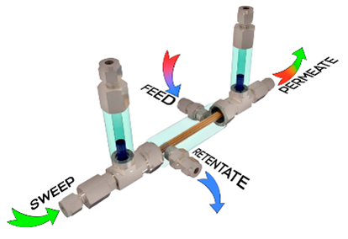

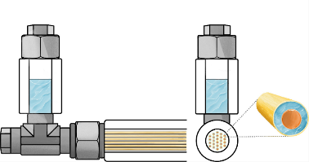

Figure S1 – 3D image of the membrane-assisted gas absorption unit and its schematic diagram

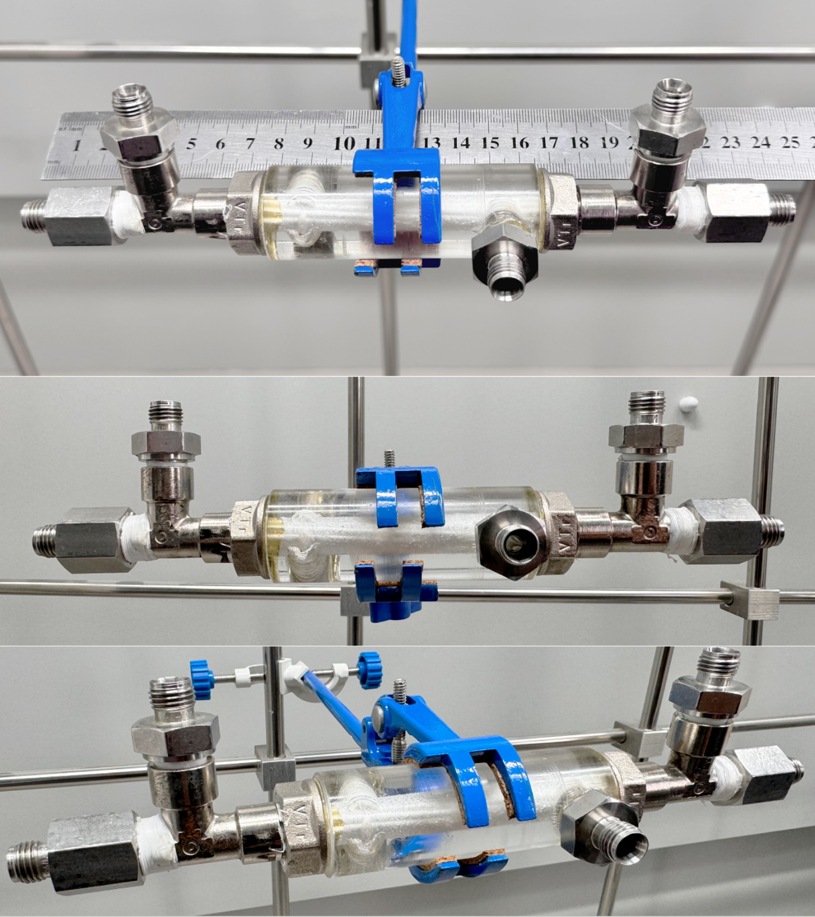

Figure S2 – Photos of membrane-assisted gas absorption cell.

Table S2 - Permeance (Q, GPU) of PSF and PEI+PI-based membranes for single gases

|  |  |  |  |  |  |  |  |  |
| --- | --- | --- | --- | --- | --- | --- | --- | --- |
| Sample | Qa, GPU | | | | | | | |
| N2 | CH4 | Xe | C2H6 | C3H8 | C4H10 | CO2 | H2S |
| PSF | 13.2 | 30 | 6.2 | 22.9 | 18.9 | 17.4 | 220.4 | 244.3 |
| PEI+PI | 1.6 | 2.8 | 0.9 | 2.0 | 2.0 | 2.0 | 30.7 | 13.6 |

@ pressure drop 101 kPa, 25 ℃.

a1 GPU = 1 × 10-6 cm3 cm-2 s-1 cm Hg-1

Table S3 - Selectivity of PSF and PEI+PI-based membranes for single gases

|  |  |  |  |  |  |  |  |
| --- | --- | --- | --- | --- | --- | --- | --- |
| Sample | α (CO2/*x*) | | | | | | |
| CH4 | C2H6 | C3H8 | C4H10 | H2S | N2 | Xe |
| PSF | 7.3 | 9.6 | 11.7 | 12.7 | 0.9 | 16.7 | 35.5 |
| PEI+PI | 11.0 | 15.4 | 15.4 | 15.4 | 19.2 | 34.1 | 2.3 |
|  | α (H2S/*x*) | | | | | | |
| CH4 | C2H6 | C3H8 | C4H10 | CO2 | N2 | Xe |
| PSF | 8.1 | 10.7 | 12.9 | 14.0 | 1.1 | 18.5 | 39.4 |
| PEI+PI | 4.9 | 6.8 | 6.8 | 6.8 | 8.5 | 15.1 | 0.4 |

Table S4 - Permeance (Q, GPU) of PSF and PEI+PI-based membranes for gas mixture components

|  |  |  |  |  |  |  |  |  |
| --- | --- | --- | --- | --- | --- | --- | --- | --- |
| Sample | Qa, GPU | | | | | | | |
| N2 | CH4 | Xe | C2H6 | C3H8 | C4H10 | CO2 | H2S |
| PSF | 18.4 | 37.2 | 9.1 | 27.4 | 22.8 | 19.4 | 296.5 | 314.7 |
| PEI+PI | 4.4 | 4.8 | 3.0 | 3.7 | 3.5 | 2.3 | 33.7 | 24.5 |

@ pressure drop across the membrane 101 kPa, 25 ℃.

a1 GPU = 1 × 10-6 cm3 cm-2 s-1 cm Hg-1

Table S5 - Selectivity of PSF- and PEI+PI-based membranes for gas mixture components.

|  |  |  |  |  |  |  |  |
| --- | --- | --- | --- | --- | --- | --- | --- |
| Sample | α (CO2/*x*) | | | | | | |
| CH4 | C2H6 | C3H8 | C4H10 | H2S | N2 | Xe |
| PSF | 8.0 | 10.8 | 13.0 | 15.3 | 0.9 | 16.1 | 32.6 |
| PEI+PI | 7.0 | 9.1 | 9.6 | 14.7 | 1.4 | 7.7 | 11.2 |
|  | α (H2S/*x*) | | | | | | |
| CH4 | C2H6 | C3H8 | C4H10 | CO2 | N2 | Xe |
| PSF | 8.5 | 11.5 | 13.8 | 16.2 | 1.1 | 17.1 | 34.6 |
| PEI+PI | 5.1 | 6.6 | 7.0 | 10.7 | 0.7 | 5.6 | 8.2 |