**Suplementary data**

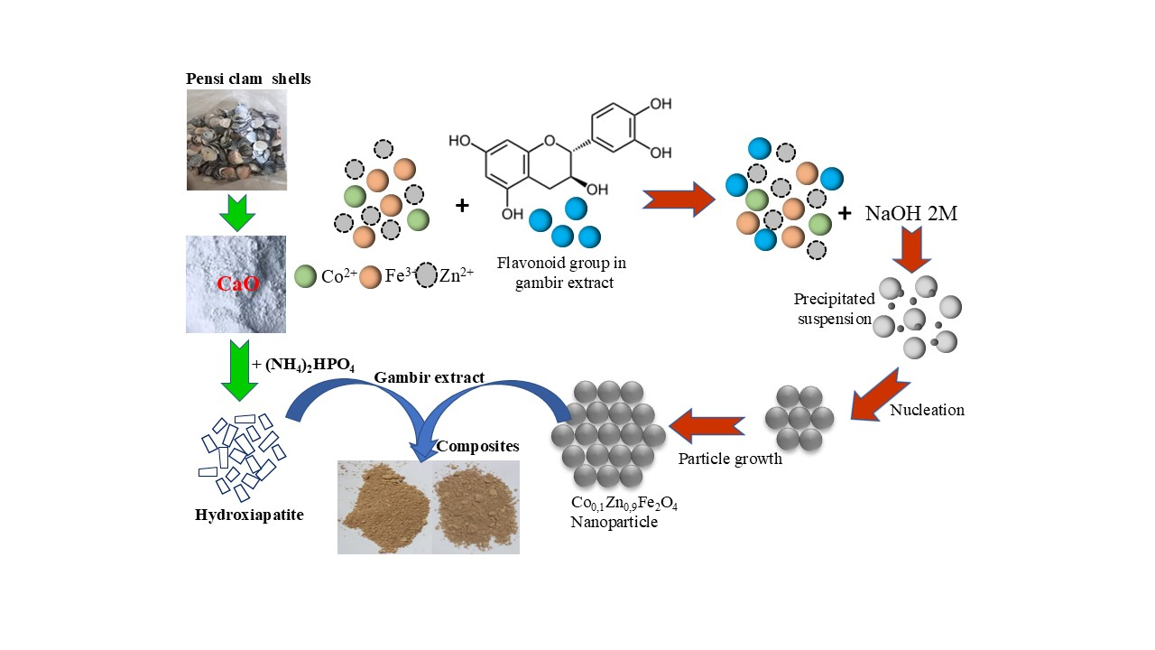

**Figure S1** Proposed synthesize mechanism of HA/Co0.1Zn0.9Fe2O4 nanocomposites

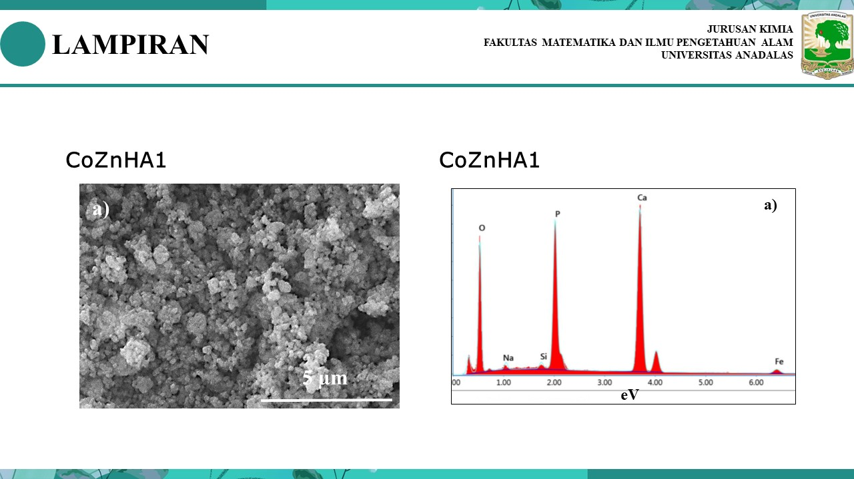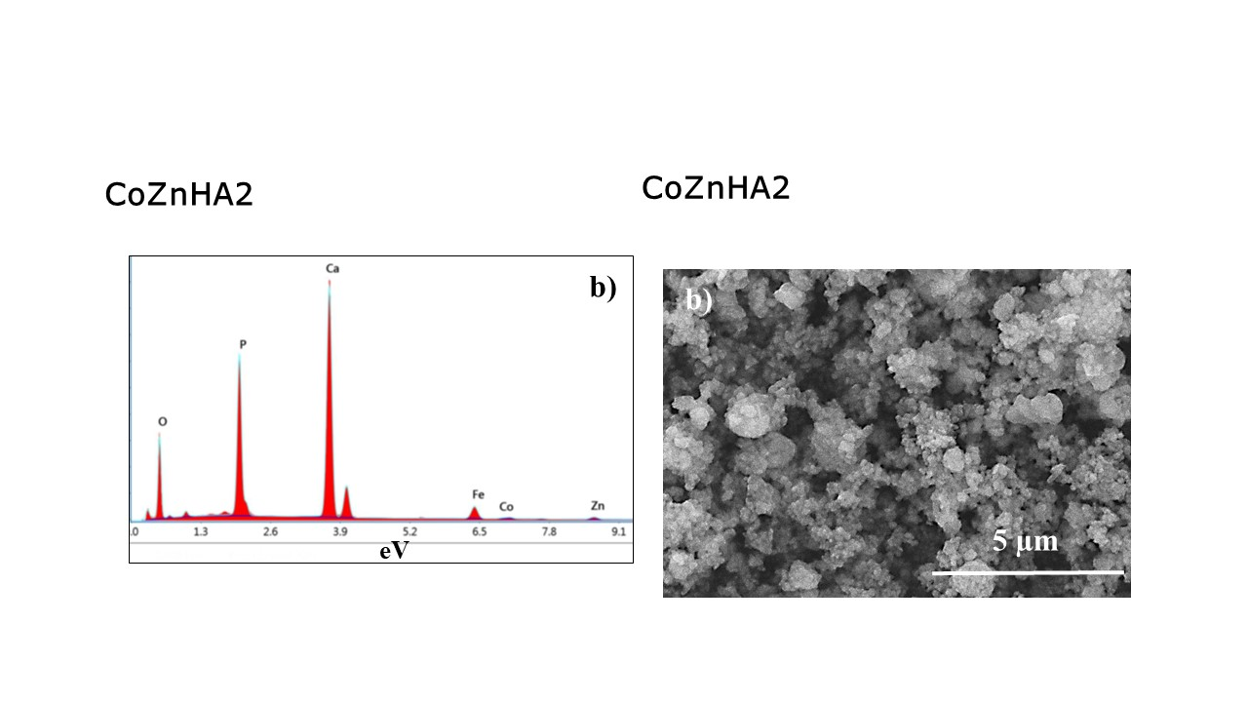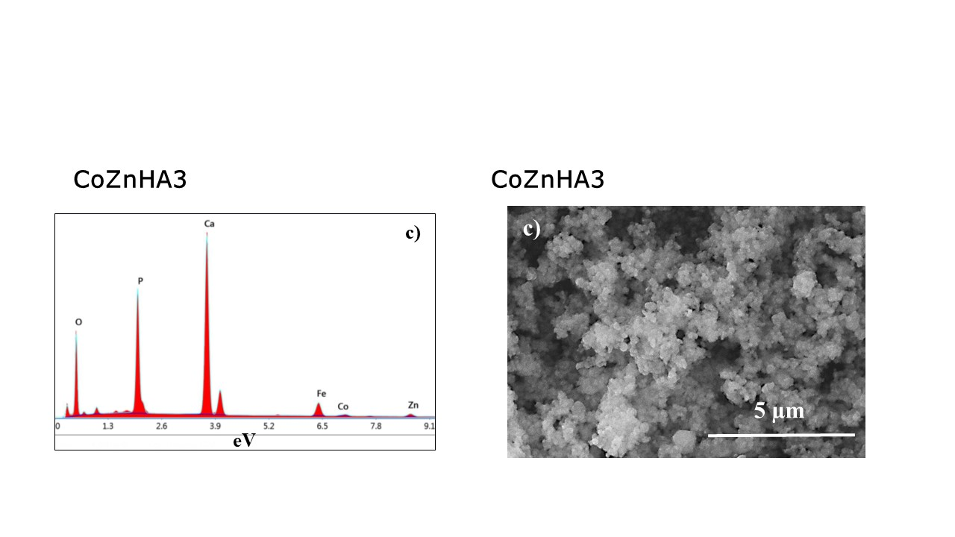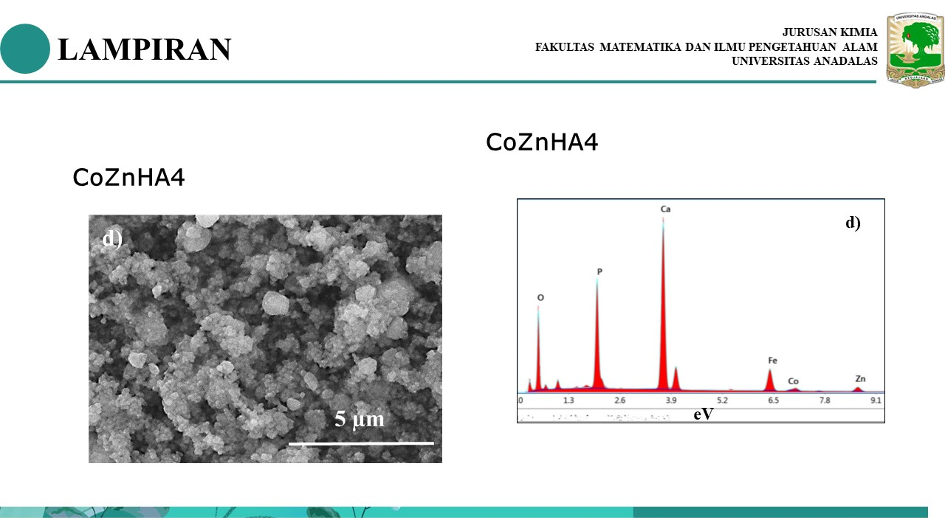

**Figure S2** Energy-dispersive spectra of a) CoZnHA1, b) CoZnHA2, c) CoZnHA3, and d) CoZnHA4







**Figure S3** High-resolution XPS spectra of HA/Co0.1Zn0.9Fe2O4 a) nanocomposite, and O 1s, Ca 2p, P 2p, Fe 2p, Zn 2p, Co 2p, and C 1s (b-h) present in the nanocomposite.