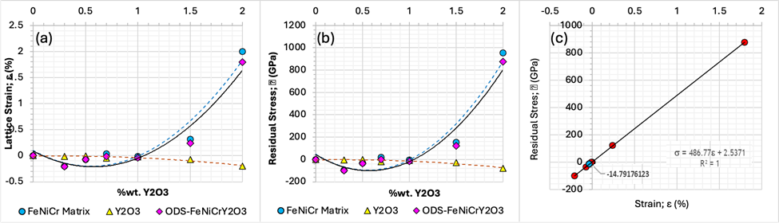
Figure 6 Lattice strain and residual stress analysis of the ODS FeNiCrY₂O₃ cast alloys as a function of Y₂O₃ content. The lattice strain and residual stress are calculated from the peak broadening of the patterns using the Williamson-Hall method. (a) Average lattice strains along the major crystallographic directions (a-axis). (b) Residual stresses along the major crystallographic directions (a-axis). (c) Equilibrium residual stress-strain curve of the alloys.

