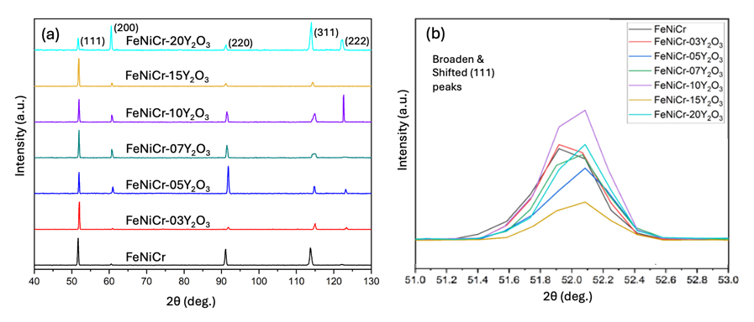
Figure 5 HRPD patterns of FeNiCr cast alloys with varying concentrations of Y₂O₃, illustrating peak intensities and positions. (a) HRPD patterns of the FeNiCr cast alloys with Y₂O₃ content ranging from 0 to 2.0 wt.% from 2θ at 40 to 130 degrees. The peaks are sharp and distinct, with variations in intensity and position depending on the concentration of Y₂O₃. (b) A zoomed-in version of the HRPD patterns focuses on a specific range of 2θ angles from around 51.0 to 53.0 degrees. These data demonstrate the effect of Y₂O₃ on changing the lattice parameters of FeNiCr cast alloys, which are also strongly related to the residual stress.

