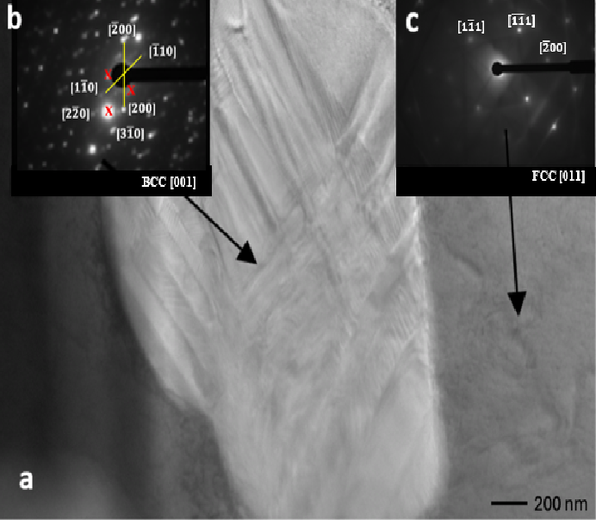
Figure 4 (a) TEM image of FeNiCr10Y₂O₃ alloy showing structural identification of matrix and dispersoid within a few nano meters, (b) and (c) show the indexed diffraction pattern for a BCC [001] and FCC [011] crystals (https://www.globalsino.com/EM/page3916.html). The spacing ratio of the main points is shown as well as the angle between the normal planes of the main planes; 45◦ for zone [001] and 54.74◦ for zone [011], respectively. The forbidden reflections (b) in zone [001] are indicated by the red-cross outside the 45◦ angle path. This may be due to the cubic Y₂O₃ bixbyite structure with C2 and C3i/S6 symmetry sites. (Gaboriaud et al., 2015; Jadhav et al., 2017).

