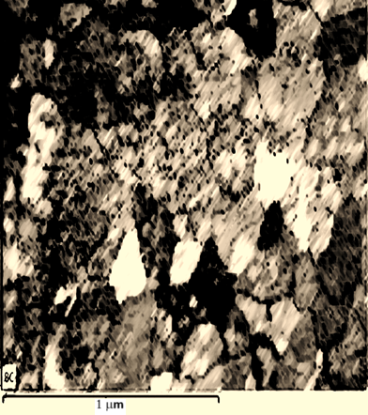

**(a)**

**(b)**

Figure 3 (a) SEM image illustrating the structure of -FeNiCr matrix and yttria clusters, featuring an average globular austenite grain size of approximately ~1.1 microns, along with the dispersion of nano oxides both within the grains and along the grain boundaries, and (b) EDS mapping observation of the inner part of melt-casted ODS FeNiCr10Y2O3 alloys. The images reveal the uniform dispersion of Y elements, which are strongly associated with Fe. This suggests the effectiveness of the pre-linking method for achieving homogeneous distribution of Y2O3 in the alloys.