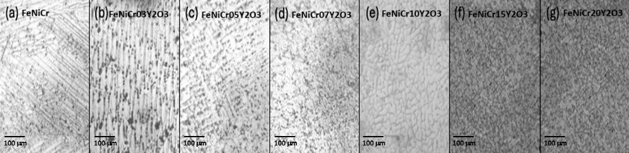
Figure 2 Effect of Y₂O₃ dispersion on the microstructure of melt-casted ODS FeNiCrY₂O₃ cast alloys. Optical microscope images with 100x magnification of the inner part of the alloys with different dispersions of Y₂O₃: (a) 0.0 wt.%, (b) 0.3 wt.%, (c) 0.5 wt.%, (d) 0.7 wt.%, (e) 1.0 wt.%, (f) 1.5 wt.%, and (g) 2.0 wt.%.

