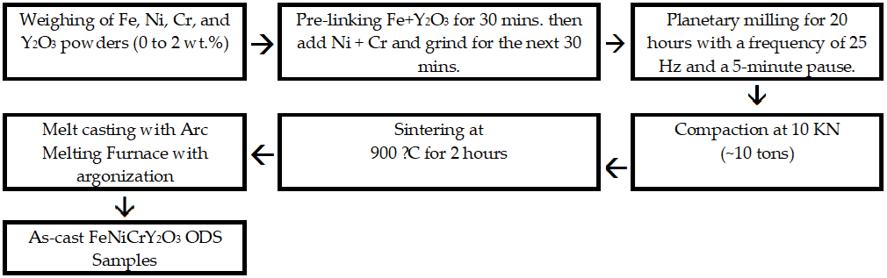

Figure 1 Schematic illustrating the preparation of FeNiCrY2O3 cast alloys with ODS compositions varying from 0 to 2.0% by weight of Y2O3.