**Supplementary Material**

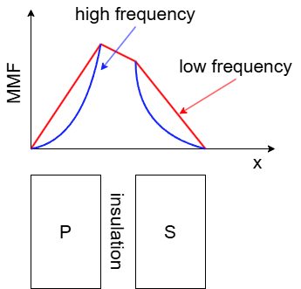

**Figure S1** Variations in MMF at high frequency

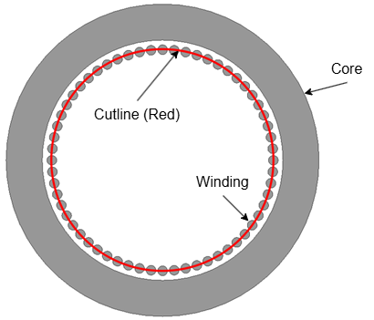

**Figure S2** Determined cutline across the primary and secondary windings conductors

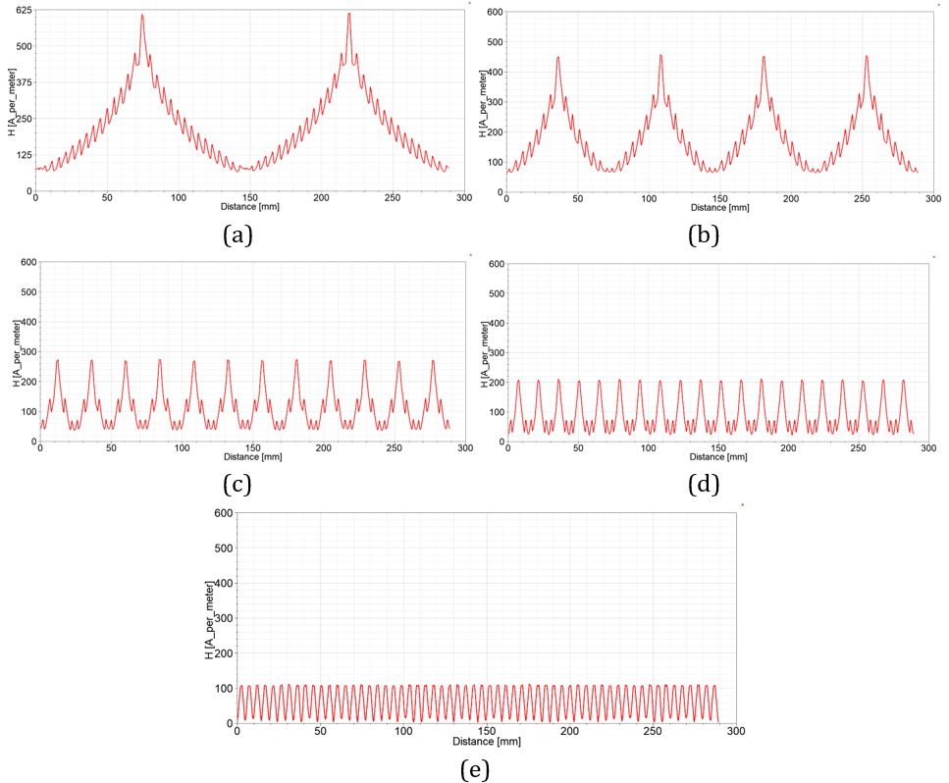

**Figure S3** MMF distribution across the defined cutline according to Figure S2 (a) conventional, (b) interleaved type-a, (c) interleaved type-b, (d) interleaved type-c, (e) interleaved type-d