SUPPLEMENTARY MATERIAL

Separation Technique of Tannins and Caffeine in Black Tea Using Modified Microwave-Assisted Extraction and High-Performance Liquid Chromatography

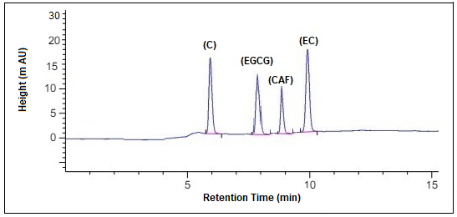

**Figure 1** HPLC-DAD chromatogram obtained for the separation of catechin (C), epigallocatechin gallate (EGCG), caffeine (CAF), and epicatechin (EC) standard solution (tr: 6.000, 7.912, 8.901, 9.991 min respectively). Chromatographic conditions: C18 reverse phase VDSpher PUR 100 C-18-M-SE (150 × 4.6 mm), mobile phase acetonitrile/methanol/0.05 % H3PO4 1/49/50 (v/v/v) and 20 mM NaH2PO4); flow rate 0.8 mL min−1; injection volume 8 µL; λ = 210 nm

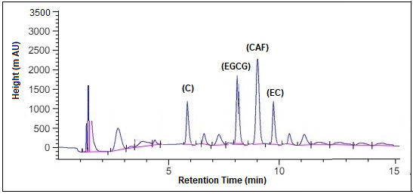

**Figure 2** Chromatogram of black tea samples where the retention time 5.991, 8.201, 9.000, 9.880 min respectively for C, EGCG, CAF, EC