SUPPLEMENTARY FILE

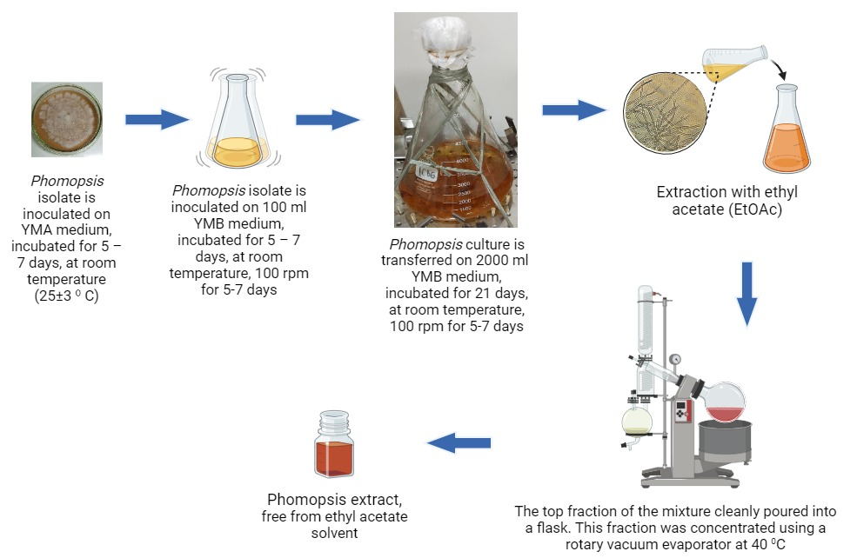

Figure S1. Schematic of the extract manufacturing process

Figure S2. Schematic of the in silico study

Table S1. Chemical compounds in Phomopsis ethyl acetate extract from LC-MS/MS analysis
Compounds | Anti-cancer potency | Formula | RT [min] | Area | Relative Abundance (%) | Class
- 7-Hydroxycoumarine | √ | C₉H₆O₃ | 11.99 | 4.9E+10 | 53.18 | Phenolic
- Dimethyl phthalate | - | C₁₀H₁₀O₄ | 11.99 | 1.4E+10 | 15.32 | Ester
- Sorbic acid | √ | C₆H₈O₂ | 3.93 | 7.8E+09 | 8.54 | Carboxylic acid
- Diisobutylphthalate | - | C₁₆H₂₂O₄ | 21.19 | 4.9E+09 | 5.31 | Ester
- Bis(2-ethylhexyl) phthalate | - | C₂₄H₃₈O₄ | 29.25 | 1.9E+09 | 2.04 | Ester
- PPG n6 | - | C₁₈H₃₈ O₇ | 10.97 | 1.7E+09 | 1.91 | Alcohol
- PPG n8 | - | C₂₄H₅₀O₉ | 13.36 | 1.7E+09 | 1.84 | Alcohol
- PPG n5 | - | C₁₅H₃₂O₆ | 9.66 | 1.7E+09 | 1.82 | Alcohol
- PPG n7 | - | C₂₁H₄₄O₈ | 12.21 | 1.5E+09 | 1.68 | Alcohol
- Cyclo(phenylalanyl-prolyl) | √ | C₁₄H₁₆N₂O₂ | 8.22 | 1.3E+09 | 1.37 | Alcaloid
- NP-011220 | - | C₁₁H₁₈N₂O₂ | 7.41 | 1.1E+09 | 1.18 | Phosphor
- (5E)-7-methylidene-10-oxo-4-(propan-2-yl)undec-5-enoic acid | - | C₁₅H₂₄O₃ | 15.79 | 7.8E+08 | 0.86 | Fatty acid
- Phthaldialdehyde | - | C₈H₆O₂ | 11.98 | 6.9E+08 | 0.76 | Benzaldehid
- Triphenyl phosphate | - | C₁₈H₁₅O₄P | 19.42 | 6.2E+08 | 0.68 | Organophosphates
- 3-[(4-hydroxyphenyl)methyl]-octa hydropyrrolo[1,2-a]pyrazine-1,4-dione | √ | C₁₄H₁₆N₂O₃ | 5.29 | 5.3E+08 | 0.58 | Alcaloid
- Monobutyl phthalate | - | C₁₂H₁₄O₄ | 21.19 | 3.2E+08 | 0.35 | Ester
- 1,3,7-Trihydroxy-6-methoxy-4,5-diisoprenylxanthone | √ | C₂₄H₂₆O₆ | 23.07 | 2.6E+08 | 0.28 | Flavonoid
- 4-Methoxychalcone | √ | C₁₆H₁₄O₂ | 17.04 | 2.1E+08 | 0.23 | Flavonoid
- Dibenzoylmethane | √ | C₁₅H₁₂O₂ | 20.96 | 1.7E+08 | 0.19 | Flavonoid
- 4-Acetamidobutanoic acid | - | C₆H₁₁NO₃ | 1.75 | 1.5E+08 | 0.17 | Acetamide
- 4-(hydroxymethyl)benzoic acid | √ | C₈H₈O₃ | 7.07 | 1.4E+08 | 0.15 | Phenolic
- DL-Mandelic acid | - | C₈H₈O₃ | 5.14 | 1.4E+08 | 0.15 | α-Hydroxy acids
- Ethyl palmitoleate | - | C₁₈H₃₄O₂ | 21.75 | 1.4E+08 | 0.15 | Fatty acid
- 4-Hydroxybenzaldehyde | - | C₇H₆O₂ | 6.43 | 1.3E+08 | 0.15 | Aromatic aldehyde
- N-Acetyl-L-leucine | - | C₈H₁₅NO₃ | 7.02 | 1.1E+08 | 0.13 | Amino acid
- Terephthalic acid | - | C₈H₆O₄ | 5.70 | 1E+08 | 0.11 | Dicarboxylic acid
- Monomethyl phthalate | - | C₉H₈O₄ | 8.51 | 1E+08 | 0.11 | Ester
- Bis(3,5,5-trimethylhexyl) phthalate | - | C₂₆H₄₂O₄ | 26.26 | 9.7E+07 | 0.11 | Ester
- Suberic acid | - | C₈H₁₄O₄ | 7.76 | 6.7E+07 | 0.07 | Dicarboxylic acid
- Citral | √ | C₁₀H₁₆O | 14.83 | 5.7E+07 | 0.06 | Monoterpen
- Oxybenzone | - | C₁₄H₁₂O₃ | 18.29 | 5.2E+07 | 0.06 | Aromatic ketones
- 9-Oxo-10(E),12(E)-octadecadienoic acid | √ | C₁₈H₃₀O₃ | 20.92 | 4.7E+07 | 0.05 | Fatty acid
- Phenylglyoxylic acid | - | C₈H₆O₃ | 6.81 | 4.2E+07 | 0.05 | Glyoxylic acid
- Pimelic acid | - | C₇H₁₂O₄ | 5.94 | 4.1E+07 | 0.05 | Dicarboxylic acid
- 3-[(1-Carboxyvinyl)oxy]benzoic acid | √ | C₁₀H₈O₅ | 8.82 | 3.6E+07 | 0.04 | Phenolic
- (+)-ar-Turmerone | √ | C₁₅H₂₀O | 20.52 | 3.3E+07 | 0.04 | Sesquiterpen
- 3-Allyl-2-hydroxybenzoic acid | √ | C₁₀H₁₀O₃ | 11.28 | 3.2E+07 | 0.04 | Phenolic
- Ferulic acid | √ | C₁₀H₁₀O₄ | 10.52 | 3.2E+07 | 0.03 | Phenolic
- 1,3-Diphenylacetone | - | C₁₅H₁₄O | 18.78 | 2.9E+07 | 0.03 | Ketones
- cis-12-Octadecenoic acid methyl ester | - | C₁₉H₃₆O₂ | 25.77 | 2.6E+07 | 0.03 | Fatty acid
- 18-β-Glycyrrhetinic acid | - | C₃₀H₄₆O₄ | 25.34 | 1.8E+07 | 0.02 | Triterpenoid
- Chalcone | √ | C₁₅H₁₂O | 20.46 | 1.9E+07 | 0.02 | Flavonoid
- 3,3-Dimethylglutaric acid | - | C₇H₁₂O₄ | 6.98 | 1.7E+07 | 0.02 | Carboxylic acid
- Hydroxycinnamic acid | √ | C₉H₁₀O₂ | 8.79 | 2E+07 | 0.02 | Phenolic

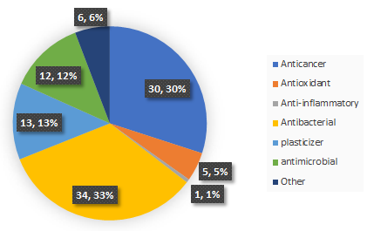

Figure S3. Functions of the compounds contained in Phomopsis extract (base on literature)

Table S2. Detection of ethyl acetate in extract
