Supplementary Material: Novel Multiphase CO₂ Photocatalysis System Using N- TiO₂/CNCs and CO₂ Nanobubble

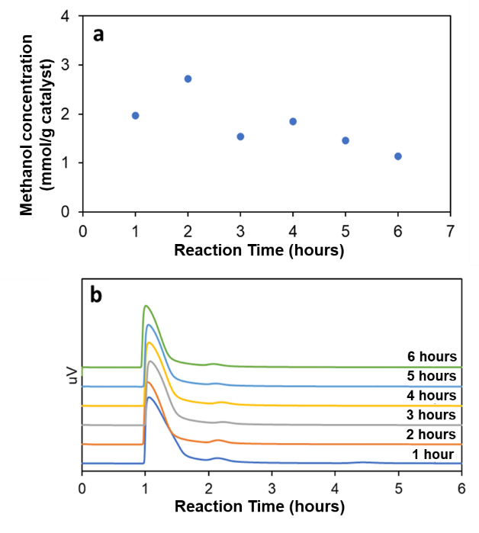
Figure S1 Methanol product after 6 hours of photocatalytic reaction using N-TiO₂/CNCs for 6 hours under UV light irradiation.

Table S1 Methanol product after 6 hours of photocatalytic reaction using N-TiO₂/CNCs for 6 hours under UV light irradiation.

Reaction Time (h) | Methanol Yield  (mmol/g catalyst)
1 | 1.97
2 | 2.72
3 | 1.54
4 | 1.85
5 | 1.46
6 | 1.13

