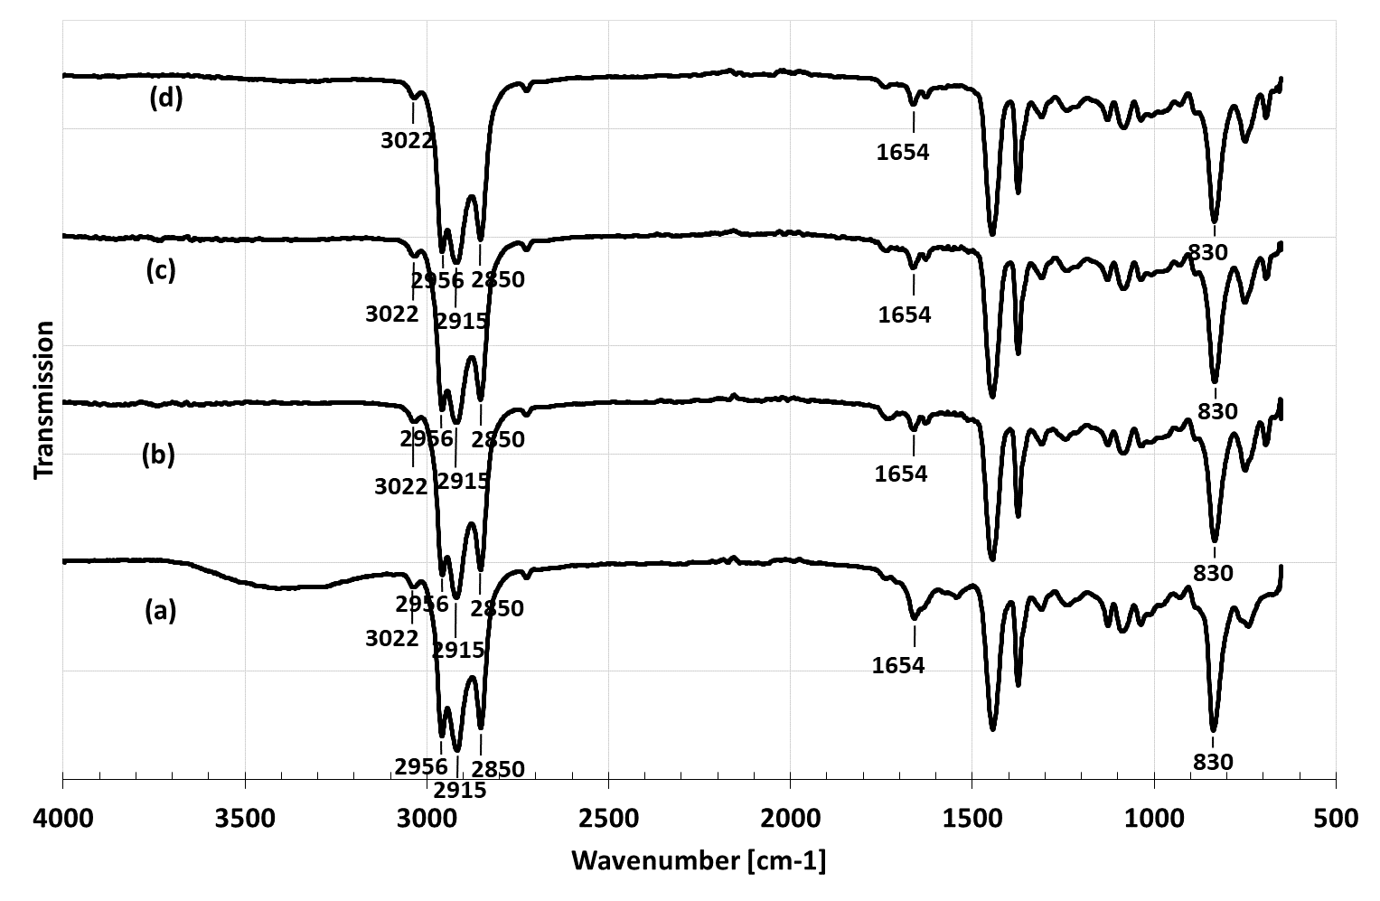
Figure 6 FTIR spectra of NR (a) compared with PHNR using water (b) 15 mL, (c) 20 mL, and (d) 25 mL

