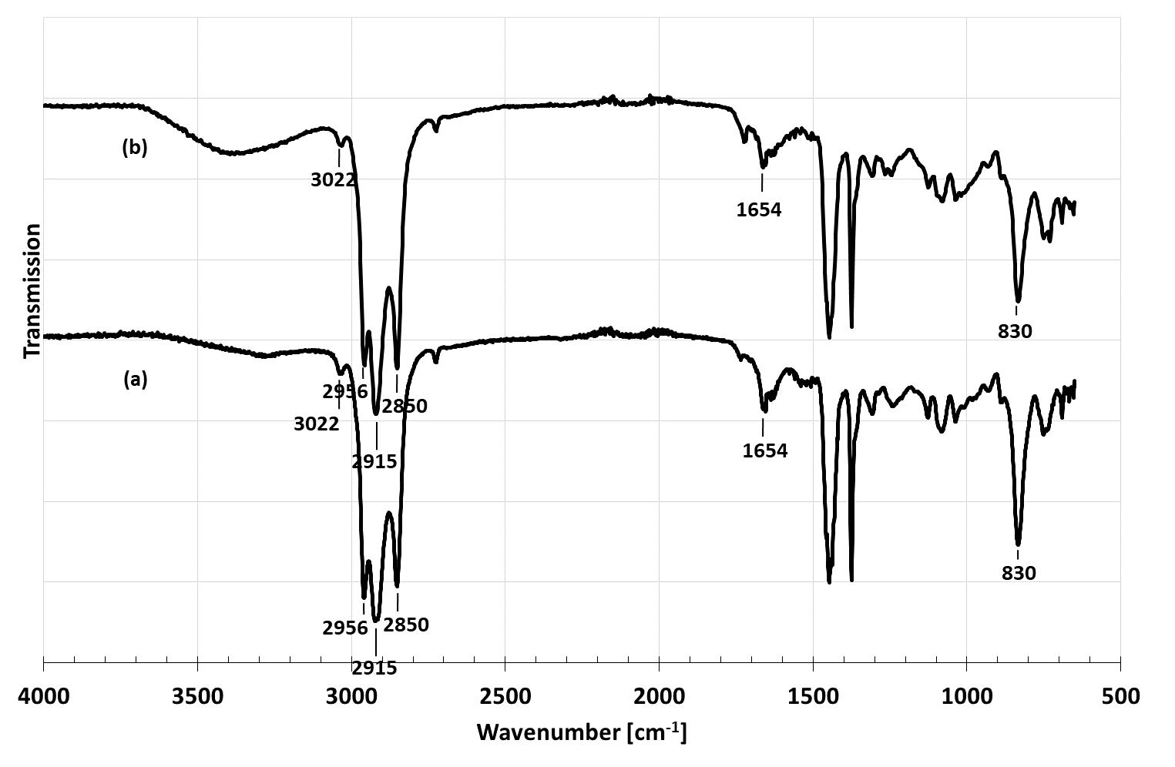
Figure 5 FTIR spectra of PHNR using (a) EDTA and (b) CuSO₄

