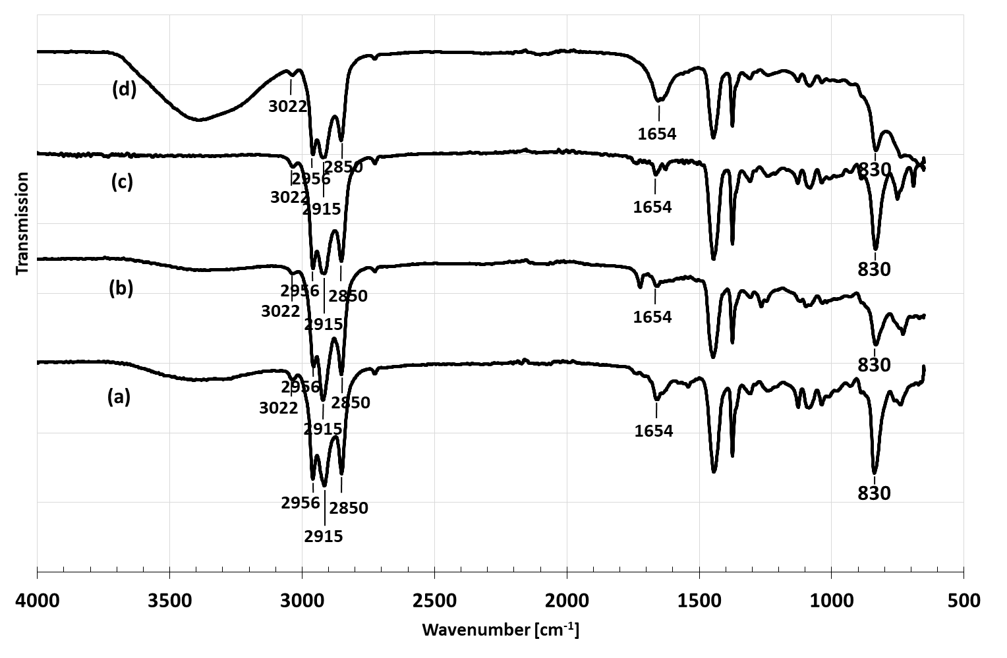
Figure 4 FTIR spectra of NR (a) compared with PHNR using (b) hexane, (c) toluene, and (d) xylene

