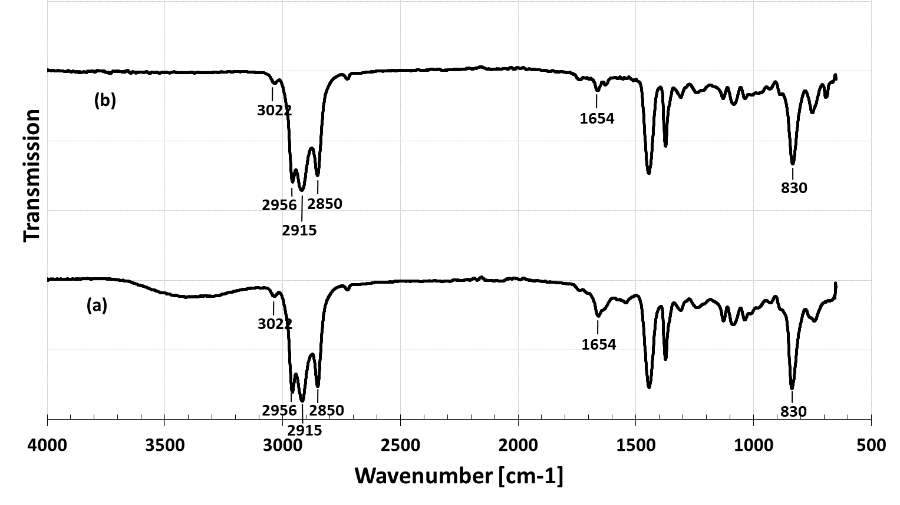
Figure 3 FTIR spectra of NR (a) and PHNR (b)

