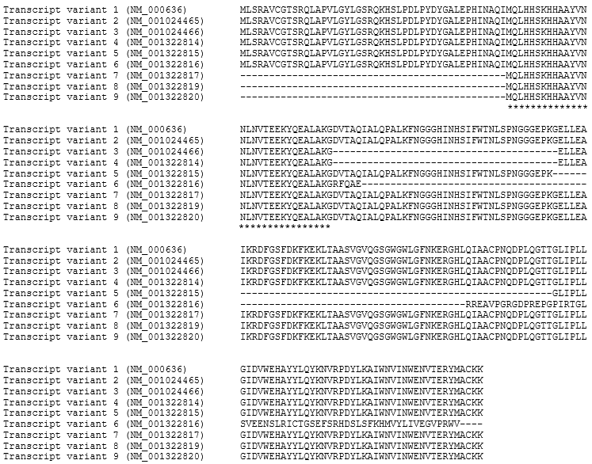
Figure S1. The conserved region common to all SOD2 variants spans from amino acid 46 until 76 (black box) which is aligned with nucleotide 238-282 within exon 2 of human SOD2 gene (https://www.ncbi.nlm.nih.gov/nuccore/NM_000636.4). Transcript variant 1 was used as the wild-type sequence.

