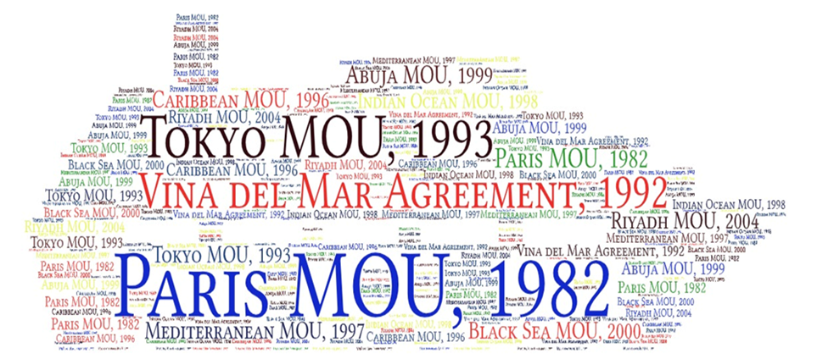

Figure S1 The illustration of regional Memorandums of Understanding (MoUs)

