Supplementary Materials
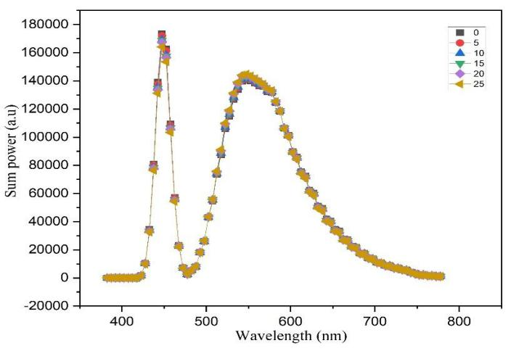

Luminescence power of WLEDs when varying SiO₂ contents in KLP:TE@SiO₂ composition.

