Dear Prof. Thongchai Rohitatisha Srinophakun
We have finished the review and made the decision on your manuscript entitled [
Techno-economic Analysis of Bioethanol Production from Palm Oil Empty Fruit
bunch ] which was submitted to the International Journal of Technology.
We have decided that your manuscript Needs to be Revised
We also send you the review result from the reviewers. Here is the detail
review result:
Notes from Editor:1. Please revise according to the reviewer's comments, and
highlights the revised in a different color.
Highlights in yellow color
2. It is suggested to include at least 3 relevant IJTech articles (2019 -
present) as references.
Hossain, N., Zaini, J., Mahlia, T.M.I., 2018. The efficacy of the period of Saccharification on oil palm (Elaeis Guineensis) Trunk Sap Hydrolysis. International Journal of Technology, Volume 4, pp.652-662
Sugiarto, B., Dwinanda, M.F., Auliady, D., Andito, R.N., Muchar, M., Simanjuntak, C., 2021. Investigation of Cyclohexanol as an Oxygenated Additive for Gasoline– Bioethanol Mixtures and Its Effect on the Combustion and Emission Characteristics of Spark Ignition Engines. International Journal of Technology, Volume 12(5), pp.1071-1080
Wibowo, C.S., Setiady, N.I., Masuku, M., Hamzah, A., Fedori, I., Muchar, M., Nugroho, Y.S., Sugiarto, B., 2020. The Performance of a Spark Ignition Engine using 92 RON Gasoline with Varying Blends of Bioethanol (E40, E50, E60) Measured using a Dynamometer Test. International Journal of Technology, Volume 11(7), pp.1380-1387
3. Please upload the revised manuscript by filling * required (for response
letters, you can download the template in Step 5).
Reviewer (1)
Introduction: 1. Authors have to explain what related the Figure 1, is used by
author to calculate the economic feasibility or just to show the general
process for bioethanol production?
The explanation in Figure 1 is briefly filled in the context, we give general detail that concludes in the simulation part to produce ethanol with our proposed technique and laboratory data.
2. add the reason why use Aspen plus?
Aspen Plus is suitable for simulating the chemical process. It can be used for a wide variety of chemical engineering tasks in the industry.

Methodology: 1. authors have to concern to write the chemical formula such
as H2O2
When the process is completed, Sodium Hydroxide (NaOH) is added by the NaOH-line, Hydrogen Peroxide (H₂O₂) is added by the H₂O₂-line, and water is added by the WATER2-line. Lignin is delignification by Hydrogen Peroxide (H₂O₂).
H₂O₂ is the formula.
H2O2-line is the name of the stream in simulation.
2. Authors have to explain further for 99.5 %wt. ethanol production?
This is the specification of the product which we make as the target of production. This must meet the minimum requirements of the market.

or Anhydrous ethanol for fuel blending as a customer requirement.
3. all equations should be stated in the text
Therefore, M&S index value used to advance the purchased equipment cost should be in 2017 and the present index in 2020 following equation (1).
Equipment cost₂₀₂₀ = Equipment cost₂₀₁₇ $×\left(\frac{M\&S Index 2020}{M\&S Index 2017}\right)$ (1)
In other cases, the equipment cost is estimated by the scaling equation, which shows in equation (2)
Estimated cost = Base case equipment cost $\text{×}{\left(\frac{\text{The capacity of estimated equipment}}{\text{The capacity of base case equipment}}\right)}^{\text{n}}$ (2)
Where n is the exponential value depending on the specific type of equipment

Results and Discussion:
1. The ethanol production is due to the design of
bioethanol production. authors have to explain more related the choosing
method for ethanol production?
Briefly, the presentation on ethanol production is in Figures 1 and 2 and the reader can find more in detail with our paper. (Suwajittanon, P., Thongrak, P., Srinophakun, T.R., 2022. Techno-economic analysis of commercial-scale bioethanol production from oil palm trunk and empty fruit bunch. Agriculture and Natural Resources, Volume 56(4), pp.825-836

2. add parameters used that simulated using empty fruit bunch as feedstocks
We provided those parameters in the input files of ASPEN. A reader can simply address this from our available cloud apace.
3. Authors have to explain the processes used such as pretreatment,
hydrolysis, fermentation, and purification.
Pretreatment (to digest Lino-cellulosic to smaller molecules), Hydrolysis (to convert small molecules to sugars), Fermentation (to produce ethanol from sugars), and Purification (to purify ethanol to 99.5%).
4. Based on this method "Pervaporation technologies", authors have to
discuss the ethanol dehydration technology. how many % and compare with
other methods if any
A comparison of the proposed purification is available elsewhere (Suwajittanon et al., 2022).).
Suwajittanon, P., Thongrak, P., Srinophakun, T.R., 2022. Techno-economic analysis of commercial-scale bioethanol production from oil palm trunk and empty fruit bunch. Agriculture and Natural Resources, Volume 56(4), pp.825-836
5. How about the value of MARR?
We have not given any focus on MARR.
6. Authors have to discuss the economical feasibility of bioethanol
production and listed the comparable data in Table.
A key comparison of the feasibility study can be found in “Suwajittanon, P., Thongrak, P., Srinophakun, T.R., 2022. Techno-economic analysis of commercial-scale bioethanol production from oil palm trunk and empty fruit bunch. Agriculture and Natural Resources, Volume 56(4), pp.825-836”
References: ok
Other: 1. improve and add some information to this sentence "The results show that bioethanol production is profitable" in the abstract. 1. Graphical abstract is not abstract. Currently, it is wrong. authors have to provide a picture/image to represent this study
We provide the graphical abstract as shown below:
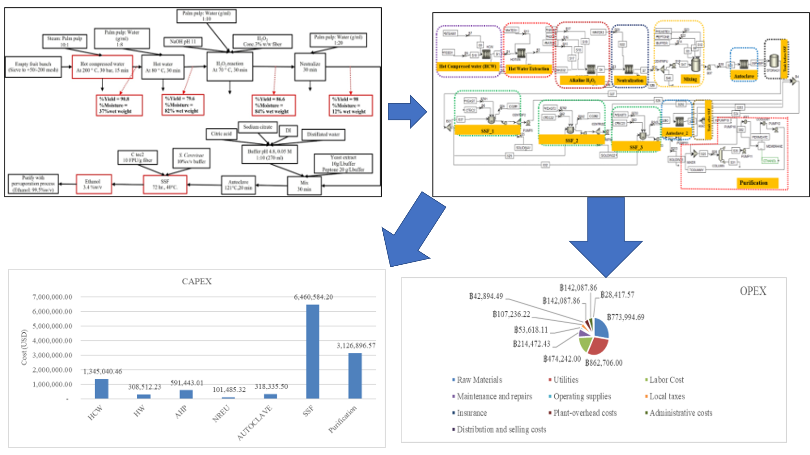
Originality2 (fair)
Technical2 (fair)
Methodology2 (fair)
Readability2 (fair)
Practicability2 (fair)
Organization2 (fair)
Importance3 (average)
Attachment from reviewer:
-
Reviewer (2)
Introduction: The introduction explains the state of the art of study.
The aim is to express the economic viewpoints, especially in Thailand to address the waste utilization of the palm oil industry.
Methodology: The methodology is written based on the previous study.
We conclude our methodology part following the previous work.
Results and Discussion: the currency should be converted to USD
We estimated our budget and investment in USD.
References: Galbe ...... format should be revised
We reformat all the references
Galbe, M., Sassner, P., Wingren, A., Zacchi, G., 2007. Process Engineering Economics of Bioethanol Production. In: Biofuels, Springer, Berlin, Heidelberg, pp.303-327
Galbe, M., Zacchi, G., 2007. Pretreatment of lignocellulosic materials for efficient bioethanol production. In: Biofuels, Springer, pp.41-65
Gnansounou, E., Dauriat, A., 2011. Technoeconomic Analysis of Lignocellulosic Ethanol. In: Biofuels, Elsevier. pp.123-148
Halder, P., Azad, K., Shah, S., Sarker, E., 2019. Advances in Eco-Fuels for a Sustainable Environment. Woodhead Publishing, Cambridge, USA
Hassan, N., Nakk, A., Idris, A. (2020) Strategy to enhance sugar production using recyclable inorganic salt for pre-treatment of oil palm empty fruit bunch (OPEFB). BioResources, Volume 15(3), pp.4912-4931
Other:
Originality3 (average)
Technical4 (above average)
Methodology4 (above average)
Readability3 (average)
Practicability3 (average)
Organization4 (above average)
Importance4 (above average)
Attachment from reviewer:
-
Reviewer (3)
Introduction: Please provide the novelty and aims of the study.
The aim is to express the economic viewpoints, especially in Thailand to address the waste utilization of the palm oil industry.
Methodology: Where does the data in Tables 1 and 2 come from?
Those tables are the brief data from our experimental section. We decide to make all of them available on our website instead to reduce the number of pages.
Table 3 does not provide data on where the capital to build a bioethanol
the plant will come from, whether owned or borrowed from a bank, or a
combination of both with a certain portion.
We changed to Table 1 and adjusted the format.
Our feasible study is the conceptual stage in which an investor would have his/her decision on how to get a budget from.
Results and Discussion: Round the numbers in Tables 4, 5, and 6 so that the
last three digits are 000. Eliminate decimals as well.
Table 4 Total capital investment in bioethanol production

Estimating capital investment items based on delivered-equipment cost
Cost parameter | Solid-Fluid  processing | Cost ($)
Direct costs
Purchased equipment delivered | 100 | 2,597,000
Purchased-equipment installation | 39 | 1,013,000
Instrumentation and controls (installed) | 13 | 338,000
Piping (installed) | 31 | 805,000
Electrical systems (installed) | 10 | 260,0000
Buildings (including services) | 29 | 753,0000
Yard improvement | 10 | 260,000
Service facilities (installed) | 55 | 1,428,000
Land | 6 | 156,000
Total direct plant cost | 302 | 7,610,000
Indirect costs
Engineering and supervision | 32 | 831,000
Construction expenses | 34 | 883,000
Contractor's fee | 18 | 467,000
Contingency | 36 | 935,000
Total indirect plant cost | 120 | 3,116,000
Fixed-capital investment (FCI) | 422 | 10,726,000
Working capital (15% of total capital investment) | 74 | 1,596,000
Total capital expenditure (CAPEX) | 496 | 12,322,000
Table 5 Estimating total product cost
Estimating the total product cost
Manufacturing cost
Direct product cost |  | Cost ($)
 | Raw materials | 774,000
 | Utility | 863,000
 | Labor cost | 474,000
 | Maintenance and repair | 214,000
 | Operating supply | 54,000
Fix charges
 | Local taxes | 107,000
 | Insurances | 43,000
 | Plant overhead cost | 142,000
General expense
Administrative cost |  | 142,000
Distribution and selling cost |  | 29,000
Total production cost (OPEX) |  | 2,869,000
Table 6 Economic result summary of the base case
Economic parameter | Value
Total capital cost (CAPEX) | 12,322,000 USD.
Total production cost (OPEX) | 2,869,000 USD.
Total annual income | 5,006,486 USD.
Net present value (NPV) | 9,016,964 USD.
Internal rate of return (IRR) | 15%
Payback period (PB) | 7 years
References: Please put three references from the recent IJTECH paper.
Hossain, N., Zaini, J., Mahlia, T.M.I., 2018. The efficacy of the period of Saccharification on oil palm (Elaeis Guineensis) Trunk Sap Hydrolysis. International Journal of Technology, Volume 4, pp.652-662
Sugiarto, B., Dwinanda, M.F., Auliady, D., Andito, R.N., Muchar, M., Simanjuntak, C., 2021. Investigation of Cyclohexanol as an Oxygenated Additive for Gasoline– Bioethanol Mixtures and Its Effect on the Combustion and Emission Characteristics of Spark Ignition Engines. International Journal of Technology, Volume 12(5), pp.1071-1080
Wibowo, C.S., Setiady, N.I., Masuku, M., Hamzah, A., Fedori, I., Muchar, M., Nugroho, Y.S., Sugiarto, B., 2020. The Performance of a Spark Ignition Engine using 92 RON Gasoline with Varying Blends of Bioethanol (E40, E50, E60) Measured using a Dynamometer Test. International Journal of Technology, Volume 11(7), pp.1380-1387
Other:
Originality3 (average)
Technical3 (average)
Methodology3 (average)
Readability3 (average)
Practicability3 (average)
Organization3 (average)
Importance3 (average)
Attachment from the reviewer:
-
Please login into the application https://ijtech.eng.ui.ac.id/login for more
detail.
You must respond to this revised and resubmit the request before 06 Dec 2022,
after which point we will presume that you have withdrawn your submission
from International Journal of Technology (IJTech) Online System.
Yours sincerely,
Dr. Eny Kusrini
Managing Editor
International Journal of Technology (IJTech)
p-ISSN : 2086-9614
e-ISSN 2087-2100
https://ijtech.eng.ui.ac.id/
IJTech is currently indexed in SCOPUS and Emerging Sources Citation Index
(ESCI) Thomson Reuters

