Benchmarking Approach to Support Technology Investment Decisions: A Study of Technology Implementation in Last-mile Distribution

Abstract. The rapid increase in business-to-consumer online retail has challenged the existing distribution models. Seamlessly integrated, more sustainable and digitalized last-mile distribution processes are vital to meeting the requirements posed by future online retail. Investments to new and more advanced technological solutions are needed to improve the operational performance and to meet all the external requirements. The variety of available technological solutions creates a significant, multi-layered challenge to individual organizations’ ability to select the most fit-for-purpose technology for their own and their customers’ needs. This is a well-recognised issue at the front end of innovation process and it calls for deep insight before proceeding to actual product development. This paper describes how domain-specific benchmarking can be a valid tool in increasing strategic knowledge supporting the technology investment decisions. In this research 16 technologies and technology topics applied to distribution logistics were evaluated in terms of the technologies’ perceived feasibility. The feasibility comprised three technology dimensions – applicability, tangibility and maturity - as benchmarking indicators, chosen on the basis of literature. The demonstrated application of domain-specific benchmarking supports managerial evaluations of individual technologies, as well as enables further customising the benchmarking indicators to be used in the proposed model.

*Keywords:* Online retail, benchmarking, distribution, technology, last-mile

**1. Introduction**

The consumer goods value chain and distribution are influenced by several technology and market trends such as digitalization, individual selection, consumer-centric business, e-commerce and new service models (Alicke et al., 2017; Reinarz, 2019). In 2019, online retail accounted for 14.1% of total worldwide retail, and the turnover of online retail is forecast to grow more than 10% annually (Statista, 2020). Efficient logistics and technological infrastructure are the key drivers of online retail. However, organizing the delivery of physical goods effectively from the producer to the consumer has been a challenge, especially in regard to last-mile operations (Vanelslander et al., 2013; Hsiao et al., 2018; Lim et al., 2018; Piroth et al., 2020). Generally, the last-mile section of the supply chain has been recognized as the costliest, and operationally and environmentally most ineffective, individual element of the entire process (Gevaers et al., 2014).

The results of a recent study (Vakulenko et al. 2019) highlight the crucial role of the seamless alignment of last-mile operations in the overall customer experience, further raising the importance of fluent operational performance. However, though multiple novel technologies exist for developing new distribution models, problems adopting them into the organization of efficient delivery have restricted the wider growth of online retail, because poor execution of logistics demotivates consumers from using online stores (Lin et al., 2016). Also, the environmental impacts of last-mile logistics are significant and therefore new technological solutions are expected to provide greener alternatives (Kusrini et al., 2020) and match the future regulatory requirements (Ranieri et al., 2018).

Digitalization is growing at tremendous speed in the field of logistics, with countless

incremental changes all going on at the same time in the logistics processes (Yu et al., 2017). Despite the range of new technologies available today, the challenge remains in how they could fully benefit and be customized to the specialized processes of particular domains like distribution logistics (Amling and Daugherty, 2018). A recent survey on the logistics of small and medium sized enterprises (SMEs) (Kianto et al., 2018) indicated a shortage of strategic knowledge management related especially to new technology. Durst and Evangelista (2018) made similar observations of Swedish and Italian third-party logistics companies. Yet et al. (2009) have identified organizational knowledge management to be a major performance driver in logistics.

New delivery technologies should also be risk-free (as far as possible), offer better consumer experiences and fit their lifestyle to gain their acceptance (Wang et al., 2018; Zhou et al., 2020). Cano et al. (2021) highlights that securing logistics efficiency and maintaining competitive advantage are possible only by adopting and investing advanced technological solutions. Technological investments are also needed in interfacing infrastructure and in key human skills and competencies, and they will need to be made before, or at the same time as, substantial cash outlays are committed to the technology. In the worst-case scenario, investments in new technology solutions that eventually turn out to be unfeasible may cause devastating financial losses. In most business organizations, the question of technological uncertainties is a strategic one, as it is linked to managerial decisions on technology investments and gaining added value (e.g Berawi, 2021). Due to the accelerating level of digitalization and turbulent global environments, many scholars (e.g., Kim & Wilemon, 2002; Cagan & Vogel, 2002; Gassman & Schweitzer, 2014) are emphasizing the relevance of front-end phase-related knowledge gain. In order to make successful investment decisions and overcome various uncertainties, such as being able to scope which technologies are the most fit-for-purpose for specific products, managers will be required to gather perceivable experiences to support the decision-making (Cagan & Vogel, 2002; Schweitzer, 2014). Kianto et al. (2018) further adduce the potential of increasing collective knowledge and reducing technological uncertainty occurring especially among SMEs in logistics by strengthening technological knowledge-sharing platforms and procedures.

In sum, the challenges identified by literature address the different needs of consumers, intermediate customers, and end customers as well as understanding the risks and benefits of multiple available technologies, which make the managerial decisions and choices a demanding task entailing considerable uncertainties. Hence this paper focuses on decision making at the front end of the innovation phase of product development, in the case of online retail-related last-mile deliveries. The paper has three aims: (1) to develop a conceptual model for classifying alternative technologies or technology trends to support decision making, (2) to demonstrate the feasibility of the model for evaluating alternative last-mile technologies for online retail and (3) to provide usable insight, especially for practitioners, on the applicability of different last-mile technologies. The first aim is clearly to present the model as a hypothesis, the applicability of which needs to be assessed by the managers of practice and the validity by the researchers. The second aim — the demonstration — will serve as a first-step model validity test. The proposed model is novel and the foremost contribution of this research. The model’s application in this paper is primarily to measure the consensus of managers’ perception of the applicability, tangibility and maturity of alternative technologies when considering investment decisions. In more general sense, the aim is to assist in better informed decision making, and to reduce uninformed risks in technology deployment.

The emerging technologies are identified on the basis of a literature analysis. The third aim is conditional to the first two. The demonstration of the model in evaluating emerging technologies, assuming the model to be valid, will also give direct information about these technologies as to their acceptability, maturity and applicability. The demonstration is done using survey data from logistics and supply chain managers evaluating the identified emerging technologies. The model’s demonstration is not validation, however, but yet a necessary step towards validation. The overall research design is constructive (see Pasian & Turner, 2015). The proposed model represents the construct, object. One application of the model is to use it as a measurement tool for applicability, tangibility, and maturity assessment of last-mile technologies.

**2. Methods**

2.1. Benchmarking

The methodological approach was done with a benchmarking (BM) method focusing on last-mile and online retail domain companies to gain and manage domain-specific knowledge. Mann et al. (2010) describe the key elements of BM as including 1) seeking the best solutions by learning from other organizations in the selected area, 2) analysis of the results to gain knowledge for one’s own organization, and 3) the eventual implementation of the most suitable practices. The gained BM information allows organizations to recognize and effectuate corrective measures within their existing operations (Feigenbaum, 1951). BM supports the change process within organizations upgrading their processes for the demands of the future (Bhutta & Huq, 1999).

Despite being a useful tool for raising awareness and supporting decision-making, BM information is really only a guideline (Boxwell, 1994). In addition to collecting information, the main targets of BM can be summarized as learning and recognizing how some other organizations perform better, and further analysing how to align this knowledge with strategic decisions (ApQc, 1996). BM processes often consist of four main phases: (1) planning, (2) collection of the data, (3) analyses of data, and (4) integration of the BM results to internal decision-making processes (e.g., Camp, 1989). As the acquired BM results are generally targeted at continuous improvement (Wudhikarn et al., 2020), the proposed model has been described as a BM circle needing regular updates (see Figure 1).

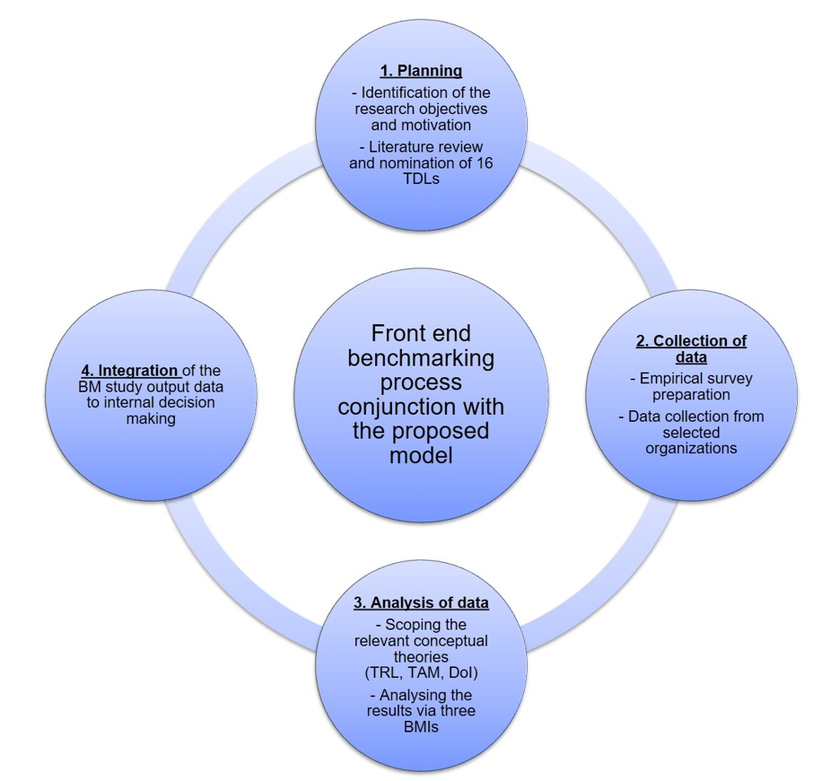

**Figure 1** Front End BM Process Conjunction with the Proposed Model

*2.2. Constitution of the Proposed Model*

To develop an overview of emerging technologies and broader technology topics that potentially provide solutions for future distribution logistics in the online retail context, we conducted a literature review of journal articles and other scientific publications. The main method was an online search for articles published after 2014, i.e., within the last 5 years before the search began. The search criteria were combinations of the following words or phrases: retail, customer, consumer, last mile, delivery, distribution, emerging, digital, technology, ICT, online, supply chain, city, logistics, renewal and B2C. The literature findings were analysed qualitatively, in a concept-driven way (Schreier 2014), and the technology topics with links to distribution logistics (TDLs) were selected based on the analysis. The classification of technologies is a synthesis from the literature, based on researchers’ brainstorming. Hence the process of classification was a heuristic process. The empirical part of this study evaluates the present role and attitudes of relevant stakeholders regarding emerging technologies. The evaluation covers 16 emerging technology topics selected based on the literature review, which focused on technology topics which already have usable applications in production. The literature review process is summarized in Table 1.

|  |  |  |
| --- | --- | --- |
| **Type** | **Criteria** | **Additional information** |
| Inclusion | Abstract, concluding chapters and/or keywords indicate that last-mile logistics or delivery logistics in general are a key topic in the publication. | The search was not limited to specific journals in order to include all potentially relevant publications. |
|  | Publications are written in English. | English is the most common language in international logistics research |
| Prioritization | Peer-reviewed publications were prioritized as the most important sources. | Peer-reviewed publications support the quality control of the work. |
|  | Abstract, concluding chapters and/or keywords indicate that last-mile operations and emerging technologies in that field are key areas of focus in the publication. |  |
| Exclusion | Studies that are clearly focusing on other transportation research domains than last-mile distribution processes. In the line of earlier studies (e.g. Huebner et al. 2016) last-mile distribution can be considered as an individual research area with its’ own characteristics. |  |

**Table 1** Inclusion, Exclusion and Prioritization Criteria of Publications

The adoption of new technologies is a complex and multi-dimensional process with various dependencies which need to be acknowledged also in BM studies (Azadegan and Teich, 2010). The conducted literature review showed various models on how to evaluate the development of technologies and categorize the factors related to the adoption of different technologies. The models and theories generally fall into either the development stage of a technology within a given timeframe, or they describe the adoption processes and commercialization potential. After scoping the research literature, the considered benchmarking indicators (BMI) in this study are the Technology Acceptance Model (TAM) by Davis (1989), the Technology Readiness Level (TRL) by Sadin et al. (1989) and the Diffusion of Innovations theory (DoI) by Rogers (1962). The three BMIs selected to measure the emerging technologies’ perceived development stages were (1) ‘Range of application possibilities’ / BMI1, (2) ‘Tangibility’ / BMI2 and (3) ‘Maturity’ / BMI3.

*2.3. Collection of Empirical Data and Nomination of TDLs*

The selected TDLs1-16 are presented in Table 2. These TDLs have already passed through the earliest stages of implementation and are being applied in some industries. However, they are not yet widely utilized in distribution logistics operations. The TDL variety serves the purpose of getting more information on the suitability of the proposed model, as it was expected that the survey respondents would use a wider scale in their rating if the TDLs are more divergent.

|  |  |  |
| --- | --- | --- |
| **TDLn** | **Technology** | **Possible applications in last-mile distribution** |
| TDL1 | Fifth Generation mobile communications technologies - 5G | Potentially a wide range of solutions, where high reliability and low latency of 5G is beneficial: e.g., in real-time tracking of deliveries and vehicles. ( Dekhne et al., 2019) |
| TDL2 | Distributed ledger technology and blockchain | Recording transactions between delivery parties in a permanent and secure way and reducing the need for manual documentation. (Wang, 2019) |
| TDL3 | Self-driving vehicles | Automated last-mile deliveries to end-customers’ doors. (Chen et al., 2021) |
| TDL4 | Drones and robots | Deliveries of small items such as small food packages. These solutions are less dependent on the transport infrastructure. (Boysen et al., 2021) |
| TDL5 | Internet of Things (IoT) | Service and product tracking. (Zhong et al., 2017) |
| TDL6 | Immersive technologies (virtual reality, augmented reality, mixed reality) | Route simulation and guidance. (Remondino, 2020) |
| TDL7 | Artificial Intelligence (AI) and machine learning | Demand forecasting and planning, dynamic and predictive solutions, streamlined order-delivery process. (Giuffirada et al., 2022) |
| TDL8 | Cloud computing | Optimization of multi-actor logistics operations and demand-driven city logistics. (Nowicka, 2014) |
| TDL9 | Parcel locker and post systems | More flexible deliveries and ease of access for the delivery service provider and customer. (Lemke et al., 2016) |
| TDL10 | Online platforms & mobile applications | Interface of services for end-users/customers and an access point for a wide range of solutions. (Pigatto et al., 2017) |
| TDL11 | Crowdsourcing | Broadening the scale of possible distributors and finding transport capacity during demand peaks. (Castillo et al., 2018) |
| TDL12 | Wireless sensor networks (WSN) | Cold chain processes and managing food packages and their lifecycle. (Vanderroost et al., 2017) |
| TDL13 | Data loggers, data-logging systems | Cold chain processes. (Trebar et al., 2013) |
| TDL14 | Radio Frequence Identification (RFID) | Tracking of deliveries and identification of parcels. (e.g. Hinkka, 2012) |
| TDL15 | Big Data analytics | Demand forecasting and planning and transportation management. (e.g Wang, 2019) |
| TDL16 | Location technologies (Global Positioning Systems - GPS, etc.) | Scheduling and route optimization and predictions and communication on estimated delivery times. (e.g Piroth et al., 2020) |

**Table 2** TDLs and Their Possible Applications in Last-mile Distribution Context

**3. Data and Results**

*3.1. Conceptual Models to Approach Technology Implementation*

To evaluate the maturity of an individual technology, NASA has developed the Technology Readiness Level (TRL) concept, which also provides assessment tools. The TRL scale includes nine levels, starting from TRL 1 where only the basic conceptual idea of a technology has been reported, and ending with TRL 9 where the technological capabilities have already been verified in an actual operational system (Sadin *et al.*, 1989). The European Association of Research and Technology Organisations, EARTO (2014), underlines that among EU member states there is a need for a more comprehensive understanding of the TRL scale principles in order to have this visible in the technological research schemes of research institutes, industries and governmental actors. This technology model is naturally associated with our survey’s ‘maturity’ level assessment, which has been selected here as BMI3

Technologies will require an extensive end-user portfolio if they are to be widely

recognized, and various factors affecting the acceptance of a new technology also depend

on the individual characteristics of the end-user. According to Davis (1989), external variables like social influence are an important element when the end-user is encountering a new technology and is forming a general attitude and intent of whether the technology could have practical use. These influencing factors are further divided into perceived usefulness and perceived ease of use. The former portrays the level of usefulness of a new technology to be used as a part of or replacing an existing process. The latter describes how easily the new technology can be used based on the end-users’ experiences. (Davis, 1989; Ventakesh *et al.*, 2000). In addition to the conceptual framework linking the result demonstrability directly to the perceived usefulness, there are also empirical studies which have demonstrated a correlation between result demonstrability and intent to use the particular technology (Moore & Benbasat, 1991; Agarwal & Prasad, 1997; Venkatesh & Davis, 2000). This model corresponds to our survey’s assessment of ‘tangibility’, as it is assumed that the tangibility of a given technology is elementally associated with the prospective use. Therefore, this technology model has been selected as BMI2.

There can be a variety of heterogeneous end-users using the same technologies in different business areas. The end-users can be differentiated based on their individual capabilities and business models. The different type of user categorization is here based

on their general willingness to adopt new innovations like new technologies. Rogers (1962) created a widely cited theory of Diffusion of Innovations to categorize adopters into five groups depending on their capability and willingness to adopt new innovations. The categories were (1) innovators (2.5%); (2) early adopters (13.5%); and (3) early majority (34%), late majority (34%) and laggards (16%) who are the most reluctant to adopt new innovations (Rogers, 1962). Based on this model, it can be assumed that when a technology is being widely used and/or utilized in the everyday lives of the general public, it has already passed various phases and adopter categories. The diffusion process is linked to our survey’s BMI1 ‘range of applications’, as it is expected that the more there is ‘range’, the higher is the probability of diffusion.

*3.2. Empirical Survey among Last-mile Organizations*

The developed model was tested by conducting an empirical survey. It was estimated that majority of the leading experts of the field in Finland belong to that group. Even if the respondent rates typically remain modest in these kinds of survey, it was also estimated that number of responses will be appropriate for model testing purposes, even if smaller number of respondents would mean higher deviations.

A survey related to this research was published online from 9 November to 15 December 2019. The survey received a total of 35 responses. Respondents were asked to give a score of 0–10 points for each BMI per TDL or select the option “I cannot say”. With 16 different TDLs and three dimensions/BMI1-3, the survey included a total of 54 questions, along with several background questions including, “What type of organization do you work for?” “Which sector of the organization do you work for?” and “What is your role in the organization?” The survey data was analysed quantitatively to create an overall picture of the respondents’ attitudes towards the TDL under review. The average score (avg.), standard deviation (SD) of the responses and number of respondents (N) answering the question were calculated. The survey results are presented in Table 3 and Figures 3-4.

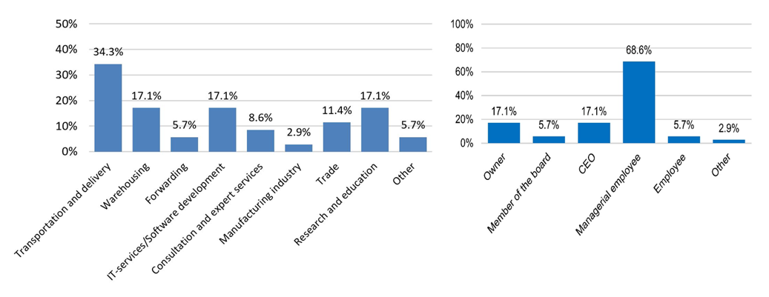

**Figure 2.** Respondents Business Sectors (a) and Respondents’ Roles in Their Organizations (b)

The number of responses (N) per dimension was maximum 35. The total number of responses per TDL (N total) is the sum of responses per dimension and was maximum 105 (3*35). This value indicates how well known each technology was among the respondents. Location technologies and self-driving vehicles received the most responses (Ntotal=103).



**Table 3** The Detailed Survey Results

Several SDs were calculated for each dimension and were between 1.61 (SD value of maturity of wireless sensor networks) and 2.60 (SD value of maturity of crowdsourcing). The average values of the SDs are shown in the second column from the right and reflect the unity of answers for each technology topic. In other words, the smaller the average of the SDs, the more consistent were the views of the respondents towards the technology. Based on the average values of the SDs, location technologies, IoT, AI and machine learning and WSN had the most consistent responses. Crowdsourcing, self-driving vehicles and blockchain technologies had the highest average SDs (>2.24). Under each BMI, the leftmost column in the group shows the average score for each dimension (avg.). The rank column shows the order of the TDLs in the range of application possibilities and was therefore ranked first under this category. The average score of the three BMIs was calculated for each TDL and is shown in the rightmost column. The survey results are presented as a spider diagram in Figure 3. The technology topics have been sorted according to the average score of the three BMIs (Tot. Avg.) so that the score decreases clockwise.

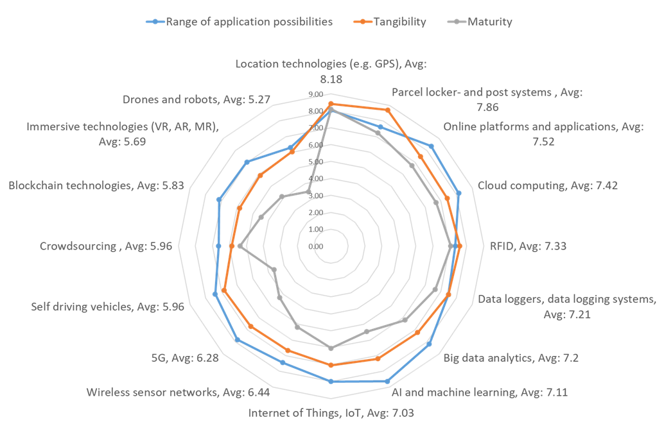

**Figure 3** Spiderweb Diagram of the Survey Results

**4. Discussion**

*4.1. Analysis of the Survey Results*

The goal of the conducted survey was to gain a picture of online retail and distribution

professionals’ views on the range of possibilities for applying the chosen technologies.

Based on the results, there are generally high expectations that digitalization will

significantly improve various aspects of logistics. However, as history has shown, not all

technologies maintain their position and they can quickly give way to a more suitable

innovation. Other aims of the survey were to analyse how clearly these technologies are linked to practical operations in last-mile logistics, how specific the solutions are that these

technologies can offer (tangibility), and how advanced, proven and ready-to-implement

(maturity) the technologies are perceived to be. All of the technologies received an

average score above 5.0 on a scale of 0–10 for tangibility and range of application possibilities. This indicates that the chosen 16 technologies based on the literature review

findings have at least some level of support among logistics experts.

The maturity score varied from 3.48 (drones and robots) to 8.09 (location technologies, GPS), which was to be expected, given that some of the technologies are broadly used in other industries and/or the logistics sector, while others are clearly at an earlier phase of deployment — especially from the perspective of last mile distribution. Technologies that are already widely used tended to receive high ratings in maturity and tangibility (location technologies, RFID, smart locker and post systems). This may partly reflect the extensive use of these technologies in some industries where their implementation has reached all groups of technology adopters presented in the Diffusion of Innovations theory (Rogers, 1962). Figure 4 is visualizing the unity of answers and their potential impact on general awareness of technologies.

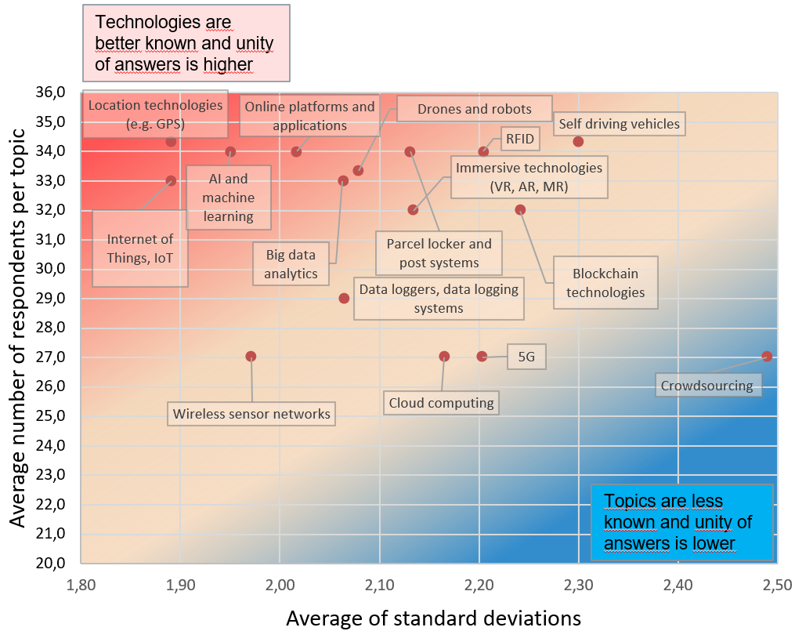

**Figure 4** Mapping of TDLs based on Their Average SDs and Number of Respondents

ICT technologies, such as Big Data analytics, AI and machine learning, cloud

computing, and online platforms and applications were perceived to have a high range of

application possibilities but had relatively average scores for maturity and tangibility.

This suggests that the potential of these technologies has been noted, but that there is

some uncertainty as to their possible roles in distribution logistics. From the perspective

of TAM (Davis, 1989), the perceived usefulness is still incomplete and the concrete

benefits unclear. The technology concepts that received a relatively low score in the range-of application possibilities and tangibility were crowdsourcing, drones and robots,

immersive technologies and blockchain. This indicates that these technologies are still mostly used by early adopters presented in the Diffusion of Innovations theory (Rogers,1962), and their perceived usefulness (Davis, 1989) in the daily operations of distribution logistics is less clear compared to technologies that received higher technology dimension scores. The technologies with a relatively high number of responses and low SDs were location technologies (e.g., GPS), online platforms and applications, AI and machine learning, and IoT. The respondents’ awareness of these topics might reflect the overall visibility of these technologies.

*4.2. Limitations and Future Research Perspectives*

Despite the fierce competition and regulatory limitations affecting especially what type of information horizontal competitors are able to share, it is claimed that regular BM studies arranged regularly by an impartial organization could improve the awareness of technology trends within the specific domain. The limitations, however, steer the selection of BMIs, as they are not allowed to have economical or otherwise sensitive dimensions. Therefore, it is proposed to use non-confidential BMIs and perceived dimensions reflected from well-known theories. The obtained general trend information can further be utilized in decision-making processes at the front end of the innovation phase, at a time when considering technology investments and their feasibilities for specific purposes are particularly relevant. The proposed model is scalable, and the number of BMIs can be increased if they are considered useful in future studies. In addition, the BMIs can be modified to include other perceivable dimensions for each TDL such as disruptive potential, sustainability, or some other dimension depending on the future study focus. The number of emerging technology topics continues to grow at the same time that others are being replaced or merged. Therefore, the selection of TDLs for inclusion in a BM study should be updated regularly.

**5. Conclusions**

This BM survey was used to demonstrate the use of the conceptual model that assessed the emerging technologies in terms of their maturity, acceptability and applicability. The proposed conceptual model was based on BM methodology, technology adoption theories and trend scoping. The model was demonstrated to be usable in mapping and measuring the perceived potential and suitability in the selected scope of online retail-related last-mile logistics. The results of the survey data used for demonstration confirmed the applicability of the proposed conceptual model, but the wider application and use requires more research. Intuitively, the proposed model should be applicable to almost any domain for the assessment of technology and hence in assisting in decision making on technology investments.

The role of technologies in logistics is growing along with digitalization. The

proposed model and its demonstration can help bring clarity and understanding of the

prospective, yet in many respects uncertain and risky technologies.

The theoretical contribution of this paper is the merging of different technology models and their inherent perspectives into a framework that can be used for technology evaluation before significant investments and commitments are made. Whilst the emphasis is on bringing forth a tool for the practice, the proposed conceptual model is novel and therefore sets a hypothesis to be tested further by future research and practice.

**Acknowledgements**

This paper is part of the Open Mode – Towards Customer Centric Supply Space

Management research project funded by Business Finland. The authors wish to acknowledge also ADMIRAL project from the European Union’s Horizon Europe Research and Innovation Programme under Grant Agreement No. 101104163. . The content of this paper remains solely on the responsibility of the authors. The

funders are not responsible for any data, methods or conclusions.

**References**

Agarwal, R., and Prasad, J. 1997. The role of innovation characteristics and perceived

voluntariness in the acceptance of information technologies. Decision Sciences, 28:

pp. 557-582.

Alicke, K., Rexhausen, D. and Seyfert, A. 2017. Supply Chain 4.0 in consumer goods.

Mckinsey & Company, pp.1-11.

Amling, A. and Daugherty, P.J. 2018. Logistics and distribution innovation in China.

International Journal of Physical Distribution & Logistics Management.

ApQc / American productivity & Quality centre. 1996. Emerging Best Practises in

Knowledge Management. Houston, Texas: American productivity & Quality Centre

Publications.

Berawi, M.A., 2021. Philosophy of Technology Design: Creating Innovation and Added

Value. International Journal of Technology. Volume 12(3), pp. 444-447

Bhutta, K. S., & Huq, F. 1999. Benchmarking - best practises: an integrated approach.

Benchmarking: An International Journal, Vol. 6 No. 3, pp. 254-268.

https://doi.org/10.1108/14635779910289261

Boxwell, R.J. Jr. 1994. Benchmarking for Competitive Advantage. McGraw-Hill. New

York.

Boysen, N., Fedtke, S. & Schwerdfeger, S. 2021, Last-mile delivery concepts: a survey from

an operational research perspective. *OR Spectrum* **43**, 1–58.

Cagan J., & Vogel C.M. 2002. Creating breakthrough products: innovation from product

planning to program approval. Prentice Hall, Upper Saddle River.

Camp, R. C. 1989. Benchmarking: The search for industry best practices that lead to

superior performance. Milwaukee: ASQC Quality Press

Cano, J.A., Gómez-Montoya, R.A., Salazar, F., Cortés, P., 2021. Disruptive and Conventional Technologies for the Support of Logistics Processes: A Literature Review. International Journal of Technology. Volume 12(3), pp. 448-460

Castillo, V.E., Bell, J.E., Rose, W.J. & Rodrigues, A.M. 2018. Crowdsourcing last mile delivery: strategic implications and future research directions. Journal of Business Logistics, 39 (1), pp. 7-25.

Chen, C., Demir, E., Huang, Y. & Qiu, R. 2021, The adoption of self-driving delivery robots in last mile logistics, Transportation Research Part E: Logistics and Transportation Review, Volume 146, 2021, 102214.

Davis, F.D. 1989. Perceived usefulness, perceived ease of use, and user acceptance of

information technology. MIS Quarterly. 13, pp. 319-339.

Dekhne, A., Hastings, G., Murnane, J., & Neuhaus, F. 2019. McKinsey & Company April 2019,

Travel, Transport & Logistics Practice. Automation in logistics: big opportunity, bigger uncertainty.

Durst, S. and Evangelista, P. 2018. Exploring knowledge management practice in 3rd party

logistics service providers. VINE Journal of Information and Knowledge Management Systems, Vol. 48 No. 2, pp. 162-177.

EARTO. 2014. The TRL Scale as a Research & Innovation Policy Tool – EARTO

Recommendations.https://www.earto.eu/wp-content/uploads/

The_TRL_Scale_as_a_R_I_Policy_Tool_-_EARTO_Recommendations_-_Final.pdf

(retrieved 3.2.2020)

Feigenbaum, A.V. 1951. Quality control: Principles, practise and administration: An

industrial management tool for improving product quality and design and for reducing operating costs and losses. McGraw-Hill, New York.

Gassmann, Oliver and Schweitzer, Fiona. 2014. Managing the Unmanageable: The

Fuzzy Front End of Innovation, p. 3-14, Springer.

Gevaers, R., Van de Voorde, E., Vanelslander, T. 2014. Cost Modelling and Simulation

of Last-mile Characteristics in an Innovative B2C Supply Chain Environment with

Implications on Urban Areas and Cities, Procedia - Social and Behavioral Sciences, Volume 125, 2014, Pages 398-411.

Giuffrida N, Fajardo-Calderin J, Masegosa AD, Werner F, Steudter M, Pilla F. Optimization

and Machine Learning Applied to Last-Mile Logistics: A Review. *Sustainability*. 2022; 14(9):5329

Hinkka, V. 2012. Challenges for building RFID tracking systems across the whole supply

chain. International Journal for RF Technologies: research and applications. 3 (3), pp. 201-218.

Hsiao, Y.-H., Chen, M.-C., Lu, K.-Y. & Chin, C.-L. 2018. Last-mile distribution planning

for fruit-and-vegetable cold chains. International Journal of Logistics Management. 29 (3), pp. 862-886.

Huebner, A.H., Kuhn, H. and Wollenburg, J. (2016), "Last mile fulfilment and distribution in

omni-channel grocery retailing: a strategic planning framework", International Journal of Retail & Distribution Management, Vol. 44 No. 3.

Kianto, A., Hussinki, H., Vanhala, M., Nisula, A-M. 2018. The state of knowledge

management in logistics SMEs: evidence from two Finnish regions, June 2018

Knowledge Management Research & Practice 16(4):1-11, DOI:

10.1080/14778238.2018.1488523

Kim J. & Wilemon D. 2002. Focusing the fuzzy front-end in new product development.

R&D Manage 32(4):269–279

Kusrini, E., Kartohardjono, S., Putra, N.S.D., Budiyanto, M.A., Wulanza, Y., Berawi, M.A.,

Suwartha, N., Maknun, I.J., Asvial, M., Setiawan, E.A., Suryanegara, M., Harwahyu, R., Yatmo, Y.A., Atmodiwiryo, P., 2020. Science, Engineering and Technology for Better Future. International Journal of Technology. Volume 11(7), pp.1286-1291

Lemke, J., Iwan, S. & Korczak, J. 2016. Usability of the Parcel Lockers from the Customer

Perspective – The Research in Polish Cities. Transportation Research Procedia, 16, pp. 272-287.

Lim, S.F.W.T., Jin, X. & Srai, J.S. 2018. Consumer-driven e-commerce: a literature

review, design framework, and research agenda on last-mile logistics models.

International Journal of Physical Distribution & Logistics Management, 48 (3), pp.

308-332.

Lin, Y., Luo, J., Cai, S., Ma, S. & Rong, K. 2016. Exploring the service quality in the ecommerce

context: a triadic view. Industrial Management & Data Systems, 116 (3), pp. 388-415.

Mann, S. R., Abbas, A., Kohl, H., Orth, R., & Görmer, M. 2010. Global Survey on Business

Improvement and Benchmarking. Germany: Global benchmarking Network. 2010. 40pp. http://publica.fraunhofer.de/documents/N-153910.html [Accessed 12st of

January 2021]

Moore, G. C., I. Benbasat. 1991. Development of an instrument to measure the

perceptions of adopting an information technology innovation. Inform. Systems Res.

2 pp. 192–222.

Nowicka, K. 2014. Smart City logistics on cloud computing model. Procedia – Social and

Behavioral Sciences 151, pp. 266-281.

Pasian, B., & Turner, R. (Eds.). (2015). Design Methods and Practices for Research of Project

Management (1st ed.). Routledge

Pigatto, G., Machado, J. G. de C. F., Negreti, A. dos S., & Machado, L. M. (2017). Have you

chosen your request? Analysis of online food delivery companies in Brazil. British Food Journal, 119(3), pp. 639–657.

Piroth, P., Rüger-Muck, E. & Bruwer, J. 2020. Digitalisation in grocery retailing in

Germany: an exploratory study, The International Review of Retail, Distribution and

Consumer Research.

Ranieri, L., Digiesi, S., Silvestri, B. & Roccotelli, M. 2018. A review of last mile logistics

innovations in an externalities cost reduction vision. Sustainability, 10 (3), pp. 782-

799.

Remondino, M. 2020, Augmented reality in logistics: qualitative analysis for a managerial

perspective, International Journal of Logistics Systems and Management 2020 36:1, 1-15.

Rogers, E.M. 1962. Diffusion of innovations. New York, Free Press of Glencoe.

Sadin, S. R., Povinelli, F. P. & Rosen, R. 1989. The NASA technology push towards

future space mission systems. Acta Astronautica. 20, pp. 73-77.

Schreier, M. 2014. Qualitative Content Analysis. Sage Handbook of Qualitative Data

Analysis. SAGE Publications Ltd.

Schweitzer F. 2014. Integrating Customers at the Front End of Innovation. In: Gassmann

O., Schweitzer F. (eds) Management of the Fuzzy Front End of Innovation. Springer,

Cham.

Statista. 2020. ECommerce Market Report. Statista Digital Market Outlook. November

2020.

Trebar, M., Lotric, M., Fonda, I., Pletersek, A., Kovacic, K. 2013. RFID Data Loggers in Fish

Supply Chain Traceability. International Journal of Antennas and Propagation. 2013, pp. 1-9.

Vanderroost, M., Ragaert, P., Verwaeren, J., De Meulenaer, B., De Baets, B., Devlieghere, F.

2017. The digitization of a food package’s life cycle: existing and emerging computer systems in the logistics and post-logistics phase. Computers in industry. 87, pp. 15-30.

Vakulenko, Y., Shams, P., Hellström, D., Hjort, K. 2019. Online retail experience and

customer satisfaction: the mediating role of last mile delivery, The International

Review of Retail, Distribution and Consumer Research, 29:3, 306-320.

Vanelslander, T., Deketele, L. & Van Hove, D. 2013. Commonly used e-commerce

supply chains for fast moving consumer goods: comparison and suggestions for

improvement. International Journal of Logistics Research and Applications, 16 (3), pp. 243-256.

Venkatesh, V., Davis, F.D. 2000. A theoretical extension of the technology acceptance

model: four longitudinal field studies, Management Science. 46, pp. 186-204.

Wang, Y. 2019. Future of Mobility: evidence review 2019, University of Cardiff.

Understanding the impact of emerging technologies on the freight sector.

Wang, X., Yuen, K.F., Wong, Y.D. & Teo, C.C. 2018. E-consumer adoption of innovative

last-mile logistics services: a comparison of behavioural models. Total Quality

Management & Business Excellence, pp. 1-27.

Yu, Y., Wang, X., Zhong, R.Y. & Huang, G.Q. 2017. E-commerce logistics in supply

chain management: implementations and future perspective in furniture industry.

Industrial Management & Data Systems. 117 (10), pp. 2263-2286

Zhong, R.Y., Tan, K. & Bhaskaran, G. 2017. Data-driven food supply chain management and

systems. Industrial Management & Data Systems. Guest editorial. 117 (9), pp. 1779-1781.

Zhou, M., Zhao, L., Kong, N., Campy, K.S., Xu, G., Zhu, G., Cao, X. & Wang, S. 2020.

Understanding consumers’ behavior to adopt self-service parcel services for last-mile delivery. Journal of Retailing and Consumer Services, 52, pp. 1-12.