100 A sample:
Sample 100 A: Evolution of austenitic diameters according to depth
I was able to upload a limited number of photos for the size requested during the submission
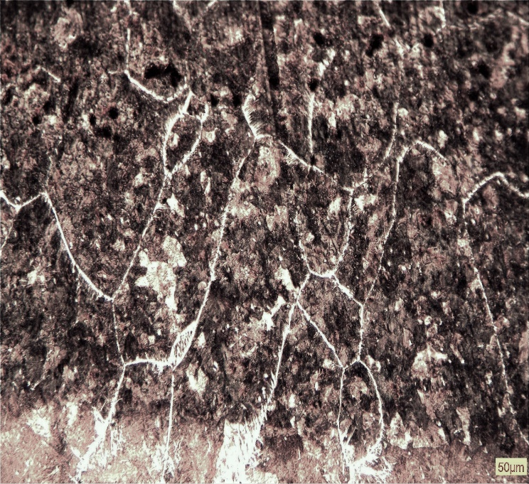  n1=3;  n2=13;  ng=n1+n2/2;  g=100; % GROSSISSEMENT  m=2*(g/100)^2*ng;  dexp100A(2)=1/m^0.5 =229µm  1 mm under up surface | 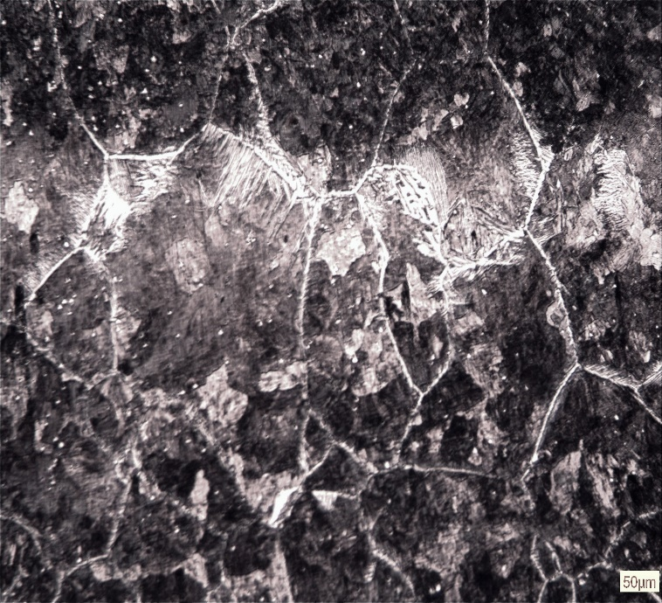  n1=7; n2=12  n1=7;  n2=12;  ng=n1+n2/2;  g=100; % GROSSISSEMENT  m=2*(g/100)^2*ng;  dexp100A(3)=1/m^0.5;  dexp100A=196µm  1.5 mm under up surface

Some photo of hardness measurement

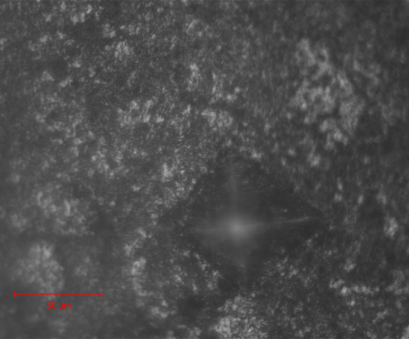
1 mm under up surface

