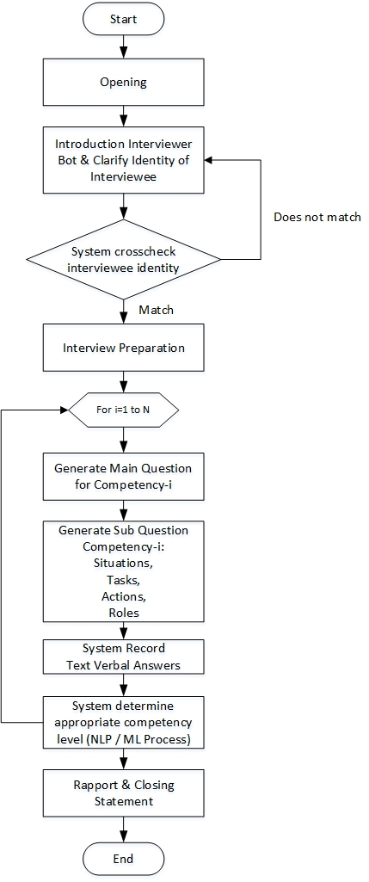

Figure 1 Design flow of interview bot.

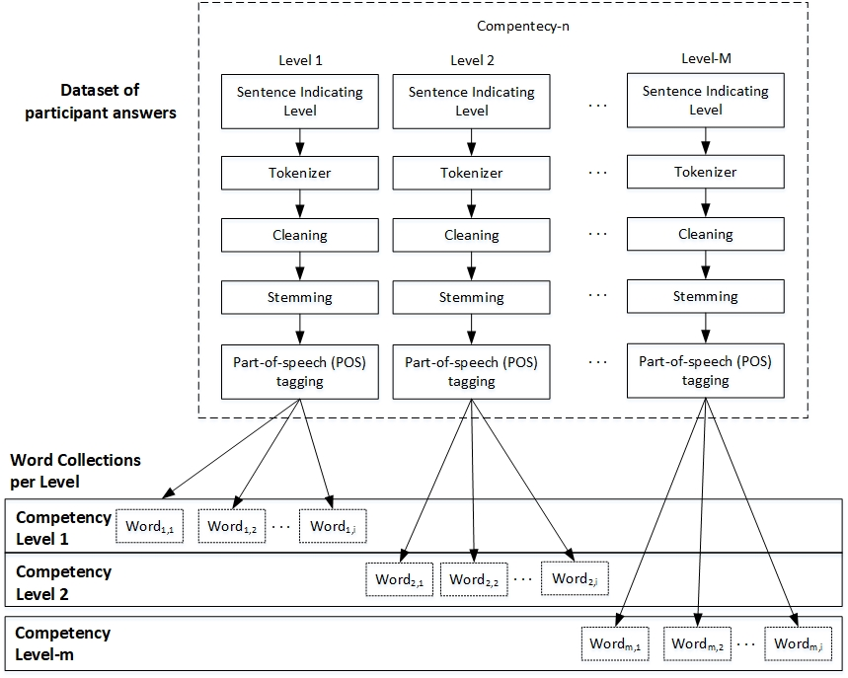

Figure 2 Method for data training

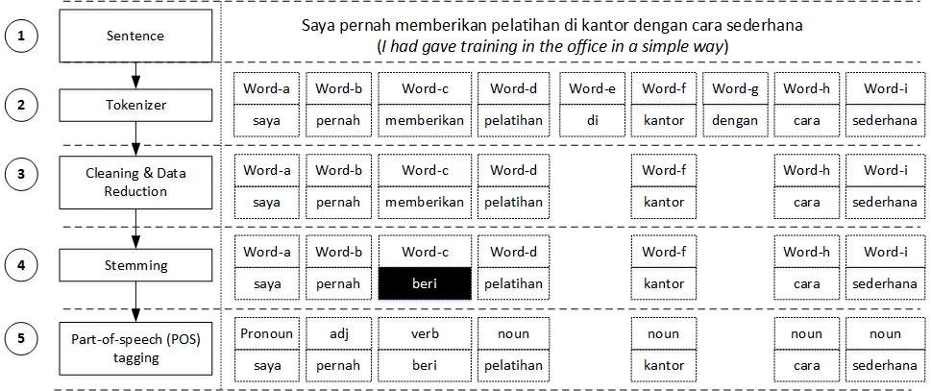

Figure 3 Initial process of NLP Implementation.

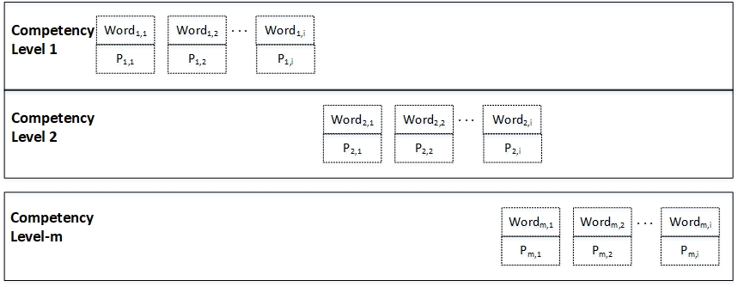

Figure 4 The Applied Model Contains Competency Levels and Their Sets of Words and TF Results

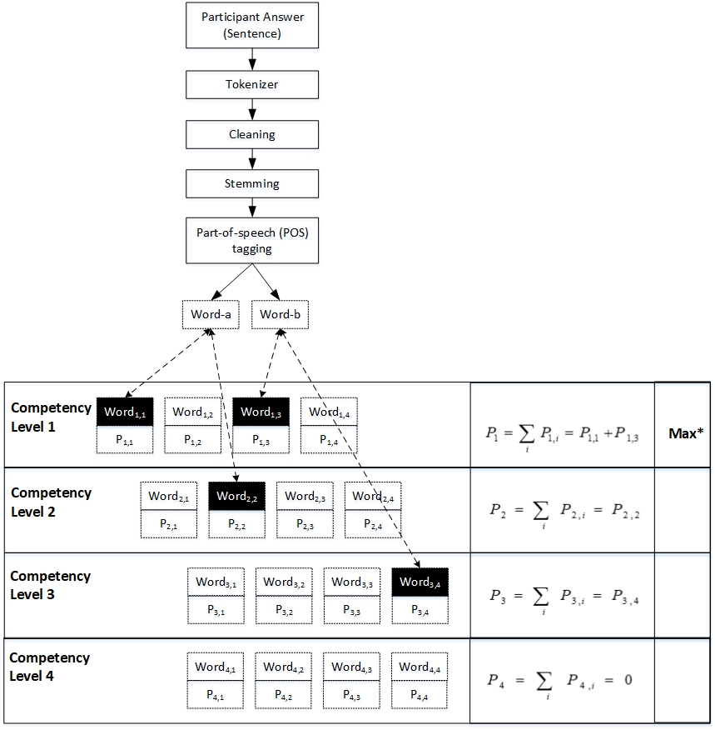

Figure 5 Proposed Testing Method

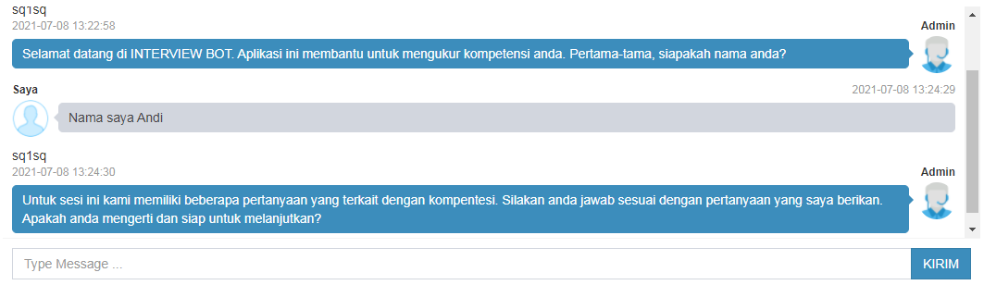

Q (machine): Welcome to the INTERVIEW BOT. This application helps in measuring your competencies. First, please tell me what your name is.
I (Interviewee): My name is Andi
Q (machine): In this session, we have several questions related to some competencies. Please answer according to each question. Do you understand, and are you ready to proceed?
Figure 6. Example of the interview bot user interaction in Indonesian (Part of Opening & Identify Interviewee), with translation.

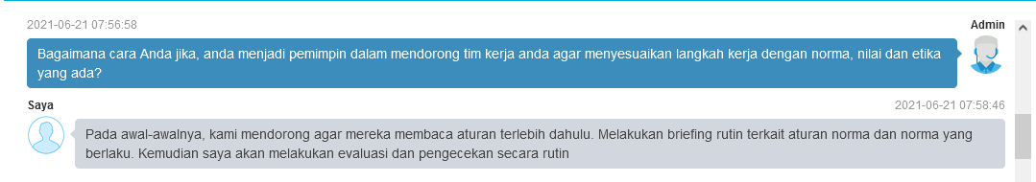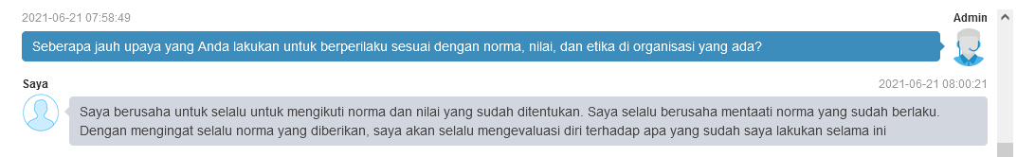
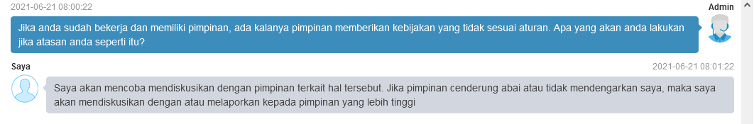

Q (machine): What would you do if you become a leader to encourage your team to follow the pace of works with existing norms, values, ​​and ethics?
I (Interviewee): In the beginning, I encouraged them to read the rules first. We conduct regular briefings about the current rules. After that, I will evaluate and check it regularly.
Q (machine): How much effort do you make to behave according to your organisation's rules or norms, values, ​​and ethics?
I (Interviewee): I always try to obey the established norms and values. I always try to comply with the rules or norms. By remembering the norm, I will evaluate myself against what I have done so far continuously.
Q (machine): If you are already working and have a leader, there are times when the leader gives policies that are not following the rules. What would you do if your leader does like that?
I (Interviewee): I will try to discuss with the leader regarding this matter. However, if the leader tends to ignore or does not listen to me, I will discuss it with or report to the higher leader.
Figure 7. Example of a part when bot giving question and interview give feedback or answer bot in Indonesian, with translation.

